*■kkkkkkkkkkkkkkkkkkkkkkkk k* 0 — fj 3 G I T 3 0 3

BRECK H CAMP CML 12/39 PO BOX 47070 ATLANTA GA 30362-0070

OgOOOOOC

pccco ? e

■UiJOOiA-

PCCOfr'CCC

WUUQO

i>

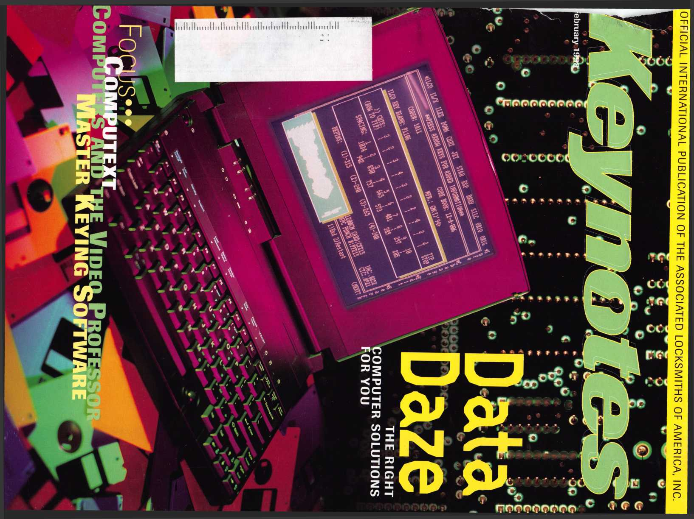

SAFETECH 'OB CONVENTION AND TRADE SHOW • VALEEV FORGE, PENNSYLVANIA • MAY 10-2

Die Hard Manipulation Time Lock Servicing Advanced Servicing and Defeat Methods

Red Label GSA Containers,

Safe Opening Extravaganza Electric Locks and Safe Retrofitting Safe Moving and Installation



SAFE AND VAULT TECHNICIANS ASSOCIATION 3 0 03 LIVE OAK STREET DALLAS, TEKAS 75204 21 4.8 27.723 3 214.B27.1 B10 (FAX)

**E-MAIl: [CONVTION@ANEHFW.COM](mailto:CONVTION@ANEHFW.COM)**

ALOA ’98 International Convention & Security Expo

*‘No one succeeds alone. The*

*input*, *tolerance and sharing*

*of knowledge front others in*

*this industry account for most*

*of my success. My part was to*

*leant—a lifetime process*

Nashville Convention Center

Dan Graffeo, CRL, CMS  
ALOA Member #8188  
1996 recipient, ALOA Lifetime  
of Outstanding Achievement

Nashville, Tennessee

*Associated Locksmiths of America 3003 Live Oak Street Dallas, Texas 75204*

*e-mail [convtion@anet-dfw.com](mailto:convtion@anet-dfw.com)*

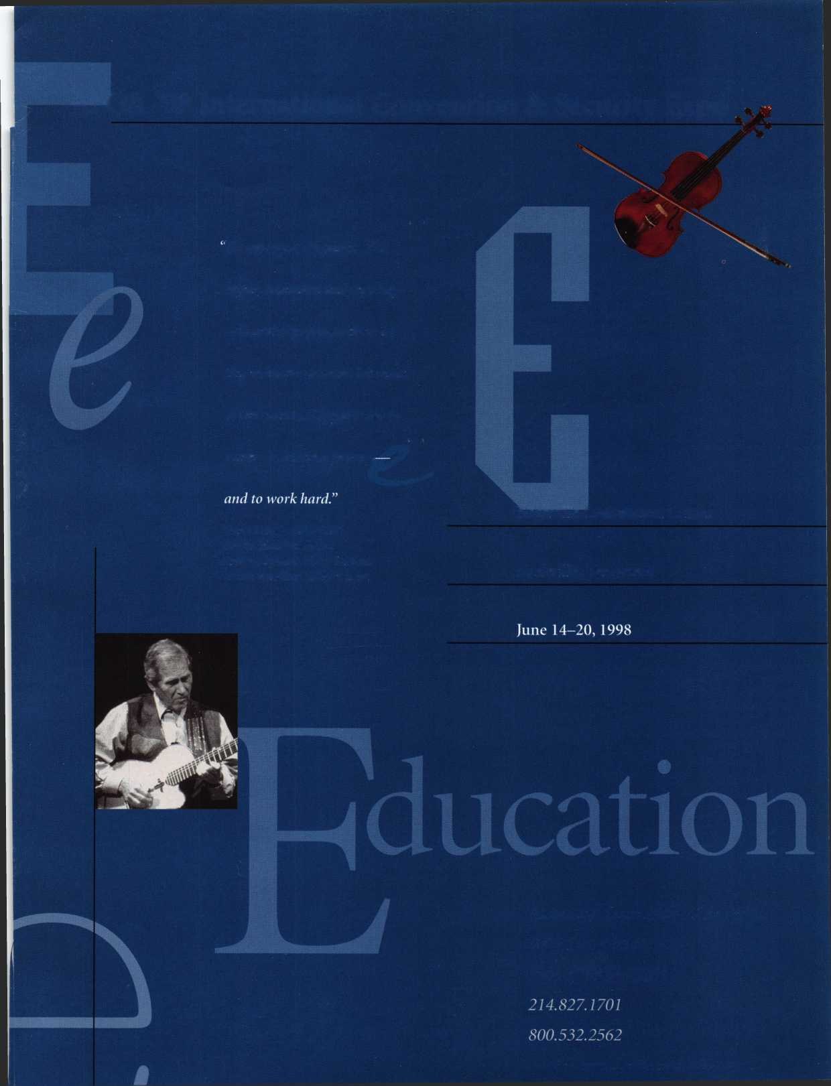

**Advertising**

46

Associate Members

50

Classifieds

53

Buyers’ Guide

58

Ad Index

**Ffthruary**

Contents

**Volume 44, Issue 2**

President’s Journey Every member should have a vote.

8

Focus on Education

Don’t miss out on ACE at MLANJ.

10

Legislative Comment

Industry position paper builds coalition.

54

PRP Report

Additional sittings at ISC.

55

Trade Tips

Button pin spring action and 8~cut keys.

56

Chapter News Big hello from Japan.

6

Mail Box

The truth versus rumors—about ALOA.

7

Upcoming Events Mark June 15-20, Nashville.

9

Applicants for Membership Scheduled for clearance March 1.

12

Industry News

High Security Council moving ahead.

14

Security Marketplace High tech, high tech, high tech.

58

ALOA Extra

Features

16

Making the Political Process Work For You

For a newcomer to politics, here’s a primer.

By Richard Ensman

18

Evolution of the Security Industry, part 1

Why do locksmiths exist? Some of todays answers lie in yesterday’s truths.

By Steven Spiwak

43

Auto Insurance for Locksmiths

Locksmiths may have special needs they’re unaware of.

By Rick Janis

44

Benefiting From Safe Work

Basic safe work can be a profitable new skill to aquire.

By Don Dennis, CPL

^ **February 1998**

27

Master Keying By the Letter

A chart that makes a two step master key progression so easy to follow it’s almost impossible not to understand? Hmm.

By Greg Perry, CML, CPS

Business Software for Small Shops

You really have to computerize to stay competitive.

By Derrick Frazier

24

Learning Computer Skills With the Video Professor

Here’s a flexible training option for the busy locksmith.

By Sal Dulcamara, CML

The Cover

There’s a bunch of software out there and crunching through all the possibilities may look impossible. But if you take into consideration the special needs of the professional locksmith, the choices narrow quite a bit. See what recommendations are to be had in the articles on pages 22, 24, 34 and 36.

Cover photograph ©Steve Hinds Feature design by Valerie Rowe

How Safe Are Safe Deposit Boxes?

If you service these boxes, you may have been asked for related security advice. Have a few facts ready.

By Vivian Marino

34

Evaluating Master Keying Software

A well designed program can save time and prevent math mistakes—but the current programs don’t do everything.

By Jerome Andrews, CML

36

Computext: Computerized Codes and More

Our author gives you a quick guide to one of four major computerized code programs.

By Sal Dulcamara, CML

40

Burglary Tools

Sure we’re all familiar with basic locksmithing tools.

How much do you know about what the other guy is using?

By Steven Spiwak

60

Back Page

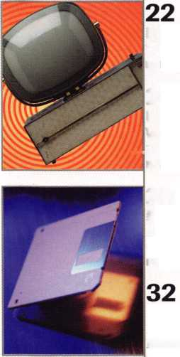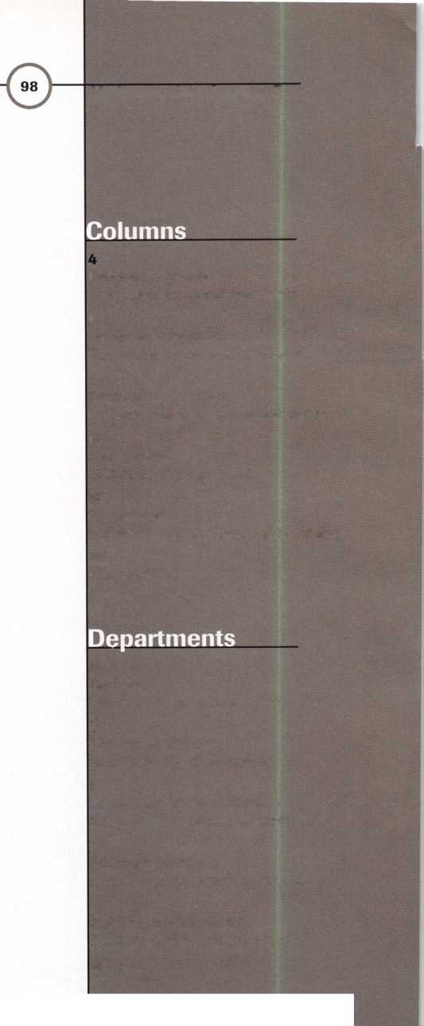

0) Executive

|  |  |  |
| --- | --- | --- |
| Editor | Anne McDonald Davis, ABC |  |
| Associate Editor | Mike Emery |  |
| Advertising Sales Manager | Anelia M. Banda |  |
| Sales Assistant | D’Anna Weber |  |
| Contributing Authors | Jerome V. Andrews, CML  Kim Bowers,CML  Paul Chandler, CRL  Claire Cohen, CML  Brian Costley, CML, CMS  Bob De Weese, CPL  Ray D’Adamo, CML  Sal Dulcamara, CML  James Glazier, CML  Wayne Gurnee, CRL  A.J. Hoffman, CML  Ken Holmlund, CRL  Ray Lusk, CML  Mark Ohno |  |
|  | David Parrott | Complete address and |
|  | Randy Simpson, CML  Steven Spiwak  Robert Stafford, CPL | phone number listings for the ALOA Board and |
|  | Dave Thielen | Keynotes authors are |
| Editorial Advisors | John D. Cannon, CML, Technical Content | available in your |
|  | Jerome Andrews, CML | membership directory or by |
|  | A.J. Hoffman, CML | contacting the ALOA office |
|  | Leonard J. Passarello, CPL | at 3003 Live Oak Street; |
|  | Randy Simpson, CML | Dallas, TX 75204; |
|  | Robert Stafford, CPL | (.214)827-1701; FAX (214] |
| ALOA Professional Staff |  | 827-1810; e-mail |
| Executive Director | Charles W. Gibson, Jr. | aloa@anet-dfw. com; |
| Office Manager | Mary May | website [www.aloa](http://www.aloa). org |
| Receptionist | Margo E. Vela |  |
| Comptroller | Kathy J. Romo |  |
| Financial Assistant | Debra Bradshaw |  |
| Associate Executive Director | Carmen D. Murphey, CMP |  |
| Meetings Manager | Jessica Vasquez |  |
| Meetings/Exhibits Assistant | Janelle Vergara |  |
| Legislative Manager | Tim McMullen |  |
| PRP/Education Manager | David Lowell, CML, CMS |  |
| Education Assistant | Ashley Spenser |  |
| Membership Coordinator | Brandon Durrett |  |
| Membership Assistant | Jackie Arnett |  |
| Mailroom Assistant | Jesse Morales Jr. |  |



Mission Statement: The Associated Locksmiths of America, Inc. is dedicated to enhancing the professionalism, education and ethics among locksmiths and  
those in related sectors of the physical security industry. With approximately 10,000 members in the United States, Canada and the freeworld, ALOA is poised to  
help members obtain the knowledge, the strength, and the confidence to perform their role in the physical security field with pride and dignity. But it is only  
through active involvement and participation that ALOA can fully achieve its potential-and can help members to achieve theirs.

Policies: Keynoted is the official publication of the Associated Locksmiths of America, Inc. CALOA). Keynotes® acts as a moderator without approving,  
disapproving, or guaranteeing the validity or accuracy of any data, claim, or opinion appearing under a byline or obtained or quoted from an acknowledged  
source. The opinions expressed by the authors do not necessarily reflect the official views of ALOA. Also, appearance of advertisements and new products or  
service information does not constitute an endorsement of products or services featured by the Association. The Association does not accept responsibility for  
the inaccuracy of any data, claim, or opinion appearing in this publication, due to typographical errors on the part of the authors, Association staff or its agents.  
Editors Note: This publication is designed to provide accurate and authoritative information in regard to the subject matter covered. It is provided and  
disseminated with the understanding that the publisher is not engaged in rendering legal or other professional services. If legal advice and other expert  
assistance is required, the services of a competent professional should be sought.

Authors’ Payment: Payment for eligible submissions to KEYNOTES will be based on the following criteria: topic, time spent and past contributions. Authors who  
regularly submit to KEYNOTES are generally paid a higher rate. The latter is especially true of authors who write to fit specific editorial needs and submit said copy  
by KEYNOTES deadlines. As a general guideline: Average payment for a 750 word, business or ‘light’ technical article would be $200. Payment for a 1500 word article  
involving significantly higher time and research efforts would be $400.

Payment will not be offered for articles submitted by ALOA employees or members of the ALOA Board of Directors (unless material is of a technical nature),  
nor for articles submitted by a company that promote that company’s products or services. ALOA reserves the right not to pay for articles submitted by an  
individuals) that promote a particular company’s products or services.

Disclaimer: The Associated Locksmiths of America, Inc., (ALOA), reserves the right to refuse any article for any reason. Additionally, ALOA reserves the right  
/ to edit, amend or modify any article submitted for publication in order to preserve technical accuracy, clarity, fairness or grammatical correctness. ALOA will make  
the best efforts to notify the author of any changes. The extent of ALOA’s liability for any article or information contained therein will be a notice of correction or  
\ retraction in the next possible issue.

} Keynoted (ISSN 0277 0792) is published monthly except for the combined June/July issue by The Associated Locksmiths of America, Inc., 3003 Live Oak St.,  
Dallas, TX 75204-6186. Telephone: (214) 827-1701; FAX (214) 827-1810; e-mail [aloa@anet-dfw.com](mailto:aloa@anet-dfw.com). Subscription rates for members-$15.00 per year. Second  
class postage paid at Dallas, Texas. POSTMASTER: Send address changes to: Keynotes, 3003 Live Oak St., Dallas, TX 75204-6186. © Copyright 1998, All rights  
reserved. No part of the contents may be reproduced or reprinted in any form without prior written permission of the publisher.

Board

President

Dallas C. Brooks  
(334) 826-8990

Regional Vice Presidents  
Southeast

•Jeffrey S. Nunberg, CML, CMS

Chairman: Finance and Personnel

(305) 324-8800

North Central

•John J. Greenan, CPL, CPS

Chairman: Legislative Committee

(773) 486-2030

South Central

•Randy L. Simpson, CML

Chairman: Bylaws Committee

(713) 780-7026

Southwest

John I. Shandy, CML

Chairman: Membership Committee

(303) 776-7898

Northeast

James H. Glazier, CML

Chairman: Education Committee

(301) 831-5454

Northwest

Raymond C. Lusk, CML

Chairman: Convention Committee

(509) 624-3152

Secretaiy

John D. Cannon, CML

Chairman: Publications and Public Relations

(703) 960-6413

Trustees:

David M. Lowell, CML, CMS

Chairman: Nominating, PRP and Trustees

(214) 827-1701

Breck H. Camp, CML

(770) 455-6244

Henry H. Printz, CML

(201) 538-2737

Leonard J. Passarello, CPL

(416) 752-7210

Edwin Toepfer, RL

(416) 225-5589

Directors

*These officers also serve as directors.

Dana L. Bamum, CML  
Chairman: Chapters Committee  
(610) 565-9900  
Mark E. Blum, CML, CPS  
(517) 482-5809  
A.J. Hoffman, CML

Chairman: Library/Museum Committee

Barry K. Leas, CRL

(610) 272-9292

Clyde Roberson, CML, CPS

(540) 380-5000

Donald E. Rule, CML

(601) 324-2658

Anthony J. Ramunno, CML, CPS

(330) 782-6204

Robert H. Stafford, CPL

Chairman: Grievance Committee

(860) 768-7917

Bruce J. Tarbet, CML

(601) 924-4184

Chairmen of International Affairs

Laurence P. Mills/Australia

(129) 958-0445

Hans Mejlshede, CML/Europe

FAX (453) 139-1004

Members-at-Large

Jerome V. Andrews, CML

(860) 621-3601

Steven G. Engel, CML, CPP

Chairman: Strategic Planning Committee

(414) 731-5400

Past Presidents

1995-1997 David Lowell, CML, CMS  
1993-1995 Breck Camp, CML  
1991-1993 Henry Printz, CML  
1989-1991 Evelyn WersonicK CML  
1987-1989 Leonard Passarello, CPL  
1985-1987 Joe Jackman, CML  
1983-1985 Stanley Haney, CPL  
1981-1983 Louis LaGreco, CPL  
1979-1981 John Kerr, RL  
1977-1979 Clifford Cox, CML  
1974-1977 Charles Hetherington  
1972-1974 Gene Laughridge  
1970-1972 William Dutcher, RL  
1968-1970 Constant Maffrey, RL  
1966-1968 Harold Edelstein, RL  
1964-1966 William Meacham  
1962-1964 Robert Rackliffe, CPL  
1960-1962 Edwin Toepfer, RL  
1956-1960 Ernest Johannesen

Keynotes



February 1998

President’s Journey

_

Grab The Reins.

I don’t know how many of you know that I ended up on the ALOA board, and now as the ALOA president, largely because I wanted ALOA members to have the right to vote by mail. I do know that for the first time since I began this battle six years ago, we have our chance—our chance to give all the members of the Associated Locksmiths of America an equal voice in how this organization works. In 1991 when I began speaking out on the view that all members are created equal, you might be surprised to hear how vocal and vehement the opposition was. According to some, the 200-plus folks that show up in person at the membership meeting each year are “the only ones who care” and “the only ones who have a right to decide anything.” I simply don’t believe that is true. Don’t misunderstand—I know how much commitment it takes to walk into that annual meeting and take a stand. I appreciate all the hard work that has been done in the past. But I also know that a number of those who attend the ALOA membership meeting do so in conjunction with a convention, trade show and with social events that they likely would have attended anyway. They are there in person, yes, because they care, but also because they can afford the time and money it takes from their businesses. And I will not, repeat WILL NOT, see a dues-paying member of ALOA go un-represented because a handful of his fellow members have a little more money and a lot more clout. While I am president of this organization, we will do our best to respect the rights of everyone who signs their dues check each fall. We certainly won’t be able to please everyone, or to be everything to everybody—but it won’t be because we deliberately chose to ignore the rights and opinions of others.

The catch? We have to pass a new set of bylaws to allow new governance of ALOA and to allow vote-by-mail. AND, the attendees at the June 20 membership meeting in Nashville, Tenn., will have to pass those new bylaws. And if they don’t? The same group will continue to make all your decisions.

I hope that your businesses prosper, and that you attend many ALOA conventions and membership meetings in the future. But even if you have never been able to make it to a membership meeting and even if you never are able to make it to another membership meeting, you better be at THIS one. Or forever hold your peace.

QjtfLc&tJL.



|  |  |
| --- | --- |
| Kwok-kei Leung | 160 |
| Henry Raymond | 93 |
| Stewart Levine, CML | 67 |
| Toshihiro Asano | 66 |
| Mary Ohmit, CPL | 63 | |
| Allen Konrath | 49 I |
| Charles Robertson, CML | _48 |
| lack Hobin. CPL | 47 |
| Yuriko Yanai | 43 |
| William Neff, CML | 36 |
| Myeong-Rae Cho | 36 |
| Salvatore Dulcamaro, CML | 35 |
| Thomas Freehling, CML | 32 |
| Jeanne Lodge, CML | 27 |
| Roy Renderer, CML | 25 |
| Danny Rudd, CPL | 23 |
| Robert Carroll, CPL | 23 |
| Barbara Watt | 23 |
| David M A Federico | 23 1 |
| John Elliott, CML | 22 |
| James Watt, CML | 22 |
| Diana Barnum, CRL | 22 |
| John Heckman, CML | 22 |
| J Thomas Hood, CML | 22 |
| Robert DeWeese, CPL | 22 |
| Larry Warnick, CML | 21 |
| Jerome Cohen, CML | 21 |
| Eugene Altobella | 21 |
| Jim Williams | 21 |
| D. Michael Lee, CPL | 18 |
| James Fowler, CML | 18 |
| David Harris, CML | 18 |
| Elvis Hammerschmidt, CPL | 18 |
| John Kerr, RL | 17 |
| Marian Swann. CRL | 17 |
| Charles Cole. CML | 17 |
| Ronald Heidzig | 17 |
| John Dorsey, CPL | 16 |
| Joseph Ferrero, CML | 16 |
| William Grant, CRL | 16 |
| Brian Reetz | 16 |
| Walter Lascar, RL | 15 |
| James Cawby, CML | 15 |
| William McElheney, CML | 15 |
| Michael Robinson, CRL | 15 |
| Rex Parmelee, RL | 14 |
| Lawrence Smith, CML | 14 |
| Thomas Vandersteen, CML | 14 |
| Edwin W Scott | 13 |
| James Gruber | 13 |
| Peter Gauthier, CPL | 13 |
| Philip Rovenolt, CPL | 13 |
| Russell Fuller. CRL | 13 |
| Robert Rodocker, CRL | 12 |
| Frank Hartung, CML | 12 |
| Gary Teams. CPL | 12 |
| Rolando Bouza | 12 |
| Lonnie McKinney, CML | 12 |
| James Brickler, CRL | 12 |
| Richard Sievers | 12 |
| Herbert Dusenberry, CML | 11 |
| Robert Duman, CML | 11 |
| Jon Griswold, CML | 11 |
| Robin Horsley | 11 |
| John Engel, CRL | 11 |
| Daniel Landry | 11 |
| Ernest Wright | 10 |
| William Wickward, CML | 10 |
| Lester Brodsky | 10 |
| Joseph Whitaker, CPL | 10 |
| Dale Knowles, CPL | 10 |
| Paul Souber | 10 |

The Brightest

And The Best.

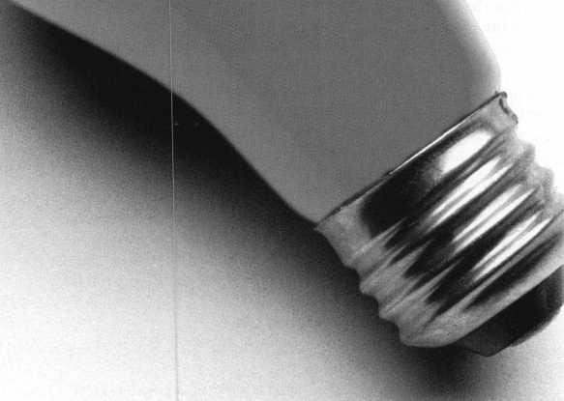

How can I join the President's Club?

You can earn membership in this prestigious dub by recruiting just 10 new members for ALOA.

*Any ALOA member may participate.

What do I get?

When you recruit 10 members, you receive a handsome blue blazer with a President's Club crest. For each additional five members you recruit, you receive a lapel pin with gold-filled numbers, indicating your recruiting successes.

You also get the satisfaction of knowing that you are helping your association, helping your industry grow, and you are helping fellow locksmiths achieve success.

How do I get started?

Contact the ALOA office for a supply of applications (214) 827-1701 or FAX (214) 827-1810. One President's Club credit is awarded for each new applicant. Credit is awarded only after the membership application is approved. Flowever, the credit will apply for the period in which the application is received. Failure to identify yourself as the sponsor on the application form at the time it is submitted to ALOA for processing will forfeit any credit.

*AL0A Board of Directors not eligible for membership in the President's Club.

**Keynotes**

Mail Box



If you have an opinion to offer on the letter(s) printed in Keynotes each month, let us know! Submissions to the “Keynotes Mail Box” department are printed on a space-available basis. Write to: Keynotes Mail Box; Associated Locksmiths of America, Inc.; 3003 Live Oak Street; Dallas TX 75204; or FAX (214) 827-1810.



This Could Happen to You

I wouldn’t usually ask you to publish a letter of this type, however, this goes beyond the usual “local police are unlocking cars in my area” stipulation. I ask that you print this so that this does not happen to a fellow locksmith.

In September of 1997, we installed a PC based access control system. Unbeknownst to us and the manufacturer, the company who manufactures their modems had redesigned them. What this means is that the control­ling computer could not communicate with the remote sites. Of course, we immediately contacted the manufacturer’s technical assis­tance department. For the first two weeks, we were instructed to check various compo­nents to the system, to no avail. Then, after 80 hours of non-chargeable labor, the manu­facturer decided to tell us weeks later, there was a problem with their software. Another two weeks later, the new software arrives. Now, here’s where it gets good. We install the new software, only to find that not only is the system still having the same problems, but now we have many new ones. It seems we were sent what is termed “Beta” software, which has not yet been perfected. A month into the problem, and we have been made guinea pigs for their untested software. Not to bore you with the details, but now it’s two more months, (about 32 hours of more non- chargeable labor), and the system still doesn’t work.

At this point in time we called the factory and told them that out customer was consid­ering a lawsuit. Their response to us was, “Tell them to go ahead, we’ll turn it in to our insurance company.”

Finally, after much begging and pleading, the factory sends an engineer down to the site, which was only two hours away. After checking the installation, which the manu­facturer admitted was a good one, they proceeded to crash my customers system and try to revamp their software. Then they left, claiming everything was working properly. The next day, not only did we discover the doors would unlock by themselves, but whenever a user was removed from the sys­tem, that person could still access the door. You can only imagine the liability claims dancing through my head!

Needless to say, four months later the system still doesn’t work, and last weekend our customer had an unforced entry with a chip that was deleted out of the system. My

**6 | KeynotesFebruary 1998**

customer is still counting how many PCs, fax machines, etc., are missing.

The final point is, we will incur approxi­mately $50,0000.00 out of pocket due to a manufacturers’ defective product. This is the same manufacturer that advertises, “You can turn to us with confidence knowing you will receive the high quality and customer service satisfaction you’ve come to expect.” We now have had to master key our customer’s entire complex for free, since we can no longer depend on the electronic locks to work.

We are also in the process of removing the defective system and installing a new 12 door system—for free of course.

Someday when this reaches the court system, after attorney’s fees, we may recoup our losses. In sending this letter, I am hoping to save a fellow locksmiths a lot of money, a lot of grief, and good customers. Our attorney says we can’t mention the name of the manufacturer, or the model number due to legal ramifications, but if you’re considering installing a OC based access control system, feel free to call me, toll free at (888) 825-3535.

Robert Easter, CRL

Rumors

I feel it’s time to clear up some misunder­standings or misconceptions about what is not paid for by your association to ALOA board members in the course of their duties.

I believe this information should have been addressed a long time ago. What prompted me to write this article was some of the ques­tions, comments and rumors I’ve heard while working the ALOA Booth at tradeshows and association meetings. To date, there are 29 members that make up the ALOA Board (20 of these are voting members). This includes the president, secretary, vice presidents, directors, trustee past presidents, and members-at-large.

No one on the ALOA board is paid for serving on the board. The 29 locksmiths that make up your board donate their time, ener­gy and resources for the love of the industry.

I know what many of you are saying to your­selves right now, “What a bunch of Bull!”

I know it’s a cliche but your board honest­ly cares about the well being of locksmiths, all locksmiths. It’s a good feeling to be one of 29 ALOA Board members to represent and speak out on behalf of almost 10,000 ALOA locksmiths. Let me tell you what a board member gets reimbursed for. At board meet­ings for working the ALOA Convention and

Security Expo: non-refiindable air fare (not first class) or if driving, mileage at 0.28 a mile; food at $25 per day; incidentals at $6 a day; ground transportation allowance is $30 and hotel room nights are picked up by ALOA.

As a dues paying member and a director serving on the board, I believe that any ALOA member has the right to ask anyone that represents them any questions that pertain to ALOA business and expect to get an answer. Your board is not trying to hide anything from you. If you have a question, ask it. Don’t rely on rumors.

Speaking of rumors, maybe there should be a section in Keynotes, called “Rumors — Fact or Fiction?” where members write in about rumors they hear about, so they can get the a reply straight from the horse’s mouth.

Let me share two rumors I heard over the weekend from members.

Rumor #1: How come the Board has their meetings in exotic cities or on cruise ships?

The fall Board meeting is traditionally held at ALOA corporate headquarters in Dallas, Texas. This allows Board members, new and old, to get familiar with the office and its workings.

Now, Dallas is a nice city but is it exotic?

The spring board meetings have been in cities that don’t have snow like San Francis­co, Calif.; Asheville, N.C.; San Antonio, Texas; and Albuquerque, N.M. Here is the way I feel about it. If 29 or so, Board mem­bers from all over the United States have to fly in to one place to meet, what difference will it make where it is as long there are good hotel rates? And we do usually get good rates as we use a chain that we’ve negotiated with as next year’s host for convention.

As for a meeting on a cruise ship, all I can say is “Fiction!” The only cruise I’ve been on happened at the ALOA Convention in New Orleans. The ALOA Dinner Banquet was a dinner cmise up the river. The board was there, but was not having an official meeting.

Rumor #2; ALOA is up for sale.

All I can say, again is “Fiction!” But if ALOA was sold for $10,000,000.00 and we had 10,000 members, we should get about $1,000. No, that’s not right. I forgot about lawyers fees. That would get us about $97.00 each.

Where do rumors come from? They come from people who don’t have the facts.

Robert Stafford, CPL

February ’98

1. 8

21st West Coast Collectors Show Contact: Bob Heilmann (310) 454-7295, evenings

1. 11

Lockmasters, Inc.

Electronic Safe Lock Course Lexington, Ky.

(800) 654-0637

10-15

Texas Locksmiths’ Association Convention and Trade Show Waco, Texas Contact: Ken Warden (210) 379-5923 **13-15**

North Carolina Locksmiths Association Quarterly Meeting and Trade Show Charlotte, NC Contact: Kathy Stewart (910) 578-8865 21-22

mark bates Associates Manipulation class Nicholasville, Ky (888) 622-5495

March ’98

3-5

Lockmasters Signature Series CCTV Course Nicholasville, Ky.

(800) 654-0637

6-8

IDN Hardware Sales, Inc.

9th Annual Trade Show and Security Conference Ypsilanti, Mich.

Contact: Fred Strasberger (800) 521-0955 ext. 203 or John Kress ext. 232 **7**

Lockmasters Signature Series Automotive Opening Course Nicholasville, Ky.

(800) 654-0637

**Upcoming**

Events

8-9

Lockmasters Signature Series Automotive Opening Course Nicholasville, Ky.

(800) 654-0637

10-11

Lockmasters Signature Series Advanced Picking Course Nicholasville, Ky.

(800) 654-0637

12

Lockmasters Signature Series Push Button Manipulation Course

Nicholasville, Ky.

(800) 654-0637

1. 14

Lockmasters Signature Series Advanced Impressioning Course Nicholasville, Ky.

(800) 654-0637

1. 15

Annual Retreat and Free Clinics Eureka Springs, Ark.

Contact: Betty Gray

(501) 524-3660

(501) 427-1066 fax

or Janis Reves

(501) 631-6406, evenings

26-29

MLANJ

Annual Security & Lock Show Morristown, N.J.

(973) 267-8884 [www.MLANJ.org](http://www.MLANJ.org)

28-29

GCLA 13th Annual Midwest Trade Show and Classes (708) 386-3695 FAX (708) 366-2094

April ’98

7-10

Clark Security Products Trade Show Contact: Terri Burges (800) 854-2088 ext. 273

8-13

MLA of Great Britain

Convention

Birmingham, England

Contact: Peter Hall

14 Olive Grove; Burton Joyce;

Nottingham, NG14 5FG

May ’98

18-23

SAFETECH ’98 Valley Forge, Pa.

(214) 827-SAFE (7233)

(214) 827-1810 fax

e-mail: [convtion@anet-dfw.com](mailto:convtion@anet-dfw.com)

June ’98

14-20

ALOA ’98 Security Expo Nashville, Tenn.

(800) 532-2562

(214) 827-1810 fax

e-mail: [convtion@anet-dfw.com](mailto:convtion@anet-dfw.com)

July’98

17-19

S. C. Association Meeting Columbia, So. Car.

(803) 735-1600

August ’98

13-16

SAVTA Fall Board Meeting Las Vegas, Nev.

(214) 827-SAFE (7233)

(214) 827-1810 fax

October ’98

17-19

S. C. Association Meeting Columbia, So. Car.

(803) 735-1600

13-18

ALOA Fall Board Meeting

Dallas, Texas

(800) 532-2562

(214) 827-1810 fax

e-mail: [convtion@anet-dfw.com](mailto:convtion@anet-dfw.com)



**Z'** Future Conventions

1998

ALOA'98 June 14-20 Nashville, Tenn.

SAFETECH ’98 May 18—23 Valley Forge, Pa.

1999

ALOA ’99 July 25-31 Cincinnati, Ohio

SAFETECH ’99 May 3-8 Las Vegas, Nev.

2000

ALOA 2000 Date TEA Las Vegas, Nev.

SAFETECH 2000 May 5-6

Birmingham, Ala.

2001

ALOA 2001 July 15-21 Baltimore, Md.

2002

ALOA 2002 July 21—27 Rosemont, 111.

For PRP dates, see p. 54. For ACE dates, see p. 8. Send in the dates of your organization’s activities today!

J

February 1998

***Keynotes*** | 7

Focus

On Education

namesTSTazier, CML

Education Chairman

**60** Full-Day Classes Plan

ned for Nashville.

It will not be long before Master Lock­smiths Association of New Jersey holds their Annual Convention and Trade Show in Somerset, NJ. ACE will again this year be doing their classes from Thursday, March 26, 1998 to Sunday, March 29, 1998. Some of the exciting classes available are: Two day CCTV for the Locksmith with “covert” CCTV covered extensively; Basic and Advanced Shop Management; two day Hands on Access Control; Domestic Column Servicing,

Auto Transponder and High Security Key Copying and Codes; MAS Hamilton Audition Certification, and two brand new ACE Classes, National Cabinet Lock Certification and Electronic Safe Locks.

Two evening seminars are scheduled for Thursday and Friday: GM 10 Cut by All Lock, and Hardplate and Drilling by Strong Arm. As always, this will be a great time of fellowship, education and one of the best trade shows on the east coast. You better plan to attend this one and you can get full information by contacting MLANJ at (973) 267-8884 for a brochure and details.

You should soon receive the brochure on ALOA ’98, which will be June 14 to 20, 1998 in Nashville, Tenn. at the Radisson Hotel and Exhibit Center. There will be 60 full day classes beginning on Sunday, June 14; four evening seminars on Monday and Tuesday, the 15 th and 16th; and 32 half day classes on Thursday and Friday, which are FREE to ALOA members who register for the convention. Your board of directors are bringing this to you along with the manufacturers as one more great benefit of your ALOA membership. Let’s see everyone attend this great convention and trade show. You will meet fellow locksmiths from all over the world as well as gain some of the best

8 | Keynotes

February 1998

education in the industry. If you don’t receive a brochure, contact ALOA at (800) 532-ALOA for one. Make an effort to attend this great event. These conventions are getting better every year and Nashville appears to be one of the best yet. I look forward to seeing you there. Be sure and say “Hello” to me or one of the other board members while you are there. Let us know what you would like in the way of education or improvements in ALOA. If it can be done, we will make every effort to accomplish this for you, the member.

I

I About the Chairman: James

Glazier, CML, #14240, is a retired police officer  
and operates Security Lius in Mount Airy, MD.  
He serves as ALOA’s Northeast vice president.

He also serves on the Finance, Convention and Grievance committees of the ALOA Board.

/Upcoming ACE Classes

Fox Valley Chapter

February 7, 1998 Appleton, Wis.

(920) 731-5400 Contact: John F. Engel, CRL Investigative Locksmithing Instructor: Donald H. Shiles, RL

International Security Conference and Exposition

March 22-23, 1998 Las Vegas, Nev.

Contact: Customer Service (800) 840-5602 (203) 840-5602

Master Keying Methods and Formats Comprehensive Interchangeable Core Safe Lock Troubleshooting Access Control

Servicing Aluminum Storefront Doors Commercial Grade Locksets Mas-Hamilton Auditcon System 2100 Certification

S&G Electronic Safe Locks Introduction to Closed Circuit Television The Complete Door and Door Closers Exit Devices

Investigative Locksmithing

Master Locksmith Association of New Jersey

March 26-29, 1998 Somerset, NJ.

(973) 788-9696 Contact: Charles Green 3 Full Day Classes and Two Evening Seminars

Lou-Miss Locksmith Association

March 26, 1998 Hammond, LA (205) 833-3333

Contact: Thomas L. Hunt, CPL, CPS



Keynotes

Applicants

For Membership



Dept

ALASKA

Eagle River

027701, Donald A Breese, A Sponsor: Jon Vawdrey

ALABAMA

Auburn University

027705, Kristina L Moove, A Sponsor: Marian Sagar

CALIFORNIA

Dixon

027698, Bert Chevalier, A Sponsor: John Shandy

Hanford

027760, Robert E Gapen, A Sponsor: Galen Brunner

Laguna Niguel

027727, Ernest L Kelleher, AP Sponsor: Channing Tucker

Lamesa

027717, Robert D Threadgill, A Sponsor: Frank Hartung

San Francisco

027726, William B Carey, AL

Willows

027769, Timothy H Mangum, A

COLORADO

Colorado Springs

027732, Larry R Barnes, AL

CONNECTICUT

Waterbury

027687, Paul D Cirillo, A Sponsor: David George

DELAWARE

Wilmington

027752, Charles J Loftus, A Sponsor: Henry Raymond

FLORIDA

Patrick AFB

027720, Bobby O Crumrine, AP Sponsor: Charles Robertson

West Palm Beach

027685, Maureen Moller, A Sponsor: Cliff LaFay 027684, Richard Moller, A Sponsor: Cliff LaFay

GEORGIA

Atlanta

027714, Wayland P Keller, A

Dawsonville

027719, Scott W Salter, A Sponsor: Richard Napier

Smyrna

027693, Steve M Lucy, A Sponsor: Freeman Barber

Woodstock

027712, Phillip R Fontana, A Sponsor: John Elliott

IOWA

Mt Pleasant

027766, David K Corey, A Sponsor: Clellan Davis

IDAHO

Garden City

027709, Greg M Gurule, AP Sponsor: Randy Godfrey

Sandpoint

027703, Robert K Miller, A Sponsor: Terry Huff

ILLINOIS

Des Plaines

027754, John M McManus, A Sponsor: Henry Raymond 027755, Michael E Urban, A Sponsor: Henry Raymond 027756, William L Valkenburg, A Sponsor: Henry Raymond Mattoon

027707, Leo M Kemper, A

INDIANA

Boonville

027704, Ryan R Ubelhor, AP

Elkhart

027708, Howard J Curtis, A Sponsor: Steven Youngblood

MASSACHUSETTS

Everett

027757, Paul S Reska, A Sponsor: Henry Raymond

N Reading

027686, Michael R Moriarty, AP Sponsor: Edward Saunders

MARYLAND

Baltimore

027771, David W Armour, A Sponsor: Michael Jordan 027740, Bernard D Smith, A Sponsor: Henry Raymond

Columbia

027723, Donald E Shives, A Sponsor: Frank McGrath

Silver Springs

027737, Arthur Kenney, A Sponsor: Henry Raymond

MICHIGAN

Adrian

027724, Jack L , A

Holland

027716, Joe A Nyenbrink, A

MINNESOTA

Cold Spring

027764, Ron L Orth, AP

Grand Rapids

027759, John L Johnson, AP Sponsor: John Heckman

MISSOURI

Hollister

027699, Ronald L Conley, A

NORTH CAROLINA

Reidsville

027731, Robert W Bradsher, A Sponsor: William Beranek

NORTH DAKOTA

Fargo

027730, Matthew K Carr, AP Sponsor: Todd Ladwig

NEW JERSEY

Absecon

027725, Scott E Desimone, A Sponsor: Jerry Cohen

*The following applicants are scheduled for clearance as members of ALOA. The names are published for member review and comment prior to March I, 1997, to ensure applicants meet standards of ALOA’s Code of Ethics. Protests, if any, should be addressed to the Membership Department and must be signed. Active Membership applicants (AJ have worked in the industry two or more years. Allied Membership (ALJ applicants are not locksmiths, but work in a security-related field. Apprentice Membership (AP) applicants have worked in the industry less than two years. A*

Barrington

027751, Scott B Green, A Sponsor: Henry Raymond

NEW MEXICO

Farmington

027713, Daniel W Lassell, A

NEVADA

Reno

027728, Brian Estes, A

NEW YORK

Massena

027682, Tobias A Eurto, AL

Schenectady

027694, John S Becker, A Sponsor: Charles Cole

PENNSYLVANIA

Coopersburg

027762, Clinton R Koch, AP Sponsor: Barry Leas

Harrisburg

027718, Kyle L Gingerich, A Sponsor: Rod Snell

Philadelphia

027749, Jay A McGuigan, A Sponsor: Henry Raymond 027750, Victor F Troiani, A Sponsor: Henry Raymond

Wilmington

027753, Joe Crane, A Sponsor: Henry Raymond

TENNESSEE

Hendersonville

027697, Ethan A Hotchkiss, AP Sponsor: Douglas Kennedy

Knoxville

027761, Patrick T Wilson, A Sponsor: Douglas Gregg

TEXAS

Dallas

027715, Joe F Williams, AP Sponsor: Randy Hutchison

Houston

027696, Randall L Hill, A

Huntsville

027691, Brian Goodson, A Sponsor: Shirley Oliver

VIRGINIA

Alexandria

027743, Ganson Mingo, A Sponsor: Henry Raymond

Charlottesville

027683, Melvin V Marshall, A Sponsor: Eugene Bellomy

Chesapeake

027745, Charles R Dohme, A Sponsor: Henry Raymond 027748, Jesse T Esquivel, A Sponsor: Henry Raymond 027747, David A Ihrig, A Sponsor: Henry Raymond

Fairfax Station

027744, Timothy Indart, A Sponsor: Henry Raymond

Fredericksburg

027706, Jay J Musselman, A

Manassas

027702, J Earll, A Sponsor: R Earll

WASHINGTON

Seattle

027681, Diane Murdock, A Sponsor: Jeffrey Argens

WISCONSIN

Appleton

027700, Kathy E Mayville, A Sponsor: John Engel

Fon Du Lac

027695, Tim A Sterr, A

CANADA

NEW BRUNSWICK

Moncton

027770, Greg T Olsen, A Sponsor: Dallas Brooks

ENGLAND

Urmston

027722, Warren P Neill, A Sponsor: Iain Pearson 027721, Andrew J Robinson, A Sponsor: Iain Pearson

HONG KONG

Hong Kong

027690, Yat, A Sponsor: Kwok-kei Leung

Sai Kung

027680, Hing-Tsang, AP Sponsor: Kwok-kei Leung

ITALY

Carpi

027765, Patrizia Dodi, A Sponsor: Ugo Dodi

JAPAN

Bonkyo-Ku, Tokyo

027768, Yasushi Enoki, A Sponsor: Toshihiro Asano

Kasaoka

027711, Kaneko Seigo, A Sponsor: Koichi Fujii

Osaka City

027729, Yuriko Yanai, A

KOREA

Shong-No-Gu, Seoul

027758, Naejung, A Sponsor: Joe Lee

SOUTH AFRICA

Richards Bay

027692, Gerhardus J Van, A

SINGAPORE

Ming Arcade

027763, Goh Chuan, A Sponsor: Chee Yin

Singapore

027767, Tan Seng, A Sponsor: David Parrott

TAIWAN

Taipei

027710, Gwa- A Wu, A Sponsor: Chia-Chi Wu

February 1998

Keynotes

Legislative

Comment

John J. Greenan-Committee Chairman Tim McMullen-Legislative Manager

Industry Position Paper Builds Coalitions.

ALOA is building coalitions within the electronic security industry by putting forth a newly revised position paper that has the approval of many in the industry. In light of recent legislative initiatives that are detrimental to our members, ALOA is committed to your success in the overall access control industry. An ad hoc committee of ALOA Board members, and manufac­turing and distribution members, recently drafted the following:

WE, the undersigned members of the security industry,

SUPPORT licensing legislation or regulatory requirements that uphold the principles of fair competition in the selling, maintaining or servicing of electronic security equipment in the access control business.

SUPPORT proposed or existing licensing for the installation, maintenance or service of electronic security equipment in which the requirements are equally accessible to all service groups.

SUPPORT fair licensing requirements that allow immediate access for qualified service companies or their employees to a license.

What does this all mean? Paragraph one says that legislation or regulations should not serve to restrict the access control business in selling, maintaining or servicing electronic security equipment, but rather provide for a fair and equitable environment in the industry. Paragraph two says that the security industry believes that if a state is considering or has licensing requirements in place for the installation, maintenance or service of electronic security equipment, then the requirements to obtain such a license should be equally accessible by all qualified service groups and not exclusionary to any group or groups. These requirements should promote quality, competent and ethical practitioners. Paragraph three says that the security industry believes that industry licensing requirements should not require qualified service companies or their employees to have to wait any amount of time before they have access to a license. A qualified service company can be determined

by either demonstrated experience or a competency exam. Using the terms “access control” and “electronic security,” we leave open the possibility of including all aspects of our industry in this position paper, thereby creating an even larger coalition.

How does this help ALOA members? As one part of the access control industry, we need to build coalitions. On the legislative front we have seen, too many times, locksmiths pulled into legislation that is unfair and detrimental to our members. This has been the case in Alabama, Texas and Louisiana (See **Keynotes,** January 1998). Having manufacturers and distributors endorse this position paper means that they are willing to use their resources to help us fight legislation that is bad for locksmiths. Building coalitions to ensure the success of our members is what ALOA is accomplishing.

Who supports you already? The list includes some of the big names in the

security industry:

ASSA, Inc.

Abloy Construction Locking Abus Lock Co.

Ace Lock & Security Supply Adams Rite Manufacturing Co.

Advantor Corp.

Aiphone Intercom System Alarm Controls Corp.

Armor Garage Door Locks Arrow Architectural Hardware CCL Security Products Central Lock Co.

Don-Jo Manufacturing DADCO Manufacturing DORMA Door Controls, Inc.

Dukane Corp.

The Hans Johnson Company Hart Enterprises ILCO/UNICAN Inc.

Imperial Screen Co., Inc.

Industry Lab Infinetics, Inc.

Ingersoll-Rand Co.

Jet Hardware Manufacturing Corp.

Kantech Access Control Systems Lock America, Inc.

Lockmasters, Inc.

Lori Lock

Lucky Line Products, Inc.

M.D.S.

MMF Industries/Major Metafab Co.

Marks USA Master Lock Co.

Medeco Security Locks, Inc.

NT Monarch Hardware Olympus Lock Pro Battery Inc.

Progressive Hardware Co., Inc.

Racon, Inc.

Rofu International Corporation Sargent Manufacturing Company Schlage Lock Company Securitron Magna lock Corp.

Select Products

Sentry Security Fasteners, Inc.

Southern Steel Co.

Supra Products

Synergistics, Inc.

Telectron

U-Change Lock Ind., Inc.

Von Duprin, Inc.

And the list grows even as we go to press. These companies are committed to legislation for locksmiths that is fair, unrestrictive and promotes the success of ALOA members.

Where do ALOA members fit into all of this? The members also have a responsibility to stop the passage or implementation of legislation that is bad for the locksmithing industry. When you become aware of such legislation, whether through **Keynotes,** the ALOA web page, local chapter newsletter, the Legislative Action Network or on your own, you have to get involved. Work through your local chapter on a coordinated effort for your state. Help by writing your local state representative or senator, make your voice heard. As former House Speaker Tip O’Neil once said, “All politics is local.” Grassroots lobbying means more than money, it means votes. Letting your state congressperson know you are one of many voting locksmiths has a great impact on their decisions. Local politics are won or lost by small margins, and one local chapter could easily swing the outcome. Bottom line: get involved.

Building coalitions within the security industry is important to putting locksmiths in the driver’s seat on legislative matters. ALOA is building them with the manufactures and distributors within the security industry. It’s up to you to build them within your own state.

LEGISLATIVE UPDATE

The following states have introduced legislation which effects the access control industry:

Maiyland

S.B. 61- defines “security system” to include a lock, dead bolt, or other mechanical, electromechanical, or electronic device or system operated by a key, combination, keycard, or pass code used for securing a door or window.

***Keynotes***

February 1998

ALOA SCHOLARSHIP FOUNDATION, INC.

ALOA/SAVTA SCHOLARSHIP APPLICATION  
3003 LIVE OAK ST., DALLAS TX 75204-6186  
(214) 827-1701

Please print or type

NAME PRP LEVELALOA/SAVTA # HOME ADDRESSCITYSTATE ZIP_

HOME PHONEDOBEDUCATIONAL LEVEL **(YEARS)** DEGREE, IF ANY

PRESENT EMPLOYERWORK PHONEFAX WORK ADDRESSCITYSTATE ZIP

POSITIONFULL TIME PART TIME_ TAKE HOME PAY

LENGTH OF TIME IN LOCKSMITHINGOWNER/SUPERVISOR’S FULL NAME MEMBERSHIP IN TRADE ASSOCIATIONS (LIST BY NAME)

MARITAL STATUSSPOUSE’S OCCUPATIONSPOUSE’S TAKE HOME PAY

COMBINED HOUSEHOLD ADJUSTED GROSS INCOMENUMBER OF DEPENDENTS

CLASSES DESIREDDATE OF CLASSES

ORGANIZATION SPONSORING CLASSES: ALOA SAVTA OTHERLOCATION

ALOA Scholarships are granted to selected individuals desirous of entering the locksmithing field or to selected individuals already in the locksmithing field who wish to improve their professional skills through education.

Applications for classes being taken locally must be received a minimum of 60 days prior to the date of the class, and will be reviewed as they are submitted. Scholarships for classes at the ALOA or SAVTA convention will be awarded each year at the ALOA Scholarship Foundation meeting preceding the convention and must be received by February 1.

Please attach to this form a letter stating your reasons for applying for a scholarship, what you plan to do with the knowledge you obtain and any other information you feel may be helpful to the committee in making its decision. A list of the names, addresses and phone numbers of three references who have personal knowledge of your background and character should also be attached to the form. It would be helpful to have at least one of these references be an ALOA or SAVTA member. PLEASE BE SURE TO CONTACT REFERENCES BEFORE SUBMITTING THEIR NAMES.

All scholarship recipients will be required to provide a 3 X 5 inch photograph of themselves and a copy of their last year’s tax return.

CERTIFICATION OF APPLICANT:

I CERTIFY THAT THE INFORMATION CONTAINED HEREIN, AND ALL SUPPLEMENTAL FORMS ARE COM­PLETE AND CORRECT TO THE BEST OF MY KNOWLEDGE. I FURTHER CERTIFY THAT IF I AM SELECT­ED AS A SCHOLARSHIP RECIPIENT I WILL USE THE KNOWLEDGE GAINED FOR THE IMPROVEMENT, DEVELOPMENT AND ADVANCEMENT OF THE LOCKSMITHING PROFESSION.

Signature.

Date.

5/96

LegislativeCom m ent

About the Chairman: John J.

Greenan represents the fifth generation of locksmiths  
and is vice president of Fink Safe & Lock in  
Chicago, IL. A locksmith since 1985, John also  
serves on ALOAs Convention and Strategic  
Planning committees. He is also chairman of the  
Allied Locksmiths of Illinois.

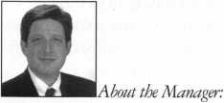

McMullen oversees legislative affairs for ALOA. He is a graduate of the District of Columbia School of Law and has an extensive background in legislative work. If you have information for Tim concerning federal or state legislation affecting the locksmithing industry, contact him at: ALOA; 3003 Live Oak Street; Dallas TX 75204; (214) 827-1701; (214) 827-1810; email: aloa@anet-dfw. com



**The Texas Locksmiths Association**

has established a fund for their legislative lobbyist.

As many of you know, last year legislation was passed in that state  
that was very unfavorable to Texas locksmiths. Those who would like to make  
a contribution to this effort may do so by making checks payable to:

Texas Legislative Fund  
Texas Locksmiths Association  
c/o Mike Clark, President  
P.O. Box 240937  
San Antonio, TX 78224-0937

Remember—fighting bad legislation for locksmiths in one state  
is good for locksmiths in the other states. Thank you for your support.

Jtlaster Hoctemttfjs &ssoctatton Beta Jergep

The Oldest Locksmith Association in the world

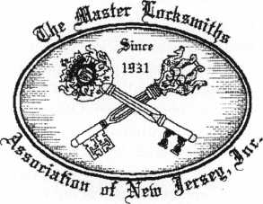

Invites you to attend our

Annual Lock & Security Show

March 26 through March 29,1998 in Somerset, New Jersey

For more information  
PO Box 2441

Morristown, NJ 07962-2441

Phone (973) 267-8884 Fax (973) 538-2248 [www.MLANJ.org](http://www.MLANJ.org)

Reader Service #1

February 1998

Keynotes

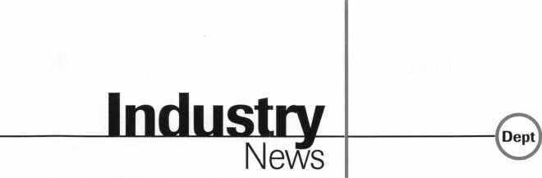

Big Decisions

The third meeting of the High Security Lock  
Manufacturers Council took place at Sargent  
Manufacturing in New Haven, Conn. It was  
decided at the meeting that for simplicity’s  
sake, identification of a “High Security Lock”  
would be limited to lock cylinders. Consider-  
ations were made for the future inclusion of  
tubular deadbolts, mortise locks, doors,  
frames, etc. Levels of high security were  
discussed including cylinders with both UL  
437 listing. Patented key blanks were given  
the highest rating, while non UL cylinders  
with patented key blanks and UL cylinders  
without patent-protected keys were graded  
lower. Final ratings will be determined at the  
next meeting. Initial discussions surrounding  
the insurance industry also took place. It was  
decided that Henrik Hall and Jeff Haversat  
would conduct and interview a representative  
of Chubb Insurance, insurer for the ASSA  
ABLOY Group, to determine the company’s  
awareness for the market and requirements  
for high security. A report of that meeting is  
to be submitted for discussion.

EG&G Florida  
employee, Bill  
Nichols, an ALOA  
member, was hon-  
ored at Kennedy  
Space Center, Flori-  
da. He was among  
those from across  
the nation who  
were selected for  
NASA’s Space

Flight Awareness Honoree Award, the high-  
est tribute paid to aerospace employees for  
commitment to mission quality and safety.  
The award is presented to less than one per-  
cent of NASA’s civil service and contractor  
work force each year. In addition to a number  
of activities held at the Kennedy Space  
Center (KSC) along with the launch, Nichols  
was among the group of honorees who  
visited Johnson Space Center in Houston.

Spreading the Word

Master Lock Company was honored by the  
National Crime Prevention Council (NCPC)  
-whose symbol is McGruff the Crime Dog®-  
for their continuing partnership in bringing  
crime prevention awareness messages to  
communities across the country. David

Campbell, president and CEO of Master Lock, received the award from John Calhoun, executive director of the National Crime Prevention Council. Master Lock has been a corporate sponsor of NCPC since 1993. During that time, the company has worked with police crime prevention units in hundreds of cities, distributed more than 600,000 “Home Security Tips Booklets” and recruited other businesses to take part in crime prevention activities. Consumers who access Master Lock’s home page can find crime prevention information and request a free “Home Security Tips Booklet.”

Election Time

The Greater Philadelphia Locksmith Association recently had elections for the new 1998-2000 Board. The election of new officers are as follows. President - Robert Mock; Vice President - John Magee III; Corresponding Secretary - Lou Gildenberg, CPL; Recording Secretary - Edward Fitzgerald, CML; Sargent of Arms - Edward Palwick. The Board of Directors are Nelson Dayton, CML; Ron Marcinowski, Jr., CRL; Robert Schutmmpf, CRL; William Young, CML; Ronald Blevins, CML; William Neff, CML; Fred Radich, CPL; Barry Wilensky CRL; Clifford Shafer, CML.

Be Careful

The National Insurance Crime Bureau (NICS) out of Chicago reported a potential safety issue dealing with side impact air bags. Recently, a Hillsboro County, Ohio Sheriff s Deputy was severely injured while attempt­ing to unlock a Honda Accura with a Slim Jim type tool. This vehicle was equipped with a side impact air bag that detonated during the unlock. The air bag forced the Slim Jim through the deputy’s throat causing serious injury. Anyone attempting to unlock a vehicle in this manner should question the owners as to whether the vehicle is equipped with such an air bag and use extreme caution while doing so.

Party On!

Over 2,400 guests took part in ADI’s gala ISC party tradition held this year at New York’s renown Tavern on the Green. The cel­ebration, which was co-sponsored by ADI’s family of manufacturers, included a sumptu­ous buffet, open bar, jazz band, continuous entertainment, Casino Room and a special guest appearance by music Hall of Famer

Blast Off

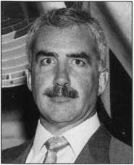

Bill Nichols

Franki Valli and the Four Seasons. ADI’s East Dealer Reception has become somewhat of a legacy over the years, and the tradition was carried out again in style at this, ADI’s 9th annual ISC East Extravaganza. Guests delighted in the hospitality consistently synonymous with ADI while enjoying a spectacular August evening in Central Park’s most charming haven. Luxury motor coaches were once again available to transport guests to and from the Jacob Javits Center, the Marriott Marquis Hotel and Tavern on the Green.

People, People, Everywhere

The American Society for Industrial Security (ASIS) 43rd Annual Seminar and Exhibits at the America’s Center, Sept. 8—11, 1997, drew more than 15,000 participants from around the world,, including more than 1,200 first-time attendees and persons who hadn’t attended in more than three years.

The ASIS Annual Seminar and Exhibits featured 130 educational sessions and 586 exhibiting companies occupying more than 150,000 square feet. Attendance figures included 3,528 educational program registrants, 5,939 Exhibit Only attendees and 5,681 exhibitor personnel, for a total attendance of 15,198 participants. The Educational Program and Exhibits Only attendees demographically were security directors/managers with decision making responsibility for organizations employing more than 1,000 people and security operating budgets exceeding $100,000 annually. In addition, the number of law enforcement personnel participating nearly doubled from previous years.

Linear, meet Stanley

Linear Corporation, a leader in wireless security, access control systems, and radio controls, has purchased the Stanley line of automatic vehicular gate operators from Whistler Corporation, the Birmingham, Mich., maker of radar-laser detection product line earlier this year as part of its acquisition of the Garage-Related Products Unit of the Stanley Works. The agreement was for an undisclosed sum. Linear plans to manufac­ture the Stanley operators as AccessMaster Gate System, to the same product specifica­tions through its Moore-O-Matic operating unit, in Waupaca, Wis. The Linear Access- Master Gate Systems line includes both

Keynotes

February 1998

swing gate and slide gate operators in light, medium and heavy duty versions to cover a fill range of residential, commercial and industrial vehicular gates. For configuring access control systems, Linear offers single and multiple portal controllers, telephone entry systems, receivers for adding radio control to an existing system.

Straight Arrow

The extensive line of Arrow Architectural Hardware is described in a new 38-page Reference Catalog now available from Security Lock Distributors. Contents include technical descriptions of all locks, cylinders, closers, exit devices and interchangeable cores plus complete information on options, accessories, functions and finishes. General specifications and dimensional data are also contained in the booklet.

New Continental Office

— Continental

Instrument^ LLC

John MacKeil office will provide

sales and customer support for Continental’s line of access control and industrial security systems in Georgia, North Carolina, South Carolina, Virginia, Florida, Kentucky, Alabama, Tennessee, and Puerto Rico.

John may be contacted in the Southeastern sales office at (864) 458-7461 or by fax at (864) 458-7462.

Renewed Vows

Schwab Corp. was founded in Lafayette, Ind., in 1872 and has been a mainstay ever since. According to company president Pete Neisel, there’s no intention of breaking up this long­standing union even though the manufactur­ing division has relocated to Cannelton. In the meantime, all administrative operation will stay put in Lafayette. Of the 70 people cur­rently employed at the Lafayette plant, approximately 40 management and adminis­trative personnel will remain at the Lafayette headquarters. Currently, Scwhab is searching for a new corporate headquarters location within Lafayette in keeping with the long­standing tradition between company and city.

|  |  |
| --- | --- |
|  | Industry |
|  | News |

■ Executive News  
New Director of Sales  
at DORMA

The DORMA group announced John C.  
Bergstrom as director of sales. With 11 years  
of architectural hardware experience,  
Bergstrom will assume responsibility for  
overall sales activity for the DORMA Group.  
All field sales agencies will report to him.  
Before joining DORMA, Bergstrom held  
two positions at KABA High Security Lock  
Co., in Southington, Conn., serving as sales  
and marketing manager for the company’s  
U.S. operation after being promoted from  
regional sales manager. Bergstrom was also a  
territory manager for Corbin Hardware. He  
began his career in sales as an inside sales rep-  
resentative for a Connecticut Branch of Car-  
penter Technology. The DORMA Group  
manufactures and markets a complete line of  
door controls and exit devices under the  
DORMA name and a line of postal  
specialties under the American Device name.

Tom Rubenoff has  
joined Security  
Lock Distributors  
as member of their  
access control  
products technical  
services group.

His primary  
responsibility will  
help customers find

solutions to problems related to the applica-  
tion, installation or maintenance of mechani-  
cal and electrical security hardware. Rubenoff  
has been in the security industry for over 17  
years, during which time he has worked as a  
locksmith, security products installer, and as  
a customer service representative.

ROFU

ROFU International  
Corp. announces the  
appointment of  
Robert E. Schaeffer  
as national sales  
manager. Schaeffer  
comes from a similar  
position with  
Dunbarton

Corporation and has over 10 years experience  
in the industry. He’ll be responsible for the

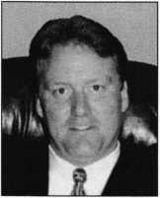

Robert Schaeffer

The Specialist

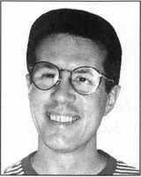

Tom Rubenoff

company’s sales of electric strikes, electro  
magnetic locks and related items in North  
America. He will be based in St. Louis,  
Missouri.

Addition at Marlee

Marlee Electronics  
Corporation  
announced the  
appointment of  
Owen Barclay to  
the position of  
director of Sales and  
Marketing. Barclay  
was selected for his  
experience in the

industry and the company’s confidence in his  
abilities to improve their market share.  
Barclay has 20 years of sales and marketing  
experience, with the last 10 years directly in

this industry.

Janis Honored

The Society of  
Certified Insurance  
Counselors (CIC)  
recently awarded  
Rick Janis, CIC, of  
Richard Janis  
Insurance with a  
certificate recogniz-  
ing his more than  
20 years of “steadfast

commitment to continuing education.”  
Earning his CIC designation and maintain-  
ing all update requirements for 20 years  
places Janis among the top one percent of all  
insurance professionals in America. Janis  
Program Administrators is the Locksmith  
Insurance Program administrator.

McElroy Joins Schlage

James McElroy has been appointed division marketing manager at the Schalge Commercial Lock Division of Ingersoll-Rand Architectural Hardware Group, it was announced by Charles V. Havill, vice president and general manager of the division. McElroy will have worldwide responsibility for all marketing functions of the Schalge Commercial Lock Division. He will report to Havill as a member of the division’s senior management team and will be based at the division’s Colorado Springs Headquarters.

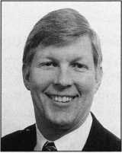

Rick Janis

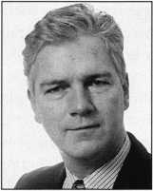

Owen Barclay

February 1998

Keynotes



Security

Marketplace

Alarm Lock Systems, Inc.

Alarm Lock Systems, Inc. a division of the NAPCO Security Group, is proud to offer its new 1997-98 product catalog. The brochure features an extensive section on the TR Trilogy digital access control lock, as well as a preview of the soon-to-be released DL3000 Series with audit trail. Featuring large, vibrant, color photos of its entire product line, this eight-page, information-packed brochure also includes in-depth specifications and ordering information on Alarm Lock's panic exit alarm devices and delayed egress exit alarms, including Models 250 and 260, and Models 700 and 710. Also well represented is Alarm Lock's line of advanced door alarms, the PG21, PG21E, and PG30, all narrow-stile door alarms with plug-in No-Cut Jumpers. In addition to these securi­ty hardware products are accessory items such as strikes, cylinders, and door pulls that round out Alarm Lock's product line.

NAPCO Security Group (800) 645-9445 ext. 64

Reader Service#10

Security Door Controls

Security Door Controls’ New “Heavy Duty” PSB560 “Sure Exit®” Request To Exit bar utilizes a new pressure sense technology that allows immediate release of EmLocks® for uninhibited egress. This eliminates perceptible movement and requires no prior knowledge to exit through a door.

Features include: Tri-Fail Safe operation with two redundant sensors and third automatic emergency release switch that bypasses all electronics and ensures continued door operation. It's unaffected by changing temperature and operates from 0° - 150°. Calibration is not required for installation unless more pressure is desired for higher security. It has auxiliary output for alarm shunt, CCTV activation or Annunciators as well as heavy-duty extrusion and metal mounting plates for durability in abusive applications. Sure Exit is handicap compati­ble and requires only the slightest touch of any object including your hand, clothes, gloves, prosthesis, hip, briefcase, package, cane or wheelchair.

Security Door Controls (805) 494-0622 (805) 494-8861 fax wunv.sdsecurity.com ***Reader Service* #i *1***

14 I **Keynotes** February 1998



American Lock

A new countertop display featuring padlocks for safety lock-out applications is now available from American Lock Compa­ny, a leading manufacturer of high quality padlocks and security accessories. The 8 1/2" wide by 13 1/4" high display board is designed to sit on a counter or hang from a pegboard, slatwall, drywall, etc. The board comes with one solid aluminum red padlock that is laser engraved to show American Lock’s unique capability to personalize locks. It also comes with one high tech composite Verton® padlock, with a red anodized aluminum nameplate on the front and back. Illustrations show American Lock’s four safety lock out hasp options. Headlines describing the eight standard color choices in both aluminum and Verton® padlocks complete the display. Mounting hardware is also provided. The display is suitable for showroom, will-call area or contractor pick-up desks of any business that sells electrical, building, plumbing and contractors’ supplies.

American Lock (800) 323-4568 ***Reader Service* #12**

All-Lock

All-Lock has announced the release of the following General Motors, Saturn, and Ford Key blanks.

KB6896 - Using GM’s Master 88 groove, this key literally supersedes all 1997 and up GM and Saturn Corporate Head key blanks, used on the 1997-98 Saturn, Oldsmobile Cutlass and Intrigue, and Chevrolet Malibu.

KB6471 - For the original look 1997-98 Chevrolet Malibu GM Corporate Head key. Plastic head with 75 groove.

KB6474 - For 1996 -98 Ford PATS vehicles with 8-cut system.

KB6475 - For the original look 1996-98 Ford 8-cut vehicle.

All keys are made of quality, nickel plated brass and plastic molded heads (where applicable).

All-Lock (800) 647-4926 ***Reader Service* #1*3***

Kwikset

Titan® will introduce its new Remote Key­less Entry Lockset (RKE) in the first quarter of 1998. This exciting product line offers the

ultimate in convenience and security by integrating conventional lockset engineering with the most secure form of radio frequency remote technology available. The new Titan Lockset allows consumers to lock and unlock their entry door with the touch of a button. The Titan RKE incorpo­rates Rolling Code Technology, an advanced form of radio frequency transmission. This technology makes it possible for the trans­mitter and receiver signal to simultaneously change access combinations each time the door is locked and unlocked. The continu­ously changing codes prevent code-grabbers from gaining electronic access to the home.

In addition to locking and unlocking capability, the Titan RKE Lockset also integrates supplemental features. This includes audio and visual feedback that confirms both locking and unlocking activa­tion, as well as provides low battery status. It also has a safety re-lock feature in the event of unintended activation. This feature will automatically relock the door after a brief interval, providing consumers with the peace of mind that their home is securely locked. A simple one-step operation provides trouble- free "re-keying" of the remote. Programming also reassesses all previously recorded remotes, providing the consumer with the assurance that their home is secured in the event of lost of stolen remote controls. **Kwikset Corporation 1 Park Plaza, Suite 1000 Irvine, CA 92714 (714) 474-8800**

Reader Service#14

Alternative Tools

There is a new kid on the block. Alternative Tools, Inc., is now producing a line of tools for the locksmith, that address problems from an alternative point of view. Their first three tools, “The Tool,” “Lever Up,” and the “Paddle Pusher” have been produced and sold with remarkable results. Keeping an eye on the sensitive nature of the tools they are producing. Alternative Tools takes steps to ensure their tools are only sold (by them) to locksmiths. Designed and tested by a

Security

Marketplace

practicing locksmith, the tools are sold at a comparatively modest price.

Alternative Tools, Inc.

162 Robin Drive Loveland, Co. 80537 ***Reader Service* #*15***

Nanotechnology

Nano-Lox-B is a push-button electronic access control system that uses a revolution­ary patented technology to enable a battery pack (3X AA alkaline) five year/2,000,000 operations at normal traffic. Incorporating a Schlage Rhodes lockset, the Nano-Lox-B250 and B125 provide 253 and 125 factory- programmed codes, respectively. Through the keyboard, a user, in about 15 seconds can (1) activate or deactivate groups of 32 codes or an individual code, (2) change an individual code, or (3) adjust code length from three to seven digits. The system also features two levels of master codes, lock-out mode and key override.

Nanotechnology 22997 Standing Oak Ct.

Cupertino. CA. 95014 (408) 973-8280 ***Reader Service #1 6***

GBC

GBC introduces the CW-350, an ultra­miniature ceiling/wall camera, so small it can fit in the palm of your hand. The GBC CW- 350 is the smallest, most, stylish, lowest pro­file ceiling/wall camera on the market. Mea­suring only 2 1/4" W x 1 3/4" H x 3 1/4" L and weighing less than two ounces. This discreet camera is designed to replace bulky, hard-to-mount ceiling cameras. The unique design of the CW-350 allows it to be mounted easily on ceilings or walls. Its miniature size inconspicuously blends into any decor. Providing the performance of cameras 10 times its size, the CW-350 is unique in the security industry. Though small in size, this discreet camera provides maximum performance. With over 425 lines of resolution and only .02 lux sensitivity the user need not sacrifice quality. The CW-350 comes standard with a built-in electronic shutter and four mm wide angle lens. Two point five mm, six point five mm, eight mm, and 12 mm lenses are also available as well as optional audio capability.

CCTV Corp.

280 Huyler Street

South Hackensack, NJ 07606

(800) 221-2240 (201) 489-0111 fax ***Reader Service #1*7**

Silent Witness

The V50 WedgeView camera by Silent Wit­ness incorporates a number of exciting inno­vations. This camera is the successor to the W50M WedgeView camera that has been installed in prisons, healthcare facilities, gov­ernment offices and residential areas. Compact and with a fully weather-sealed injection molded enclosure for indoor/outdoor use, the V50 WedgeView has an ambient operating temperature range of -20° C to + 50° C mak­ing it ideal for any environment. Cabling exits either through the rear or bottom of the unit. Not only does this offer increased user-friend­liness, but the cabling is completely hidden thereby making the V50 WedgeView applica­ble for high risk environments.

Silent Witness Enterprises, Ltd.

6554 176 St.

Surrey, British Columbia, Canada V35 4G5 (888) Buy-CCTV (604)-574-1527fax

Reader Service **#**18

Thomson Micron, LLC

DuraTRUE planetary gear heads from Thomson Micron provide a peak torque of 7,377 in-lb. with a standard backlash of eight arc-minutes. Ratios between 3:1 and 100:1 are available in 60, 90, 115 and 142 mm square frame sizes. The precision steel gears are hardened to HRC 60 minimum for long life. The self-aligning RediMount system simplifies mounting to motors, and factory-supplied lifetime grease reduces maintenance and downtime.

Thomson Micron, LLC 50 Alexander Court Ronkonkoma, NY 11779 (516) 467-8000 (516) 467-9814

Reader Service #19

Sisco

Announcing the first burglar resistant safes to carry the Brinks Home Security brand name, Sisco has introduced five solid steel models of Brink’s brand, Anti-Theft. The new line includes the first home model with a lock that opens using one’s credit card, such as VISA or American Express. Other safes in the line feature digital electronic locking mechanisms. The entry level Brinks Home

Security sale Model 5073 is a burglary resis­tant safe for valuables, firearms, medicine and other items requiring secure storage.

Sisco

1062 Del Amoro Blvd.

Carson, CA. 90746 (888) BY-SISCO (310) 638-6489fax ***Reader Service #20***

Thomson Saginaw

Thomson Saginaw “precision gear drives” that couple the high torque capacity of Thomson Micron TRUE Planetary gear heads with the positioning accuracy and dependability of Thomson Saginaw ball screws, and the mounting flexibility of Quick Mount bearing support blocks. Together these products combine to provide a convenient, fully-assembled, ready-to-use, drive unit. Thomson Micron gear heads offer three times the torque capacity of conven­tional parallel shaft spur gear heads, gear performance and space and weight savings. With Thomson Saginaw ball screws there is 90 percent plus efficiency when converting rotary motion to linear actuation and a choice of Precision or Precision Plus metric ball screws.

Thomson Saginaw 628 N. Hamilton St.

(517) 776-4123 (517) 776-3632 ***Reader Service #21***

G/O Corporation

G/0 Corporation's "Badgit" Neck Cord (lan­yard) is designed with a breakaway link that snaps apart when stressed. If a badge, compa­ny ID or keys become tangled or get caught on a piece of equipment, the breakaway link releases and the lanyard is freed. Once freed, the link can be reattached and the "Badgit" is ready for use. Aside from this built-in safety feature, the "Badgit" is ideal for those indi­viduals who wear glasses, hard hats, PPE or protective visors. Emergency situations may hasten the removal of keys or dosimeters.

The "Badgit" makes this possible with a simple snap of the breakaway link.

G/O Corporation 57350 Allen Road Slidell, LA 70461 (504) 847-0564

Reader Service #22

February 1998

***Keynotes*** ***All***

^Suppose the street outside of your home or business has been in a constant state of disrepair over the last few years. Or suppose that you’re embroiled in a dispute with a state agency over the issuance of a simple permit. Or suppose you want to express a forceful opin­ion about a proposed new federal regulation.

Elected lawmakers can help you address each of these issues— if you know who to ask, and how to ask. Besides enacting laws, debating proposed mles and regulations and providing oversight of governmental agencies, public officials provide information to constituents on the

MEET YOUR REPRESENTATIVES. Don’t hesitate  
to attend an occasional meeting of your town council or state  
legislature. Or attend the occasional open houses, town meetings  
or receptions sponsored by elected officials. Introduce yourself.  
Talk briefly about your business or profession.

MEET THEIR STAFFS. Many elected representatives,  
particularly on the state and federal level, have legislative and  
constituent service assistants. They provide research informa-  
tion, help draft legislation and field complaints and problems of  
constituents. Get to know them; they often influence the  
thinking of the legislators they work for. An added tip:  
assistants can also direct you to people in governmental agen-  
cies who can answer questions or help you solve problems.

MAKE YOUR CONTACT PERSONAL. It should  
comes as no surprise that personal involvement with your  
legislators is more effective than impersonal contact. When it  
comes time to let an elected official know your position on an  
issue, face-to-face visits and conferences will make a stronger  
impression than letters. Letters that speak about your personal  
experiences will make a stronger impression than mass-produced  
letters or telephone messages left with assistants or switchboards.  
And what about mass mailings of postcards or petitions?

They don’t hurt, but they often don’t help either. Another hint:  
elected representatives are slowly introducing electronic  
mail communications systems into their offices (even the  
White House can now be reached via e-mail). E-mailing  
communication, when available, gives you the opportunity  
for quick reaction to issues—and the opportunity for  
quick feedback.

litical Proa

workings of government and run interference for citizens who can’t navigate government’s increasingly complex machinery.

By understanding how you fit into all of this, you can learn how to work effectively with lawmakers.

You have both a right and a responsibility to work with your elected representatives to address issues that concern you, your family, your businesses and your community. Here are a few tips you can use to build solid relationships with legislators— and involve yourself in their work:

MAKE A LIST. Besides your federal representatives (a local member of the House of Representatives and two senators from your state), you are probably represented by two elected state legislators (most state legislatures and have an “upper” and “lower” house, like Congress) and a variety of local representatives: members of your city, town or village council and legislators on the county level. Add to this list elected executives (such as your mayor, sheriff, and other administrators), local school board members and elected members of special-purpose fire, water or utility districts.

Make a list of the names, addresses and telephone numbers of all your representatives, and update it once a year.

LEARN HOW GOVERNMENT OPERATES. If you want to participate in government, learn how decisions are made, how issues are researched, how committees deliberate, how legislation is brought to the floor. Remember that local, state and federal decisions are made in different ways, so an understanding of each level of government is essential. This way, you can be sure you direct inquiries to the right people.

GET INVOLVED EARLY. The mle of thumb: Don’t react. Act. If you find that existing legislation doesn’t work, explain how you’d change it. If you feel that proposed legislation is poor public policy, offer your analysis. Volunteer to serve as an advisor on a particular issue or subject matter.

TRACK LEGISLATION. Concerned about legislation in the works? Many legislatures have a telephone-accessible legislative tracking service.. Find out if your state or locality has one. Many legislators maintain mailing lists of people concerned about specific issues. Ask that your name be placed on the list appropriate to your concern. And ask that drafts of legislation be sent to you for your review and comment. The internet is also an excellent reference for tracking legislation STAY INVOLVED. Legislation results from a lengthy, and often awkward, process. To stay involved throughout the whole process, learn the names of the citizens or business groups pushing for or against a particular issue. Monitor their actions. Most legislation originated with sponsors and is then considered by committees. Find out which elected officials are sponsoring proposed legislation you favor or oppose, and which committees will be considering it. Make your views known to both the sponsor’s staff and the committee in question.

TESTIFY. When elected officials call public hearings or invite public comment on issues of importance to you, speak out. Thoughtful, insightful comments from interested citizens make a real difference as legislation is considered.

“Testimony,’’incidentally, involves more than public, in-person comment. You can offer evidence and examples in

Keynotes

February 1998

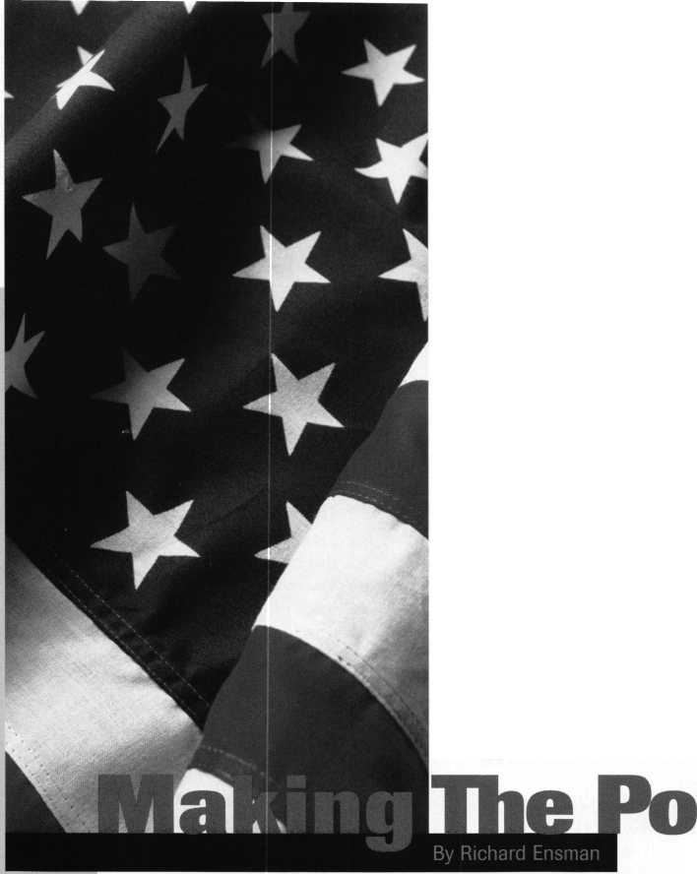

INTERCHANGEABLE CORE PRODUCTS

Interchangeable

with:

•BEST • ARROW •FALCON /

Quality **•** Price ***Delivery***

That's what KSP is all about

KILLEEN SECURITY  
PRODUCTS

Ask your wholesaler about  
our drop shipping.

Reader Service #2

Reader Service #3

February 1998

Keynotes

CONTROL

***33 Herman St.  
Worcester,* M4 *01610  
Phone (508) 798-3200  
Fax (508) 753-2183***

writing, and ask that it be included in the public record. You can send copies of authoritative editorials or articles favoring your viewpoint to officials. And if you happen on any research that’s been conducted on an issue at hand, forward it to the appropriate legislator or committee.

DO YOUR HOMEWORK.The federal Freedom of Information Act gives you the right to obtain and examine most public papers, research studies, contracts and memoranda relating to the issue you’re studying.

Most states have similar FOI laws. Public documents can give you valuable information on a particular issue, and help you shape your response to current or pending legislation. While you may encounter a slow response in some instances, the cost of obtaining documents is low—usually copying fees only. Some exceptions to FOI laws do exist, of course. These typically involve personnel records, sensitive contract negotiations and confidential law enforcement and national security data. Most governmental agencies have a FOI or Public Information Coordinator; call this individual to find out how to use the law.

GET INVOLVED IN RULE-MAKING. Stay involved even after legislation has been approved. Once complex legislation is signed into law at the state and federal levels, it’s usually passed to an administrative department for rule-making; the department develops regulations, procedures and funding mechanisms for implementing the legislation. As part of the rule-making process, interested citizens can offer proposals and suggestions, which may be incorporated into the final implementation plan. As part of the process, you’ll usually have the opportunity to submit written and verbal suggestions for the implementation of the law.

USE ALOA TO KEEP TRACK OF THINGS. Don’t hesitate to contact ALOA’s headquarters or legislative manager for information, or to offer suggestions.

isWork For You

VOTE. It should go without saying that you should never miss an election. That goes for school and special district elections as well. And if you have the time and inclination for public service, every community need qualified candidates for office.

SERVE ON COMMITTEES. Many elected officials have set up citizens advisory committees and, in some cases advisory committees dealing with specific issues. Volunteer to serve. If you can’t find a committee or task force that covers your concerns, offer to form one. And don’t hesitate to serve on legislative advisory committees organized by your own trade or professional association.

BE REALISTIC. Public officials often get a bad rap for compromising. Yet compromise is part of and parcel of the political process. While you can (and should) insist that your perspectives be considered in the legislative process, never forget that other people, who may not share your views, expect the same. Not every issue demands compromise, but some do. Understand and expect this.

THANK OFFICIALS FOR THEIR HELP. A brief personal thank you” note is a great way to express your gratitude to an official who has helped you. And it reinforces the importance of offering additional help in the future.

REMEMBER THAT THERE IS STRENGTH IN NUMBERS.

Join organizations that are concerned about the same things you are. Speak with a united voice to lawmakers about the directions you’d like to see in the future. If you can’t find an organization that deals with the issues you’re concerned about, consider starting one; even an informal group of citizens or business people can make a difference.

About the Author: Richard Ensman is a freelance writer for trade and business magazines.

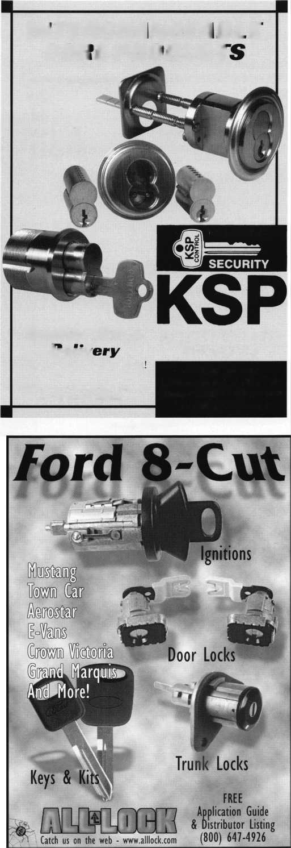

*{Editor’s Note: The following is the first installment in a series of articles by Steven Spiwak who many of you may remem­ber over the years from his classes, books or his articles in* Keynotes, Ledger, National, *etc.(see authors bio). We’re happy to have him back ivith us after a fairly long absence. Steven is planning to write on a variety of topics over the coming months, and he decided to start out with a series that “takes the high road,” as he puts it, and makes us all think about why the profession of locksmithing even exists in the first place. It’s surprising how often the everyday problems in our professional lives are often m uch simpler to solve if we ha ve a solid overvie w of who we are, and why we do what we do. So, as the words to a popular Disney song go...*

*“Let’s start at the very beginning.* —*A.Davis}*

Basic Human Needs

Scientists tell us that there are four basic human needs, namely: food, clothing, shelter and reproduction. All of which are essential to the healthy existence, continued growth and ongoing evolution of mankind. During this course of study, we will concern our­selves with the concept of shelter, shelter in particular as it relates to security.

The first evidence of the need for security can be traced to those ancient ancestors that we now familiarly refer to as cavemen. These early men retreated to caves in order to pro­tect themselves and their clans from a variety of enemies including, but not limited to severe weather, unfriendly tribes and danger­ous animals. Each of these enemies threat­ened their very existence on a daily basis.

In order to survive, early man had to develop a security system for protection, particularly at night when he was asleep, and therefore, at his most vulnerable. In fact, a solid argument can be made for the campfire strategically placed at the only entranceway into the cave before they went to sleep in the evening as the world’s first “lock,” or at the very least the first form of access control.

What then are the primary functions of a security system? Are the overriding concerns that we have today all that different from those that faced our ancestors? We will find that while the methodology utilized in the modern era to protect and to compromise that protection are infinitely more sophisticated than they were millennia ago, the basic philosophy behind those systems has changed very little.

Protection

There are two categories into which the overall concept of security can be divided. The first is protection. We use security to keep people and products safe from harm, but there are two important distinctions.

In some cases, security is designed for the expressed purpose of prevention. Preventing unauthorized people and products from gaining entrance to a specific or secured area. A good example of this use for security is an airport. In this case, those passengers who do not have a valid ticket for travel at a given time on the day in question are not allowed beyond a certain point that is specifically reserved for passengers. Furthermore, specific products that may not be intended to harm, but that have the potential for harm (incen­diary devices, firearms, caustic chemicals, etc.) are not allowed beyond the same point.

Another consideration is the level of secu­rity. This is the degree of complexity that you must implement to safeguard the per­son, or item which you are trying to safe­guard from harm. To put it quite simply, it

***Keynotes***

February 1998

is infinitely easier to gain entrance to your neighborhood movie theater without a tic than it would be to gain entrance to that most famous of United States depositories, Fort Knox.

Security is also used for the expressed purpose of preventing unauthorized people and products from being able to leave a secured area. The most obvious example of this would be a prison. The greater the degree of danger posed by the inmate population, the greater the complexity of the safeguards that must be put in place. Standard keyed locks would not only be the only line of defense. Electromagnetic locks, closed circuit television cameras, and other commonly used access control oriented alerting devices would be used as well.

The most common example of the use of security in preventing unauthorized products from leaving a secured area would be seen in the prevention of shoplifting.

All items of value in a clothing store for example, are tagged. Should unauthorized personnel attempt to remove these items from the premises an alarm will sound and/or lights will flash as they pass through the “tag detector” (in reality an electrostatic type proximity detector). This would alert authorized personnel to the fact that a store item is being attempted to be removed from the store that has not been detagged. At this point, it cannot be determined that a theft is occurring. A mistake by a clerk may have allowed the tag to remain on the item, or perhaps this particular item was tagged twice in error and only one of the two tags has been removed.

Privacy

The second use for security lies in the area of privacy. The concept of privacy as it relate: to security can be divided into three differen categories under the major heading of delin­eation - namely: aesthetics, functionality, and exclusivity. Delineation is a concept based on the fact that you can define an area in at least three ways to indicate that a particular area is private property, and that entrance beyond the area that you have delineated is prohibited.

The first manner in which you can delineate a secured area is aesthetically. Aesthetics are the simplest, most pleasant, and most often used means to achieve a minimum security status in a public area.

In fact, an entire new area of security has grown up around this concept. This new concept in security is most often referred to as crime prevention throughout environ­mental design. After all, who says that just because something looks pleasing it cant be secure? In fact, simply by using pleasant

18

looking in neat, uniform rows around the border of your property, you can discourage access. Colorful signs that inform and define an area without threat or warning also fall within the realm of aesthetic delineation. Even certain types of fencing are designed to provide additional beauty to the property in question, in addition to keeping people in or out.

The next form of delineation is the functional variety'. A functional fence would be one that can be compromised,

reserved exclusively for them. A master keyed lock system would be a good example of this type of system. The master key in a large building will enable the exclusive holders of this key to gain entrance to any of the one hun­dred offices on our imaginary premises. However, those individuals below this exclusive level may only gain entry to their own office and the common areas (garage, restrooms, etc.). This type of system has many applications for use in large institutions or similar settings where there are, in fact, a number of clearly defined levels of security for the personnel - such as the military.

The Fundamental Theory of Security

The statement most often heard by many locksmiths and security specialists is, “locks are only meant to keep honest people out. Professional thieves will always find a way to get into your house or business.” This statement is simply not true. If it were true, I would not continue to be a locksmith, or to be con­stantly writing and speaking on various subjects within the field of security.

I have an answer for those people who truly believe the statement above. It is called the “displacement theory of security.” It is the most honest rebuttal to the other scenario. I am going to explain it to you now in detail. Once you are familiar with this theory, it will answer any questions that you or your customers may have concerning the validity of those persons who have chosen the security field in general, and the field of locksmithing in particular as their lifetime vocation (or in my case and many others like me, my avocation).

* Motive
* Means
* Opportunity

The triangle above is a mnemonic learning aid. Memorize it. It will help you to indelibly etch this theory into mind. It is fairly common knowledge that if someone has the will to do some­thing, a strong enough motive, they will find a way to do it. Simply stated, “where there’s a will there’s a way.”

Those of us involved in the security industry do not believe that in the near future anyone will find a reasonable and cost effective solution to the problem of curbing the motives for theft. We therefore do not choose to attack the problem in this manner.

The means to commit crimes are unfortunately available everywhere in

but not without moderate effort. A four  
or five foot high wooden or mesh fence  
would fit this requirement. A standard  
deadbolt lock would secure the door  
against attempted break in, but not  
to the point where sophistication or  
persistence would not enable a thief to

are ones

gain entry. Functional signs

that are straight forward in presenting  
essential information. “No Trespassing”  
or “Do Not Enter” signs qualify as  
functional. Most important is the fact  
that the tone used in the message is  
informative and non threatening.

The last form of delineation is known  
as exclusivity. This is the most sophisti-  
cated and restrictive form of delineation.  
Exclusivity enables certain authorized  
persons entry into a secured area at  
specific times, but not at other times.

In effect, this form of delineation will  
allow only those specific people who  
have received the necessary authorization

February 1998

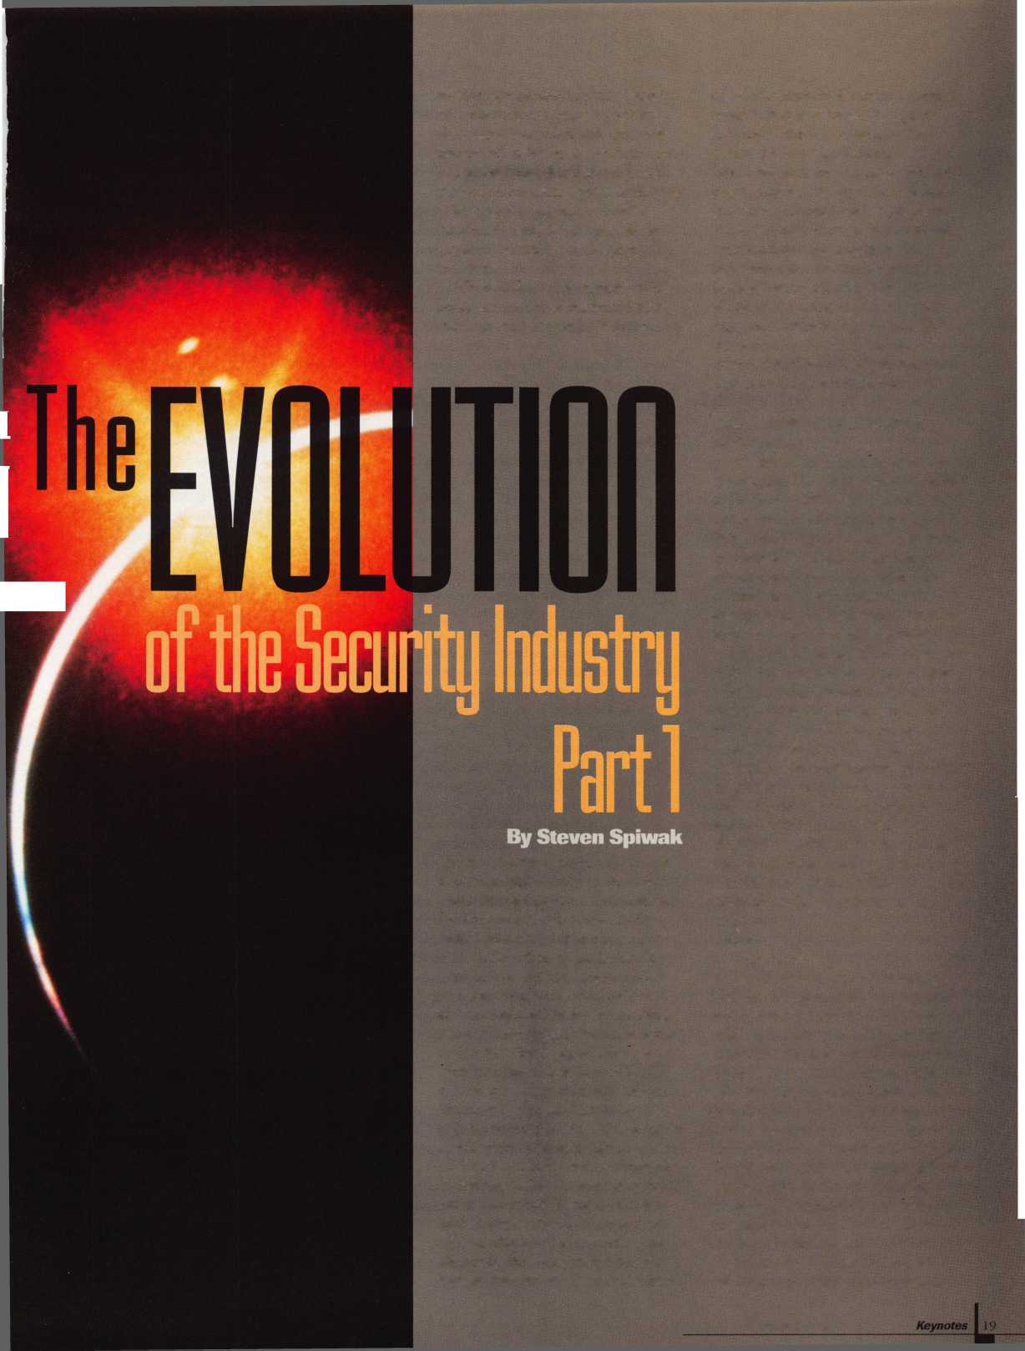

our society, including television. Everything from lock picks to battering rams to guns can be purchased quickly, conveniently, inexpensively, and often times legally!

Anyone wishing to commit a crime can find the means to attempt a crime. Fortunately, it does not mean that they will succeed.

The last element of this triangle is opportunity. Most crimes in this country are crimes of opportunity. Unfortunately, most individuals are not really aware of those factors that make it easier for the thief to succeed, while at the same time cutting down his chances of being caught after the act has occurred. The fact of the matter is that the displacement theory does work.

Here is how I can demonstrate this theory in action in the real world.

Take any standard residence. There are usually two minimum security key-in-the knob locks on the front and back doors.

These types of locks are extremely easy to compromise. A potential thief would have little or no difficulty in gaining entry. What would this thief accomplish if he were successful? Most surveys indicate that the average home would yield about $50 in cash, some inexpensive jewelry and a color television set.

Now let us take that same thief as he looks at his next potential target: a house with deadbolt locks on both doors in addi­tion to the key-in-the-knob locks, window locks on each of the windows, and a good watchdog (notice that we are not even considering an alarm at this point in our discussion). The thief looks at his potential target and analyzes the situation. The likely monetary return for his efforts at the second house will yield about the same results, but his chances of getting caught are infinitely higher. Therefore, his chances for success are lower. So, do you know what he decides to do? He chooses another target. One where the opportunity is greater. Where the upside outweighs the downside.

It is precisely this type of thinking upon which the theory of displacement is based.

By taking reasonable measures to secure your house or business, you can discourage the potential thief from seeing your house or business as a golden opportunity. Therefore, if you take reasonable measures (under normal circumstances) that are necessary to secure your home or business, the potential thief will avoid your property in favor one that is an easier target. If everyone on your block takes the same reasonable security measures as you, then the potential thief will avoid your block. And if everyone in your neighborhood takes the same measures, the potential thief will avoid your neighborhood. In fact, you will have successfully displaced a

significant degree of opportunistic crime from one area to another. Hence, the term “theory of displacement.”

The Three Fundamentals of Security

There are three major categories for defin­ing the security materials and procedures implementation: physical, electronic and human. Each of these three categories has a very specific role to play in a total security program. Physical security, as its name states, is designed to delay and/or prevent autho­rized entry into a secured area by physical attack. Physical security utilizes heavy bolts, reinforced jamb strike plates, armored collars, and assorted peripherals (cover plates, door edge guards, etc.) to accomplish its intended purpose.

Electronic security as its name states is designed to detect break-ins, create a sense of urgency in the thief, and alert authorized personnel to the fact that there is a current problem to which they must respond. Electronic security is characterized by access control devices, panic hardware, alarm systems, closed circuit television cameras, etc. all of which are specifically designed to accomplish its intended purpose.

Human security is designed to be the final piece of the security puzzle that provides the tie that binds all the other elements together - the human factor, is one element that can overcome any attempt at compromise. The one element that can react to the unexpected. Aside from the obvious decision making capabilities and responsibilities provided by the human factor there are other important aspects of a security system that can only be provided by man. Such responsibilities include guarding people or property where electronics or mechanicals can’t go.

Perhaps the most important of the human responsibilities is the element referred to as response time. Response time is the amount of time it takes for any or all of the autho­rized personnel who are on duty in positions of responsibility to respond to a given situation, whether that involve fire, burglary, or any thing else of an emergency nature.

The Three Fundamentals of Compromise

There are three major categories for defining the methods for defeating or compromising security, namely: finesse, force and coercion.

Finesse is the ability to gain unauthorized entrance to a secured area without causing any damage and without anyone even being aware that a compromise has occurred. Finesse opening can take such basic forms as lock picking, key impressioning, shimming,

bypass, pinpoint drilling, decoding and manipulation. The greatest danger posed by finesse opening techniques is the fact that the individuals, institutions or companies that have been unknowingly compromised are often times not covered by standard insurance policies. This occurs because there is no evidence of a break-in, but rather evidence only of ineptitude or a failure of those in charge to provide the necessary level of security.

Force is the method of choice when the intruder’s presence may be known. When stealth is not a necessary component of the ability to compromise the security in question, force is a viable alternative. Such techniques as: kicking in a door, explosives, gross drilling procedures, bolt cutters, freon caustic substances, etc. are utilized by the would-be thief. Force is more often used in more burglaries and takes the form of the deadlock bolt being forced back into the lock housing and out of the door jamb strike plate. This also occurs when the spring loaded latch component of a key-in-the- knob lock is compromised in the very same manner.

The final method of choice for thieves involves an area of security that few techni­cians ever get involved to any degree except under the most unusual circumstances. Coercion becomes the method of choice when neither finesse techniques nor force methods will prove to be successful. The thief or terrorist resorts to kidnapping a person or persons, explosives (threatening large groups of people), or anyone of a number of other nefarious possibilities that tend to attack the psychological weaknesses in the human condition, rather than attacking the decreasing number of signifi­cant weaknesses in modern sophisticated electrical or physical security systems.

Next month: Part 2, Applied Security Theory and Locksmith History

About the author: Steven B. Spiwak is a fourth generation locksmith who specializes in a variety of variety ofareas including crime prevention and institutional security. His broad experience in the security field spans 20 years of writing, teaching and consulting. Spiwak’s lengthy client list includes Ford Motor Company, Exxon, The Chicago Tribune, Sears, West in Hotels, the U.S. Treasury Department and the Federal Bureau of Investigation. Most recently he formed Lockport, Inc.—a security consulting compa­ny for industrial, commercial, institutional and gov­ernmental clients. Readers with article suggestions or requests for him can contact ALOA at email publ@anet-dfw. com or fax to (214) 827-1810.

Keynotes

February 1998

**Is Your HomePage Floating In**

fyKHagf jto- A

file Edit View Go Favorites Help

Address:| <http://www.ourcompany.com/home.htm/>

£° Favorites

W f l

* "Bnikirt ® ■•"•fit*

® •Network ® News I

**http://www.stmo n-ne t. com**

**[www.ourcompany.com](http://www.ourcompany.com)**

•ourcompany.com

**Welcome to**

**The Security Information Management On-Line Network**

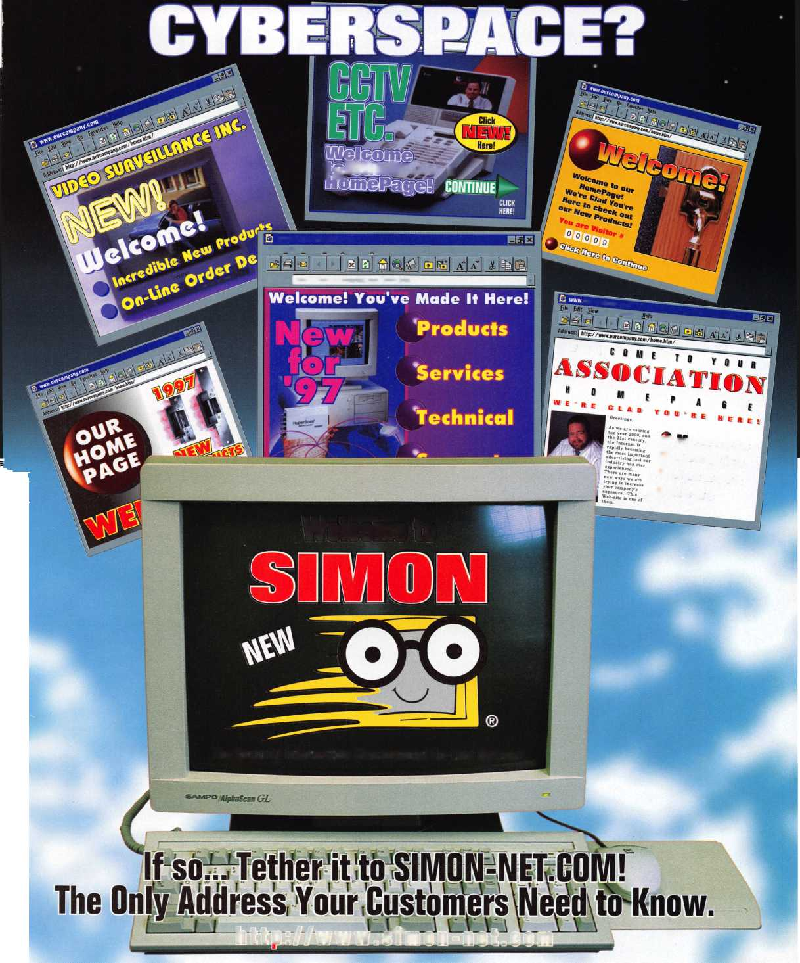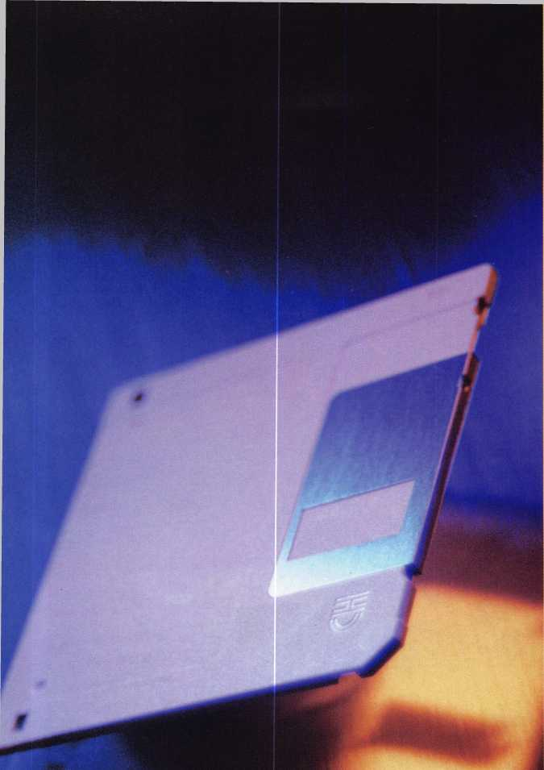

twE OVERJJUHELminC SUCCESS OF componiES likj ITIicRpsoFt, intEL AnD CAtEWAY DEmOllStRAtE OUR^ SOCIEtY'S CRpwinC nEED FOR^ COtT1PUtER§ AnD COfflPUtERJVILAtED SERyiCE. inDEED, EVERY BUSinESS FRpm CAnDY mAKinc to WEAPons mAnUFACtURinC RJQUiRJS SOfflE DECREE OF A VtOtT! Ation tO REfTIAin comPEtitivE Amoncst its rivals. 1"he LOCRgmitNinc inDUStRY is no ExcEPtion.

**BusinESS**

**Software**

**FORSltiALL**

**Shops**

**By** Derrick Frazier

Simple services from inventory control to invoice prepa­ration, even entire office management, can make it easier for small businesses to accomplish more in less time.

Many small business are reluctant to invest in com­puter technology because of the large initial expenditure that it usually requires. Entire systems—this would include the computer with monitor, printer, and startup programs—can easily run up a bill of a few thousand dollars. For the penny-pinching owner looking to cut costs at every angle, such a large investment may not seem worthwhile. What is often overlooked are the long term rewards that automation can provide. Performing time-intensive tasks such as logging inventory, writing invoices and updating calendars takes manpower — labor that could be used for the real purpose of a small company, to make money. Every hour an employee spends dealing with paperwork is an hour that a compa­ny throws money away. Instead of figuring how many pick sets are still in stock, an employee could be in the field working with a client, bringing in profit instead of taking it away. The solution to eliminating this paperwork can come through the use of computers.

Once the investment is made, the small business owner will marvel at how quickly a computer can pay for itself. With simple to understand programs, inventory management can be done with the touch of only a few buttons. The size of the inventory will dictate how advanced a system one will need; however, there is a right program for everyone. And for those businesses that do not find themselves with any great amount of

**22 | *Keynotes***

**February 1998**

stock at one time, there remain numerous other areas that a computer can make running a company easier.

Writing invoices, no matter what size your lock- smithing company is, can be both annoying and time consuming. Handwriting can be difficult to read and its presentation can be unprofessional in the eyes of potential long term clients. With only the most modest of com­puter systems, invoices, and other forms can be written from a keyboard and printed out, creating a flawless, legible document. In addition, the invoices can be filed away on a disk, eliminating the need for large file cabi­nets that take up valuable office space. At the touch of a few buttons, one can find an invoice written five years ago. Imagine how much time it could take looking in a moderately maintained file cabinet. Computer generated files allow for more thorough record keeping.

Many locksmiths that own their own business find themselves stuck at a desk for more hours during the day than they care to be. Instead of waging a paper war in the shop, a computer would allow owners to return to the field where the money is made. There are entire programs devoted to running an office, creating time where there once was not. Calendars, address books, employee work schedules, electronic checking, monthly reports and countless other tasks can all be automated, allowing for the most efficiently run office in half the time and for less money than a person could do it.

The many applications of the computer for small busi­ness by themselves are guaranteed to save considerable time and money. On a broader scale, the advantages become even more spectacular since through the use of computers and computer based technology, a small busi­ness is more apt to compete in a market against larger competitors. Computers, in a sense, level out the playing field of small companies against bigger rivals. No longer is manpower as great a limitation as before. Certainly a smaller company would be hard pressed to eliminate a larger competitor but even swaying a few percent of a rival’s share of the market can mean the difference between success and failure.

Automation, even on a small scale with the use of only an average up to date computer and a few programs, can allow the small businessman to see both an increase in profits and in time. Eliminating unnecessary paper work, appearing more professional, and increasing overall office efficiency can only work to improve the life of a small business owner. To prevail in any industry, locksmithing to be certain, efficiency serves as the reason between success and subsequent failure. Those who spend less time at a desk and more time increasing their client base, or working in the field, actually being paid for their time, are guaranteed to have the larger profit margin.

In the grand scheme of things, computers can help small companies grow into larger, more competitive ones. In

the locksmithing industry, computer technology is the small business key to success, a key that should not be overlooked.

Although there are many different software packages available with most computer systems, here are a few along with how that would best help a small business. Don’t take my word for it though. Go out and experi­ment to find what’s right for you.

**Computer Software  
Packages:**

Intuit’s

Quick Books -

Bookkeeping

Soft Key’s  
Office Mate -

Invoices, requisitions,  
misc., forms

Peachtree  
First Accounting

Accounting forms,  
bookkeeping

Symantic’s ACT!

Client name lists,  
phone numbers,  
jobs performed

Kidasa  
Software’s

Milestones -

Employee time  
management,  
project  
timetables

About the Author. Derrick Frazier is a writer and novice computer guru who since, discovering the wonders of the computer age, spends his free time trying to automate his own office. He holds a bachelors degree in cultural anthropology from the University of North Carolina at Chapel Hill.

February 1998

Keynotes

k=



sM&iM

felow employee,

Tl'cs ytwt$ IMeas ^MMcDckwMPs cVijcVen t < Bring y^» M veiftpes, ssi^ spw

**Date/Time**

**Button**

Keynotes

kCompute3|®| increasingly becoming an accepted parttef ordinary pveryday life. More and more households  
have at least one computer^ and many homes wifi have more than one. Although not as plentiful as televi-  
sions, lower price^vill probably boost the numbers of personal c omputers owned by consumers to an even  
greater extent.

In the past, thStereotype was a 12 year-old as genius computer nerd virtually glued to his keyboard  
while his paients were totally confused and intimidated by these electronic gizmos. Meanwhile grandma and  
grandpa were so frightened of this newntechnology that they didn’t even want to know what it was.

Times have changed. It is not that gmusual anymore to see gray haired older folks sitting in front of their  
|||Computers as much as some kids. Greater marketing and easier to use computers are a good part of the reason  
for this expanded ownership and use of computers. Even though computers are not as complicated to use as in  
years past, deciphering and understanding the information in software user manuals can still be frustrating.

If you are really determined and spend many hours experimenting, you might be able to figure it out on your own. Deciding that you don’t have that much free time available, if could very well cross your mind that a little bit of classroom training or tutoring might be in order.

Locksmiths who are nearly always on call sometimes find it extremely difficult to plan very far in advance. You might be interested in taking that very interesting sounding computer class, but they meet every Wednesday evening at 6 o’clock. If a job runs long you might not get there in time, and there goes your money down the drain. If only they had a class that worked around your schedule.

If that describes your situation, you may have been curious about a more flexible training program. Maybe you should be watching more television. No, not another worn out sitcom, but instead an instructional videotape. There are exercise workout videos and there are other how to training videos, so it shouldn’t be too much of a surprise to know that a number of companies produce videos on how to use your computer.

February 1998

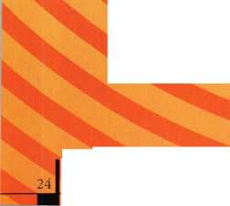

*Your Own Little Couch Potato School*

I guess you can’t ask for much more than the privacy of your own home and the comfort of your well cushioned sofa to get an education. Now don’t get too comfortable. You still have to watch the videos to learn anything. Sleep learning is not yet available.

A company called Video Professor Inc. produces computer related technical training video tapes. They make instructional tapes that show you how to figure out and use the different operating systems such as DOS or Windows 95, plus a broad selection of tapes covering many different popular software titles. There are instructional videos for many of the name brand word processors, spreadsheets and more.

After you pop your video cassette into the VCR and start the tape, you’ll see an introduction at the beginning of each video. The introduction and explanation by the president of the company explains what is included in the instructional video and how it is paced.

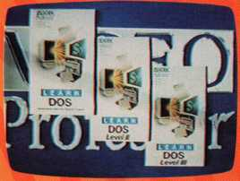

*Keeping Pace*

The tapes are approximately an hour in length, and for many software  
titles (or subjects) there are three parts in a series. Divided into levels 1,

2 and 3, some of the more common or simpler commands and features  
of the particular software are usually covered and explained in the lower  
levels. The level 2 or 3 tape will often cover more advanced skills or more  
complicated commands.

Right about now you might be doing some simple arithmetic in your  
head, and realizing that (even with three tapes) you would end up with

not more than three hours of instruction and training about a particular piece of software. A formal

classroom course on the same subject (or software title) would probably run eight hours, and even

with lunch and other breaks you’d still end up with at least six hours of classroom time. Three  
hours compared to six hours; something doesn’t seem to add up.

The big time differential has to do with pacing. Regular classroom training and video  
training are two completely different environments. In a classroom, the course will often go  
no faster than the pace of the slowest student in the class. Plus there is repetition and exercises  
to aid the students in retaining the information. Individual video training lets you go at your  
own pace. You don’t have to keep up with anyone other than yourself.

Videotape only needs to say something once. The infamous rewind

button allows the viewer to repeat the same information over

and over as often as is necessary. So a three minute segment  
repeated five times is effectively 15 minutes of reinforced  
training. Parts that you understand after hearing only once  
don’t need to be repeated.

In the company president’s introduction, he explains that  
the video moves at a fairly brisk pace. Things are shown and

explained in considerable detail, but they do move along quickly.

They presume that if something was not entirely clear, you would repeat  
the particular segment until you understood it more clearly.

***Relativity***

While viewing some of the tapes, I got the odd sensation that some segments dragged on endlessly

while other segments zoomed by without giving me time to catch my breath. It almost seemed that  
they spent way too much time in certain areas and greatly neglected others. After closer examination,

I realized that each subject covered was pretty much evenly paced.

I discovered the problem to be a matter of personal perception based on whether  
or not I was already familiar with a piece of software or at least specific features or  
functions of that software. If there was a feature or function with which I was completely  
familiar, a two minute explanation would seem like 15 minutes. I would be thinking to  
myself, "I understand already, get on with the next subject.” If it was something with  
which I was unfamiliar, that same two minutes might seem more like 15 seconds.

Obviously, the maker of the video can’t presume who knows what already. The only  
thing they can safely presume is that the viewer is not knowledgeable about any of it.

If the viewer has prior knowledge, he/she only needs view that segment once. If the  
information is completely foreign, they can view it over and over. As a wise guy once  
said, ‘'That’s why they have rewind buttons.”

*Graphic Aids on Screen*

Most of what you see on screen is a video representation of what you would normally see  
on your own computer screen when you run the program. You will also see titles and other  
graphics that point out things to do or things to observe (such as photos 3 and 4) while you are  
learning how to use a particular piece of software.

Unless you have a VCR in the same room as your computer, you will probably end up view-  
ing the tape first and then experimenting with the software on your computer later. In certain  
areas, you will probably have to refer back to the video to make sure you are doing things correctly.

I recommend making up your own special index of important places on the videos. The video pack-



NEW ILCO DISTRIBUTOR!!

Monday Security Corporation  
**1-800-886-6721**

Contact Laura for details  
on dealer discounts

We carry almost every make  
and model of new and  
used safe deposit locks,  
and safe parts, specializing  
in the antique parts.

Have you received our  
catalog?

Reader Service #4

Who Says There’s No Such Thing as



***1-BOO-UNLOCKS,***

Nationwide Automated Dispatch Network

Introducing 1-OOO-UNLOCKS. , the nation's first and only network of quality assured lockout service providers and automated dispatch service. Here's how it works. This advanced AT&T/ULI technology gives you an awesome advantage over your competition. Any lockout in your exclusive and protected territory is automatically routed to you faster than greased lightning. The 1-800- UNLOCKS automated dispatch service turns your phone into a 24 hour cash machine. Its that simple. You get the benefit of exclusive use of a powerful and extremely memorable toll free telephone number, co-op advertising for your local market, and professionally produced yellow page, radio, television and direct mail advertisements that are certain to build and grow your business dramatically.

Licensed territories are going fast. And once they are gone, they're gone. Call immediately to receive your free application to become a quality 1-800-UNLOCKS service provider

Call NOW to reserve your territory before your competitor does! 1-888-865-6257, 24 hours.

aging has an index on it with digital readout locations for specific  
technical information. The coincidence of 1100 on your VCR’s digi-  
tal counter being the same as the machine used by the video compa-  
ny is probably not very likely. Save yourself the hassle and make  
your own index.

***Video Training on CD-ROM***

Video Professor has recently introduced CD-ROM versions of their  
training tapes. I have not seen any of them yet, but I’m presuming  
that they contain the same information. One distinct advantage I see  
in the CD-ROM versions is that you can view it on your computer  
screen and not have to run back and forth from your computer to your  
television and VCR. These CD-ROMs are “view only.” It is like the  
video, but you just watch it on your computer screen instead of your  
television. Their internet site seems to indicate that interactive  
versions of the CD-ROMs will be available in the near future.

***Ordering Training Tapes***

Shown here are some of the  
titles offered. In a current  
promotion they are offering  
either a video or CD-ROM free  
(only a $4.95 shipping charge)  
choosing from their nine most  
popular titles: Windows 95,

The Internet, DOS, Word,

WordPerfect, Excel, Lotus  
1-2-3, Works and Quicken.

The regular price for the videos seems to be $39-95, but in recent  
times they have advertised a variety of special promotions and offers  
with different pricing structures. One program had a free trial  
review and a charge of $39-95 if you kept the tape, followed by a  
free bonus video. Other programs I saw had other discounts when  
purchasing multiple tapes. My recommendation is to just call them  
at (800) 554-2050 to find out what the current program is. This  
number is an order line only. If you wish to reach customer service  
or get any other information from the company itself, you can write  
to the company at: Video Professor, PO Box 150741, Lakewood, CO  
80215. Their phone number is (800) 323-8990, which can be  
reached during business hours. You can find them on the internet at  
[www.videoprofessor.com](http://www.videoprofessor.com).

If you have a very unpredictable schedule but still want to  
improve your computer skills, these videos might be the ideal alter-  
native to classroom training.

On a personal note, I had intended to list my e-mail address  
at the end of my articles, but hesitated because I had just started  
with a new internet service provider and wanted to make sure that  
I’d be sticking with them. I’ve had reliable service with them for a  
while now, so I think I can safely guess that my e-mail address  
should remain stable for some time. It is as follows:  
[lockwriter@earthlink.net](mailto:lockwriter@earthlink.net). I have a very active three year-old son that  
keeps me very busy (not to mention work and writing that  
I juggle), and I don’t check my E-mail every day. If you send me a  
note, I may not necessarily respond immediately.

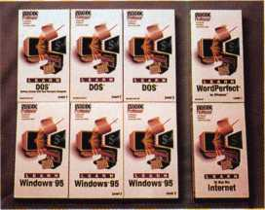

=al

**26** Keynotes

Reader Service # 6 February 1998

} About the Author: Sal Dulcamaro, CML has been in the locksmith

business for over 22 years. He is president ofAll Pro Security, Inc. in Michigan and  
has been an AL0A member for 15 years. A past president of the Locksmith Security  
Association of Michigan, Sal currently serves as editor of the association  
newsletter, e was named “Keynotes Author of the Yead’ for 1996-97.

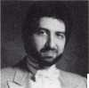

**•** •• •#!» mtpmZ #i 4»§ **•**

^mm

If you think generating a master key chart by computer is easy, you’re right.  
But understanding how the chart is developed and being able to properly utilize  
it after it’s printed is not so easy. When I started working at Security Engineering  
I was handed a chart that makes a two step master key progression so easy to  
follow that after a little studying, it’s almost impossible not to understand. At  
first, I was a little confused. After all, aren’t all key depths a number—not a let-  
ter? With that in mind, I wrote charts by hand for a while, then I let a computer  
write them for me. I was not willing to open my mind up to using letters and these

**toy The letter,,** ,,,

weird looking characters, but I kept looking at this chart and then one day it hit me. This chart is a formula, a little like algebra with those X+Y=Z formulas, but not as tough. It does most of the calculations for you, and as a bonus it lets you look at the chart as a whole instead of a page at a time. It is a completely progressed five pin system. A five pin system 0 to 9 depths has 16 pages of 64 changes for a total of 1,024 possible changes. This chart lists them all on the same 11" x 17" page. It also lists some of the ghost keys or master keys that operate the groups of changes.

First, let me say this chart is not new. It was developed by someone almost 40 years ago as a by-product of trying to develop a computer program to write master key charts. They apparently were trying to have the computer perform a merge function or substitute a numeric value in place of each letter or character. This works because the progression method is the same for all charts. The only difference is the order of progression and the numeric value placed in each position. The person who developed it has passed away and the manufacturer he worked for has given me permission to print it provided I do not use their name. It’s so old and no longer in use that they do not want any calls regarding it. If you have questions write to me at Security Engineering; 127 W. Ridgecrest Blvd.; Ridgecrest CA 93555; or send email to [glmperry@juno.com](mailto:glmperry@juno.com).

Now, let’s define some terms.

Types of keys:

GGMK (Great great grand master key) or TMK (Top master key):

This is the master key that operates all of the cylinders in a master key system.

* Change key: A change key contains none of the cuts common with the top master key. It typically operates a single cylinder or group of cylinders keyed alike.

In between these two keys are various levels of master keys, or ghost keys.

A ghost key is any key that could be cut that operates a master keyed cylinder but has not been issued as a part of the system. A five pin cylinder master pinned with one master wafer and the bottom pin in each chamber will operate with 32 different key combinations. This is because there are two different shear lines in each chamber or 2x2x2x2x2^32. If only the top master key and the change key are to be issued, then there are 30 ghost keys that operate the cylinder. In this article I’ll refer to them as follows:

® First level masters, one cut in common with the top master key.

(It does not matter which cut position.)

* Second level masters, two cuts in common with the top master key.

* Third level masters, three cuts in common with the top master key.

Fourth level masters, four cuts in common with the top master key.

February 1998

Keynotes



These master keys exist in both a vertical, horizontal direction. They also exist in an every fourth, 16th, 64th and more skip arrangement. I’ll explain this later.

Some of you may not like my depart ure from accepted master key terms such as page master or ‘column master’, but they are not as descriptive nor do they encompass all of the possible master keys that exist in a system. This chart lists all of the vertical masters, and makes finding all the horizontal masters and the skip masters a snap.

This chart was developed for a keying system with 10 possible depths, and a two step increment. There are other methods of master keying but from now on when I refer to master keying in this article it is for a 0 to

1. two step progression. This means if you pick an even number cut in the master key, such as a 2 then there are four other cuts-0,

4, 6, 8-available to be used in the change keys in that position or chamber. If an odd number cut was used such as a 9, then the four cuts available would be 1, 3, 5, 7. It doesn’t matter which cut depth is used in the master key, there are still only four remaining even or odd depths left to be used in the change keys. This brings me to a very important point: this system is written in base 4 or in groups of fours. After the first four keys are progressed in the first chamber then a second chamber must be progressed- much the same as counting where we have

1. characters, 0 to After you’ve counted to 9, you carry the 1 or progress and start over in the second column to get 10. You then get to 19 and carry the 1 to get 20 and so on. When we get to 99 then we have to progress again and go to the third column and start at 100. A two step master key system is like this only it has just four numbers with which to work, and they are stepped in twos either 02468 or 13579. This means the “counting and carry the 1 ” or progression is much faster as it occurs every four times instead of every 10 times. The only other difference between counting and a master key progression is that we choose which position to progress or “carry the 1” into. In counting, we start on the right and carry the 1 to the left, ie 1, 10, 100, 1000, 10000. We can go left to right cut position 1 to position 5 ie 12345, right

to left 54321. We can also start in the center such as 45132 or 51342. The sequence doesn’t matter. Since our progression is in base four all of our master keys will operate groups or multiples of four. For each group of four changes we have first level master keys. For every four groups of 4 or 16 changes, we have second level master keys. For every four groups of 16 changes, we have third level master keys. We also have fourth level master keys that fit four pages of 64 changes or 256 keys. This seems like a mouthful, so lets move to the chart and I’ll explain how to find all these master keys.

The first thing you must do is to pick a top master key. A good top master key will have at least one cut at each extreme, the shallowest and the deepest possible. In this case, a 0 or a 1 and an 8 or a 9 are the two extremes.

I picked my top master to be 61834.

This is now filled in across the top of the chart as follows:

a)=6 %=1 &=8 ?=3 *=4

Some of you will notice the / character along with the row of letters W, X, Y and Z in the sixth row. A six pin system would progress this position and you would use four of these large pages, one for each letter.

The next step is to fill in all of the possible progressions of the change keys. I like to also mark out all of the keys that exceed the MACS or maximum adjacent cut specification. An example would be Schlage, which has a MACS of seven. This means I cross out all change keys that have 0 and 9 or 8, and 1 and 9 next to each other. The chart is now written. On a 5 pin system, we now have 16 pages of 64 keys already progressed.

The progression for each chamber is

|  |  |  |  |  |
| --- | --- | --- | --- | --- |
| as follows:  A=8 E=3 | | J=0 | N=5 | S=6 |
| B=Q | F=5 | K=2 | P=7 | T=8 |
| C=2 | G=7 | L=4 | Q=9 | U=0 |
| D=4 | H=9 | M=6 | R=1 | V=2 |

The order of progression for the chambers on this chart is 1,3, 2, 5, 4. All of the change keys on this chart will start with A, B, C, D or 8, 0, 2,4. After we have exhausted the first progression we move to the third

chamber and progress or “carry the 1.” Let’s look at the first four keys on the chart. I will add in the standard nomenclature for identifying the keys.

AA1 AEJNS or 83056

AA2 BEJNS or 03056

AA3 CEJNS or 23056

AA4 DEJNS or 43056

You’ll quickly notice only the first

position changed. The remaining four positions stayed the same. You’ll also notice the key @EJNS or 63056 directly above this first group. This is a first level master, which means it has only one cut in common with the top master key. It only operates these four changes. We now are out of possibilities for progressing the first position so we have to start over and “carry the 1” to another chamber. This chart progresses the third position next. So instead of a J or a 0 we now move to the K or a 2, and this group is:

AA5 AEKNS or 83256

AA6 BEKNS or 03256

AA7 CEKNS or 23256

AA8 DEKNS or 43256

As we continue, the K becomes an L or a 4 and then an M or a 6. Each group had a corresponding first level master key by substituting the first cut with the first cut of the top master key. We now come to the first second level master key of the system. It has two cuts in common with the top master key and operates this group of 16 changes. It is @E&NS or 63856. When we run out of pro­gressions in the third chamber, we must again start over “carry the 1” to another position. In this case it is the second position we “carry the 1" to and progress it to F or 5. We repeat the 16 possibilities and then progress to G or 7 and finally progress to H or 9- We now have 64 possible change keys and have now found a third level master key or page master as some people call it. It is master key AA @%&NS or 61856.

We then progress the fourth progression or the fifth position on this chart that gives us the exact same 64 keys in the first four positions but the fifth position progress from S or 6 to T or 8, then U or 0, and finally V or

Keynotes

February 1998

2. This also reveals a fourth level master key, which is a column master, or the A master that is @%$N* or 61854. When we run out of progressions in this position, we move to the final progression on this chart, which is the fourth position. We start the whole sequence all over for three more columns. They are the B, C and D columns of the master key chart. This also runs us out of available progressions on a five pin system.

Now let’s look for some of the other master keys, or ghost keys that exist but are not shown on this chart. In the same way as there are vertical master keys, there are also horizontal master keys. Again they are master keys that fit groups of four, 16, 64, 256 change keys. Going across the very top row of changes reveals the first level master key that fits AA1, AA17, AA33 and AA49. It is A%JNS or 81056. It is found by comparing all the keys to find that only the second position is different between the four changes. If we then replace that cut depth with the cut from the master, we have a first level master key. The same method is used to find the all the horizontal first level master keys no matter where you are on the chart. The first row second level master key can also be found in the same fashion by noting that only the second and fourth positions are different between all the keys. By changing these cuts to the master key cuts, we now have a master key that fits all 16 changes horizontally. It is cut A%J$S or 81036. We can also change the first cut to the same as the master, and we now have a third level master that fits the top row of 64 keys. It is cut @%J$S or 61036. Skip masters skip around the page in an organized fashion. Every 4th, 16th, 64th and 256th key, and every group of 4, 16, and 64 changes are related in both vertical and horizontal directions. The chart to the right shows first- level skip masters at the bottom which skip every 4th change. An example of a first-level skip master which skips every 64th key is AEJN* or 83054. Next month we will find second level masters and put the chart to use.

§<TttT

VmJHLm, Bib mm B

Below is the upper-left corner of the chart on page 30 and 31. It contains 64 changes, AA1 to AA64. It is the "AA” page of the chart. This pattern of 64 changes repeats itself on the 3 blocks below it as "AB” "AC” and "AD? These four "pages”

|  |  |  |  |  |  |
| --- | --- | --- | --- | --- | --- |
| are the "A” column. The three columns to the right are "B” | | | | "C,” and * | *D” each |
| an b," "t; | and "U" | page. |  |  |  |
| Top master key | |  |  |  | |
| Column master "A” | | (this is a 4th level MK) | | d)%6cN* | |
| Page master "AA” | | (this is a 3rd level MK) | | d)%6cNS | |
|  |  | 2nd level MKs, vertically | |  |  |
| Horizontally | d)E6rNS | dOF&NS | <£)G6cNS |  | dOHEcNS |
| 2nd level MK |  | 1st level MKs, | vertically |  |  |
| <50%JNS | oDEJNS | dDFJNS | dDGJNS |  | dDHJNS |
| 1st level Mks |  |  |  |  |  |
| A%JNS AA1 | AEJNS | AA17 AFJHS | AA33 AGJHS | AA49 | AHJNS |
| B%JNS AA2 | BEJNS | AA18 BFJNS | AA34 BGJNS | AA50 | BHJNS |
| C%JNS AA3 | CEJHS | AA19 CFJNS | AA35 CGJNS | AA51 | CHJHS |
| D%JNS AA4 | DEJNS | AA20 DFJNS | AA36 DGJNS | AA52 | DHJNS |
| 2nd level MK |  | 1st level MKs, | vertically |  |  |
| cD%KNS | d) EKNS | oDFKHS | aGKHS |  | dDHKNS |
| 1st level Mks |  |  |  |  |  |
| A%KNS AA5 | AEKNS | AA21 AFKNS | AA37 AGKNS | AA53 | AHKHS |
| B%KNS AA6 | BEKNS | AA22 BFKNS | AA38 BGKNS | AA54 | BHKNS |
| C%KNS AA7 | CEKNS | AA23 CFKNS | AA39 CGKNS | AA55 | CHKNS |
| D%KNS AA8 | DEKNS | AA24 DFKHS | AA40 DGKNS | AA56 | DHKNS |
| 2nd level MK |  | 1st level MKs, | vertically |  |  |
| a%LNS | dDELNS | d)FLNS | d)GLNS |  | d)HLNS |
| 1st level Mks |  |  |  |  |  |
| A%LNS AA9 | AELNS | AA25 AFLNS | AA41 AGLNS | AA57 | AHLNS |
| B%LNS AA10 | BELNS | AA26 BFLNS | AA42 BGLNS | AA58 | BHLNS |
| C%LNS AA11 | CELNS | AA27 CFLNS | AA43 CGLNS | AA59 | CHLHS |
| D%LNS AA12 | DELNS | AA28 DFLNS | AA44 DGLNS | AA60 | DHLNS |
| 2nd level MK |  | 1st level MKs, | vertically |  |  |
| dD%MNS | dDEMNS | d)FMHS | d)GMHS |  | d)HMNS |
| 1st level Mks |  |  |  |  |  |
| A%MNS AA13 | AEMNS | AA29 AFMNS | AA45 AGMNS | AA61 | AHMHS |
| B%MNS AA14 | BEMNS | AA30 BFMNS | AA46 BGMNS | AA62 | BHMNS |
| C%MNS AA15 | CEMHS | AA31 CFMNS | AA47 CGMNS | AA63 | CHMNS |
| D%MNS AA16 | DEMNS | AA32 DFMHS | AA48 DGMNS | AA64 | DHMNS |
| 1st level skip | masters |  |  |  |  |

AA1,5,9,13 AE&NS AA2,6,10,14 BEEcNS AA3,7,11,15 CE&NS AA4,8,12,16 DEErNS

AA17,21,25,29 AF&NS AA18,22,26,30 BF&NS AA19,23,27,31 CF&NS AA20,24,28,32 DF&NS

AA33,37,41,45 AG&NS AA34,38,42,46 BG&NS AA35,39,43,47 CG&NS AA36,40,44,48 DG&NS

AA49,53,57,61 AH&NS AA50,54,58,62 BH&NS AA51,55,59,63 CH&NS AA52,56,60,64 DH&NS

About the Author: Greg Perry has been in the locksmith industry for 18 years. He's spent half that time as a field technician for the Security Engineering in Ridgecrest, Calif Greg's also a past president of Desert Counties Chapter of the California Locksmiths Association.

February 1998

Keynotes

|  |  |  |  |  |  |  |  |
| --- | --- | --- | --- | --- | --- | --- | --- |
| aEMNTD  AEMNT  BEMNT  CEMNT  DEMNT | 3 FMNTQ aGMNTD aHMNTO AFMNT AGMNT AHMNT BFMNT BGMNT BHMNT CFMNT CGMNT CHMNT DFMNT DGMNT DHMNT | | | aEMPTD  AEMPT  BEMPT  CEMPT  DEMPT | afmptuaGMPTu aHnpiu  AFMPT AGMPT AHMPT BFMPT BGMPT BHMPT CFMPT CGMPT CHMPT DFMPT DGMPT DHMPT | | |
| 3%&nud |  |  | A C | a%&PUD |  |  | B C |
| 3E&NUD | aF&NUD | aG&NUD | 3H8NUD | 3E&PUD | 3F&PUD | 3G&PUD | aH&PUD |
| aEJNUD | aFJNUD | 3GJNUD | aHJNUO | 3EJPUD | aFJPUD | 3GJPUD | aHjpuD |
| AEJNU | AFJNU | AGJNU | AHJNU | AEJPU | AFJPU | AG J PU | AH J PU |
| BEJNU | BFJNU | BGJNU | BHJNU | BEJPU | BFJPU | BGJPU | BHJPU |
| CEJNU | CFJNU | CGJNU | CHJNU | CEJPU | CFJPU | CGJPU | CHJPU |
| DEJNU | DFJNU | DGJNU | DHJNU | DE J PU | DFJPU | DGJPU | DHJPU |
| aEKNUD | a FKNUO | 3GKNUD | aHKNUO | BEKPUD | a FKPUD | 3GKPUD | 3HKPUD |
| AEKNU | AFKNU | AGKNU | AHKNU | AEKPU | AFKPU | AGKPU | AHKPU |
| BEKNU | BFKNU | BGKNU | BHKNU | BEKPU | BFKPU | BGKPU | BHKPU |
| CEKNU | CFKNU | CGKNU | CHKNU | CEKPU | CFKPU | CGKPU | CHKPU |
| DEKNU | DFKNU | DGKNU | DHKNU | DEKPU | DFKPU | DGKPU | DHKPU |
| 3ELNU0 | a FLNUD | aGLNUD | aHLNUO | 3ELPUD | aFLPUD | aGLPUD | 3HLPUD |
| AELNU | AFLNU | AGLNU | AHLNU | AELPU | AFLPU | AGLPU | AHLPU |
| BELNU | BFLNU | BGLNU | BHLNU | BELPU | BFLPU | BGLPU | BHLPU |
| CELNU | CFLNU | CGLNU | CHLNU | CELPU | CFLPU | CGLPU | CHLPU |
| DELNU | DFLNU | DGLNU | DHLNU | DELPU | DFLPU | DGLPU | DHLPU |
| aEMNUO | a FMNUO | aGMNUO | aHMNUD | 3EMPUD | a FMPUD | aGMPUD | aHMPUD |
| AEMNU | AFMNU | AGMNU | AHMNU | AEMPU | AFMPU | AGMPU | AHMPU |
| BEMNU | BFMNU | BGMNU | BHMNU | BEMPU | BFMPU | BGMPU | BHMPU |
| CEMNU | CFMNU | CGMNU | CHMNU | CEMPU | CFMPU | CGMPU | CHMPU |
| DEMNU | DFMNU | DGMNU | DHMNU | DEMPU | DFMPU | DGMPU | DHMPU |
| a%&NVD |  |  | A D | a%&PVD |  |  | B D |
| aE&NVO | a F&NVD | 3G&NV0 | aH&NVD | 3E&PVD | 3F&PVD | 3G&PVD | aH&PVD |
| aEJNVD | a F J NVD | 3GJ NVD | 3H J NVD | aEjpvD | 3FJPVD | 3GJPVD | aHJPVD |
| AEJNV | AFJNV | AGJNV | AHJNV | AEJPV | AFJPV | AG J PV | AH J PV |
| BEJNV | BFJNV | BGJNV | BHJNV | BEJPV | BFJPV | BGJPV | BHJPV |
| CEJNV | CFJNV | CGJNV | CHJNV | CEJPV | CFJPV | CGJPV | CHJPV |
| DEJNV | DFJNV | DGJNV | DHJNV | DEJPV | DFJPV | DGJPV | DHJPV |
| 3EKNV0 | a FKNVD | 3GKNVO | aHKNVD | 3EKPVD | a FKPVD | 3GKPVD | aHKPVD |
| AEKNV | AFKNV | AGKNV | AHKNV | AEKPV | AFKPV | AGKPV | AHKPV |
| BEKNV | BFKNV | BGKNV | BHKNV | BEKPV | BFKPV | BGKPV | BHKPV |
| CEKNV | CFKNV | CGKNV | CHKNV | CEKPV | CFKPV | CGKPV | CHKPV |
| DEKNV | DFKNV | DGKNV | DHKNV | DEKPV | DFKPV | DGKPV | DHKPV |
| 3ELNVO | a FLNVD | 3GLNVD | 3HLNVD | 3ELPVD | a FLPVD | 3GLPVD | 3HLPVD |
| AELNV | AFLNV | AGLNV | AHLNV | AELPV | AFLPV | AGLPV | AHLPV |
| BELNV | BFLNV | BGLNV | BHLNV | BELPV | BFLPV | BGLPV | BHLPV |
| CELNV | CFLNV | CGLNV | CHLNV | CELPV | CFLPV | CGLPV | CHLPV |
| DELNV | DFLNV | DGLNV | DHLNV | DELPV | DFLPV | DGLPV | DHLPV |
| 3EMNVD | a FMNVQ | aGMNVO | 3HMNVD | 3EMPVD | a FMPVD | 3GMPVD | aHMPVD |
| AEMNV | AFMNV | AGMNV | AHMNV | AEMPV | AFMPV | AGMPV | AHMPV |
| BEMNV | BFMNV | BGMNV | BHMNV | BEMPV | BFMPV | BGMPV | BHMPV |
| CEMNV | CFMNV | CGMNV | CHMNV | CEMPV | CFMPV | CGMPV | CHMPV |
| DEMNV | DFMNV | DGMNV | DHMNV | DEMPV | DFMPV | DGMPV | DHMPV |

■ u

ditnu i u

AEMGtT

BEMQT

CEMQT

DEMQT

a%&QUD

3E&QUD

3EJQUD

AEJQU

BEJQU

CEJQU

DEJQU

3EKQUD

AEKQU

BEKQU

CEKQU

DEKQU

aELQUD

AELQU

BELQU

CELQU

DELQU

aEMQUD

AEMGtU

BEMQU

CEMQU

DEMQU

a%&Qvo

aE&QVD

aEJQVD

AEJQV

BEJQV

CEJQV

DEJQV

3EKQVD

AEKQV

BEKQV

CEKQV

DEKQV

3ELQVD

AELQV

BELQV

CELQV

DELQV

3EMQVD

AEMQV

BEMQV

CEMQV

DEMQV

|  |  |  |  |  |  |  |
| --- | --- | --- | --- | --- | --- | --- |
| aJ i-iw 1 u  AFMQT  BFMQT  CFMQT  DFMQT | aJbnu i u  AGMQT  BGMQT  CGMQT  DGMQT | cu n iti w i u  AHMQT  BHMQT  CHMQT  DHMQT | AENRT  BEMRT  CEMRT  DEMRT | AFMRT  BFMRT  CFMRT  DFMRT | AGMRT  BGMRT  CGMRT  DGMRT | AHMRT  BHMRT  CHMRT  DHMRT |
|  |  | C C | 3%&RUD |  |  | D C |
| aF&aun | 3G&QUD | aH&QUD | 3E&RUD | 3F&RUD | 3G&RUD | aH&RUD |
| 3FJQUD | 3GJQUD | aHJQUD | 3EJRUD | 3FJRUD | 3GJRUD | aHJRUD |
| AFJQU | AGJQU | AHJQU | AEJRU | AFJRU | AG J RU | AH J RU |
| BFJQU | BGJQU | BHJQU | BE J RU | BFJRU | BGJRU | BHJRU |
| CFJQU | CGJQU | CHJQU | CEJRU | CFJRU | CGJRU | CHJRU |
| DFJQU | DGJQU | DHJQU | DE J RU | DFJRU | DGJRU | DHJRU |
| 3 FKQUD | 3GKQUD | 3HKQUD | 3EKRUD | a FKRUD | 3GKRUD | 3HKRUD |
| AFKQU | AGKQU | AHKQU | AEKRU | AFKRU | AGKRU | AHKRU |
| BFKQU | BGKQU | BHKQU | BEKRU | BFKRU | BGKRU | BHKRU |
| CFKQU | CGKQU | CHKQU | CEKRU | CFKRU | CGKRU | CHKRU |
| DFKQU | DGKGU | DHKQU | DEKRU | DFKRU | DGKRU | DHKRU |
| a FLQUD | 3GLQUD | 3HLQUD | 3ELRUD | a FLRUD | 3GLRUD | 3HLRUD |
| AFLQU | AGLQU | AHLQU | AELRU | AFLRU | AGLRU | AHLRU |
| BFLQU | BGLQU | BHLQU | BELRU | B F LRU | BGLRU | BHLRU |
| CFLQU | CGLQU | CHLQU | CELRU | CFLRU | CGLRU | CHLRU |
| DFLQU | DGLGU | DHLQU | DELRU | DFLRU | DGLRU | DHLRU |
| a FMQUD | aGMQUD | 3HMQUD | 3EMRUD | a FMRUD | 3GMRUD | 3HMRUD |
| AFMQU | AGMQU | AHMQU | AEMRU | AFMRU | AGMRU | AHMRU |
| BFMQU | BGMQU | BHMQU | BEMRU | BFMRU | BGMRU | BHNRU |
| CFMQU | CGMQU | CHMQU | CEMRU | CFMRU | CGMRU | CHMRU |
| DFMQU | DGMQU | DHMQU | DEMRU | DFMRU | DGMRU | DHMRU |
|  |  | C D | 3%&RVD |  |  | D D |
| a F&QVD | 3G&QVD | aH&QVD | 3E&RVD | a F&RVD | 3G&RVD | 3HSRVD |
| a F J QVD | aGjavD | aHJQVD | 3EJRVD | a F J RVD | 3GJ RVD | 3HJ RVD |
| AFJQV | AGJQV | AHJQV | AEJRV | AFJRV | AG J RV | AH J RV |
| BFJQV | BGJQV | BHJaV | BEJRV | BFJRV | BGJRV | BHJRV |
| CFJQV | CGJQV | CHJQV | CEJRV | CFJRV | CGJRV | CHJRV |
| DFJQV | DGJQV | DHJQV | DEJRV | DFJRV | DGJRV | DHJRV |
| 3 FKQVD | aGKQVD | 3HKQVD | 3EKRVD | a FKRVD | 3GKRVD | 3HKRVD |
| AFKQV | AGKQV | AHKQV | AEKRV | AFKRV | AGKRV | AHKRV |
| BFKQV | BGKQV | BHKQV | BEKRV | BFKRV | BGKRV | BHKRV |
| CFKQV | CGKQV | CHKQV | CEKRV | CFKRV | CGKRV | CHKRV |
| DFKQV | DGKQV | DHKQV | DEKRV | DFKRV | DGKRV | DHKRV |
| a FLQVD | 3GLQVD | 3HLQVD | 3ELRVD | a FLRVD | 3GLRVD | 3HLRVD |
| AFLQV | AGLQV | AHLQV | AELRV | AFLRV | AGLRV | AHLRV |
| BFLQV | BGLQV | BHLQV | BELRV | BFLRV | BGLRV | BHLRV |
| CFLQV | CGLQV | CHLQV | CELRV | CFLRV | CGLRV | CHLRV |
| DFLQV | DGLQV | DHLQV | DELRV | DFLRV | DGLRV | DHLRV |
| a FMQVD | 3GMQVD | 3HMQVD | 3EMRVD | 3FMRVD | 3GMRVD | 3HMRVD |
| AFMQV | AGMQV | AHMQV | AEMRV | AFMRV | AGMRV | AHMRV |
| BFMQV | BGMQV | BHMQV | BEMRV | BFMRV | BGMRV | BHMRV |
| CFMQV | CGMQV | CHMQV | CEMRV | CFMRV | CGMRV | CHMRV |
| DFMQV | DGMQV | DHMQV | DEMRV | DFMRV | DGMRV | DHMRV |

February 1998

|  |  |  |  |  |  |
| --- | --- | --- | --- | --- | --- |
| a- | %- | &— | $- | *_ | /- |
| A- | E- | J- | N- | s- | w- |
| B- | F- | K- | P- | T- | X- |
| c- | G- | L- | Q- | u- | Y- |
| D- | H- | M- | R- | V- | z- |

a%&$*D

|  |  |  |  |  |  |  |  |  |  |  |  |  |  |  |  |
| --- | --- | --- | --- | --- | --- | --- | --- | --- | --- | --- | --- | --- | --- | --- | --- |
| a%&N*o |  |  | A | a%&p*o |  |  | B | a%&Q*D |  |  | C | a%&R*D |  |  | D |
| a%&Nsn |  |  | AA | 3%&psd |  |  | B A | a%&asD |  |  | C A | a%&RSD |  |  | D A |
| BE&NSD | 3F&NSD3G&NSD3H&NS0 | | | aE&pso | 3F&PSD | 3G&PSD | aH&pso | 3E&QSD | a F&QSD | 3G&QSD | aH&QSD | aE&RSD | a F&RSD | 3G&RSD | 3H&RSD |
| 3EJNSD | 3FJNSD 3GJNSD 3HJNSD | | | 3EJPSD | 3FJPS0 | 3GJPSD | 3HJPSD | 3EJQSD | aFJGSD | aGJQSD | aHJQSD | aEJRSD | a F J RSD | 3GJ RSD | 3HJ RSD |
| AEJNS | AFJNS | AG J NS | AH J NS | AEJPS | AFJPS | AG J PS | AH J PS | AEJQS | AFJQS | AGJQS | AHJQS | AEJRS | AFJRS | AG J RS | AH J RS |
| BEJNS | BFJNS | BGJNS | BHJNS | BE J PS | BFJPS | BGJPS | BHJPS | BEJQS | BFJQS | BGJQS | BHJQS | BEJRS | BFJRS | BGJRS | BHJRS |
| CEJNS | CFJNS | CGJNS | CHJNS | CEJPS | CFJPS | CGJPS | CHJPS | CEJQS | CFJQS | CGJQS | chjqs | CEJRS | CFJRS | CGJRS | CHJRS |
| DEJNS | DFJNS | DGJNS | DHJNS | DEJPS | DFJPS | DGJPS | DHJPS | DEJQS | DFJQS | DGJQS | DHJQS | DEJRS | DFJRS | DGJRS | DHJRS |
| 3EKNSD | 3FKNSDaGKNSD aHKNSD | | | 3EKPS0 | 3FKPSD | 3GKPSO | 3HKPSD | 3EKQSD | a FKQSD | 3GKQSD | 3HKQSD | 3EKRSD | 3 FKRSD | 3GKRSD | 3HKRSD |
| AEKNS | AFKNS | AGKNS | AHKNS | AEKPS | AFKPS | AGKPS | AHKPS | AEKQS | AFKQS | AGKQS | AHKQS | AEKRS | AFKRS | AGKRS | AHKRS |
| BEKNS | BFKNS | BGKNS | BHKNS | BEKPS | BFKPS | BGKPS | BHKPS | BEKQS | BFKQS | BGKQS | BHKQS | BEKRS | BFKRS | BGKRS | BHKRS |
| CEKNS | CFKNS | CGKNS | CHKNS | CEKPS | CFKPS | CGKPS | CHKPS | CEKQS | CFKQS | CGKQS | CHKQS | CEKRS | CFKRS | CGKRS | CHKRS |
| DEKNS | DFKNS | DGKNS | DHKNS | DEKPS | DFKPS | DGKPS | DHKPS | DEKQS | DFKQS | DGKQS | DHKQS | DEKRS | DFKRS | DGKRS | DHKRS |
| cDELNSD | 3FLNSD aGLNSO aHLNSO | | | 3ELPSD | 3FLPSD | 3GLPSD | aHLPSO | 3ELQSD | a FLQSD | 3GLQSD | 3HLQSD | 3ELRSD | a FLRSD | 3GLRSD | 3HLRSD |
| AELNS | AFLNS | AGLNS | AHLNS | AELPS | AFLPS | AGLPS | AHLPS | AELQS | AFLGtS | AGLQS | AHLQS | AELRS | AFLRS | AGLRS | AHLRS |
| BELNS | BFLNS | BGLNS | BHLNS | BELPS | BFLPS | BGLPS | BHLPS | BELQS | BFLQS | BGLQS | BHLQS | BELRS | BFLRS | BGLRS | BHLRS |
| CELNS | CFLNS | CGLNS | CHLNS | CELPS | CFLPS | CGLPS | CHLPS | CELQS | CFLQS | CGLQS | CHLQS | CELRS | CFLRS | CGLRS | CHLRS |
| DELNS | DFLNS | DGLNS | DHLNS | DELPS | DFLPS | DGLPS | DHLPS | DELQS | DFLQS | DGLQS | DHLGtS | DELRS | DFLRS | DGLRS | DHLRS |
| 3EMNSD | aFMNSD 3GMNSQ 3HMNSD | | | aEMPSo | aFMPso | 3GMPSD | aHMPSD | 3EMQSD | a FMQSD | 3GMQSD | 3HMQSD | 3EMRSD | a FMRSD | 3GMRSD | 3HMRSD |
| AEMNS | AFMNS | AGMNS | AHMNS | AEMPS | AFMPS | AGMPS | AHMPS | AEMQS | AFMQS | AGMQS | AHMQS | AEMRS | A FMRS | AGMRS | AHMRS |
| BEMNS | BFMNS | BGMNS | BHMNS | BEMPS | BFMPS | BGMPS | BHMPS | BEMQS | BFMQS | BGMQS | BHMQS | BEMRS | BFMRS | BGMRS | BHMRS |
| CEMNS | CFMNS | CGMNS | CHMNS | CEMPS | CFMPS | CGMPS | CHMPS | CEMQS | CFMQS | CGMQS | CHMQS | CEMRS | C FMRS | CGMRS | CHMRS |
| DEMNS | DFMNS | DGMNS | DHMNS | DEMPS | DFMPS | DGMPS | DHMPS | DEMQS | DFMQS | DGMQS | DHMQS | DEMRS | D FMRS | DGMRS | DHMRS |
| a%&NTD |  |  | A B | a%&PTD |  |  | BB | 3%&QT |  |  | CB | a%&RTD |  |  | DB |
| 3E&NT0 | 3F&NTO 3G&NTD 3H&NTD | | | aE&PTD | a f&pto | 3G&PTD | aH&PTO | 3E&QTD | a F&QTD | 3G&QTD | 3H&QTD | 3ESRTD | a F&RTD | 3G&RTD | 3H&RTD |
| 3EJNTD | 3FJNTD3GJNTD 3HJNTD | | | aEJPTD | a fj ptd | 3GJ PTD | aHj ptd | 3EJQTD | aFJQTD | 3GJQTD | 3HJQTD | aEJRTv | a F J RTD | 3GJ RTD | 3HJ RTD |
| AEJNT | A F J NT | AG J NT | AH J NT | AEJPT | AFJPT | AG J PT | AH J PT | AEJGT | AFJQT | AGJQT | AHJQT | AEJRT | AFJRT | AGJRT | AH J RT |
| BE J NT | BFJNT | BGJNT | BHJNT | BEJPT | BFJPT | BGJPT | BHJPT | BEJQT | BFJQT | BGJQT | BHJQT | BEJRT | BFJRT | BGJRT | BHJRT |
| CEJNT | CFJNT | CGJNT | CHJNT | CEJPT | CFJPT | CGJPT | CHJPT | CEJQT | CFJQT | CGJQT | CHJQT | CEJRT | CFJRT | CGJRT | CHJRT |
| DEJNT | DFJNT | DGJNT | DHJNT | DEJPT | DFJPT | DGJPT | DHJPT | DEJQT | DFJQT | DGJQT | DHJQT | DEJRT | DFJRT | DGJRT | DHJRT |
| 3EKNTQ | 3FKNTD 3GKNTD 3HKNTD | | | 3EKPTD | a FKPTD | 3GKPTD | 3HKPTD | 3EKQTD | a FKQTD | 3GKQTD | 3HKQTD | 3EKRTD | 3 FKRTD | 3GKRTD | 3HKRTD |
| AEKNT | AFKNT | AGKNT | AHKNT | AEKPT | AFKPT | AGKPT | AHKPT | AEKQT | AFKQT | AGKQT | AHKQT | AEKRT | AFKRT | AGKRT | AHKRT |
| BEKNT | BFKNT | BGKNT | BHKNT | BEKPT | BFKPT | BGKPT | BHKPT | BEKQT | BFKQT | BGKQT | BHKQT | BEKRT | BFKRT | BGKRT | BHKRT |
| CEKNT | CFKNT | CGKNT | CHKNT | CEKPT | CFKPT | CGKPT | CHKPT | CEKQT | CFKQT | CGKQT | CHKQT | CEKRT | CFKRT | CGKRT | CHKRT |
| DEKNT | DFKNT | DGKNT | DHKNT | DEKPT | DFKPT | DGKPT | DHKPT | DEKQT | DFKQT | DGKQT | DHKQT | DEKRT | DFKRT | DGKRT | DHKRT |
| aELNTD | 3FLNTD 3GLNTD 3HLNTD | | | 3ELPTD | a FLPTD | 3GLPTO | aHLPTD | 3ELQTD | 3 FLQTD | 3GLQTD | 3HLQTD | 3ELRTD | a FLRTD | 3GLRTD | 3HLRTD |
| AELNT | AFLNT | AGLNT | AHLNT | AELPT | A F LPT | AGLPT | AHLPT | AELQT | AFLQT | AGLQT | AHLQT | AELRT | AFLRT | AGLRT | AHLRT |
| BELNT | BFLNT | BGLNT | BHLNT | BELPT | BFLPT | BGLPT | BHLPT | BELQT | BFLQT | BGLQT | BHLQT | BELRT | BFLRT | BGLRT | BHLRT |
| CELNT | CFLNT | CGLNT | CHLNT | CELPT | CFLPT | CGLPT | CHLPT | CELQT | CFLQT | CGLQT | CHLQT | CELRT | CFLRT | CGLRT | CHLRT |
| DELNT | DFLNT | DGLNT | DHLNT | DELPT | DFLPT | DGLPT | DHLPT | DELQT | DFLQT | DGLQT | DHLQT | DELRT | DFLRT | DGLRT | DHLRT |

Houston hairdresser Akrel “Junior” Byrd never gave a  
second thought to the safety of his safe-deposit box—  
stored under lock and key and guarded by bank personnel  
inside a steel vault—until he discovered most of its  
contents missing one day.

“I had just gone into the bank and purchased a $1,000  
savings bond for my daughter and I was about to put it  
inside the box,” Byrd recalled of the 1989 incident at First  
National Bank of Pearland. Missing were a Rolex watch,  
antique silver coins and some cash, all valued at around  
$4,000. (More than $4,000 in U.S. Savings Bonds were  
untouched.)

“The bank said I was mistaken, that it couldn’t  
happen,” said Byrd, who successfully sued four years ago.

Most of the people who keep untold personal treasures in  
the estimated 30 million safe-deposit boxes in banks,  
savings and loans and credit unions nationwide assume  
safe-deposit boxes are very safe—and more often than not  
they’re right.

The metal-case boxes are stored in concrete or steel  
vaults often equipped with sophisticated alarms, video  
camera, motion sensors, heat detectors, and other security

**How Safe Hre**

**Safe Deposit Bo»es?**

By Vivian Marino, Associated Pre

devices. Financial institutions usually have strict access  
procedures, like signature verification, restricted vault  
access and dual keys.

Yet losses due to floods or fire have occurred. And some  
experts say safe-deposit thefts have been rising, due in part  
to more sophisticated thieves and to occasional lapses in  
security procedures within financial institutions.

“The safe deposit boxes are as safe as the institutions  
are,” said Joyce A. McLin, executive director of the  
American Safe Deposit Association in Greenwood, Ind.,  
which has 3,000 member financial institutions. “Probably  
98 percent of them (have) superior procedures.”

But security experts say even the best-run financial  
institutions may inadvertently have breaches in security.

John W. Kennish, a security consultant from  
Westbrook, Conn., believes the steady spate of bank

February 1998

mergers and resulting layoffs over the last decade are partly  
to blame. “You have fewer people doing more things and  
you get burnout,” he said. “One person doing so many  
things can’t do them all well... and that includes  
monitoring the safe-deposit boxes.”

Banks disagree. “I don’t think that is an issue with  
safety of safe-deposit boxes,” said Lisa Margolin-Feher, a  
spokeswoman for the Bank of America in San Francisco.

“I think that as banks are shrinking the employee base,  
they’re keeping more experienced people.“ Most financial  
institutions offer safe-deposit boxes as a service rather than  
a way to raise revenue, and annual rental fees can start as  
low as $15. Customers want a place where they can  
privately store family heirlooms, jewelry, stock and bond  
certificates, and important papers. Items only they may  
consider valuable, like love letters or photographs, also find  
a home there.

Banks’ strict hands-off policy makes safe deposit boxes  
among the most sacrosanct of hiding places. No one,  
except the person who rents the box, or someone  
designated by the renter, is given access. Even police will  
need a search warrant to peek inside.

About the only time a safe-deposit box  
gets drilled open without customer consent  
is if the rent is overdue for a period of time,  
after which the contents are turned over to a  
state’s uncollected property division and

eventually sold at an auction.

David P. McGuinn, president of Safe  
Deposit Specialists in Houston, who runs  
seminars for financial institutions, says he’s  
heard of numerous instances of break-ins,  
many in the last decade.

Press “Many cases go unpublicized because they

are settled with the bank’s insurer,” said McGuinn, who  
appeared as an expert witness in Byrd’s lawsuit against his  
bank.

Among the more notable cases that reached the public  
eye last year alone: In Los Angeles, lawsuits were filed by  
former Bank of America customers, alleging hundreds of  
thousands of dollars in jewelry, cash and coins were stolen  
and, in some cases, fakes were substituted. In Chicago,  
Firstar Bank customers reported more than $500,000 in  
diamonds, jewelry and coins missing. In Miami, three men  
alledgedly walked away with $5 million in jewelery at a  
Sun Trust Bank.

Industry experts believe a special breed of thieves,  
armed with new tools and new schemes have been  
targeting safe-deposit boxes.

McGuinn says new locksmith devices are making it

32 I Keynotes

easier for thieves to open certain vault doors without keys, often in a matter of seconds.

“It’s really frightening,” he said.

The industry newsletter Bank Security Report reported recently that many robberies are being committed by individuals who rent safe-deposit boxes themselves in order to gain access to others’ boxes. The thieves, it says, look for financial institutions that leave customers alone and unobserved in the vaults.

It outlines a typical scheme:

“The perpetrators, who generally act in pairs, enter the vault to open their own box. One of them then distracts the safe-deposit guard long enough to make a wax impression of the guard’s master key and return it, a process that can take no more than seconds.

“Once the thieves have a duplicate of the master key cut, they again enter the safe deposit box vault, ostensibly to visit their own box. Armed with a copy of the master key, their job has been cut in half—they only have to pick the customer locks to get into other safe deposit boxes.”

Byrd, 53, theorizes that happened to him eight years ago.

He says the last time he visited his safe-deposit box prior to reporting the theft, he noticed a man and woman left alone inside the vault, leafing through some papers at a table. He moved to a private room to view the contents of his box. When he returned, the couple was gone but he recalled having difficulty locking away his box afterward.

“We found out the name of the fellow that was in there the same time I was in there the same time of his (deposit box) contract,” said Byrd. “They had nothing on him—no Social Security number, no driver’s license. The address he gave them turned out to be a vacant lot.”

Byrd received about $40,000 as a result of his lawsuit against the bank, said his lawyer, Candace Smith.

Some banks, like Bank of America, and New York- based Chase and Citibank offer limited insurance coverage on box contents for additional fees.

Homeowners and renters policies also have added coverage on certain valuables through riders.

But McGuinn says safe-deposit boxes can be made safer with vigilance and common sense. Box keys should be kept in a safe place and never left in a box door, contents should be viewed privately and put back in place. Individuals also should familiarize themselves with the security and operating procedures in their rental contract and make sure they’re adhered to.

Reprinted with permission of Associated Press.

UJags to sstopnl a saft-depnsit bm.

Know the routine - Before renting, ask about the security and  
operating procedures of the bank or financial institution and  
talk with the vault attendant. Well-run institutions usually have  
strict access procedures, like signature verification and dual  
keys. They'll also have separate viewing rooms for inspecting  
box contents in privacy and won't leave individuals inside a  
vault unattended.

Check Insurance - Banks usually aren't liable for losses, but  
they have a responsibility to protect against them. Standard  
homeowners' and renters' policies provide limited coverage for  
valuables, so it may be prudent to take out a policy rider for  
added protection. Most insurers give deep discounts if the items  
insured are in a safe-deposit box. (In New York City, for  
instance, the fee is $3 vs. $13, per $1,000 in coverage.)

A handful of banks also sell limited insurance coverage. Fees  
vary. Chase for instance, has a policy that costs $25 a year.  
Contents are insured for up to $25,000 as long as they remain  
inside the box. They're insured for up to $10,000 outside the  
box for up to 21 days. Bank of America began making  
insurance coverage part of its rental contract. In doing so, it  
raised rental fees on standard-size boxes to $40 from $25.

Keep current - Make sure the bank is notified of any address  
changes and that all rental fees are paid up. Some banks may  
give customers a safe-deposit box free for the first year, usually  
for opening an account, but impose charges later. A box may  
be considered abandoned, and its contents turned over to the  
state and eventually auctioned off, if the rent is past due for a  
period of time—sometimes as little as 30 days—and the bank  
is unable to contact the renter.

Inventory contents - Maintain a list of everything inside the  
box, along with copies of any documents and appraisals, and  
photographs of the items. This will help to expedite any claims  
should the contents become lost of damaged.

Be vigilant and use common sense - At home, keep the safe-  
deposit key in a safe place; give an extra key to someone trust-  
worthy. Inside the vault, make sure no other customers are  
there with you. Never lose sight of the key and never leave it in  
the box door. Outside the vault, open the box only when inside  
a private viewing booth or room away from bank employees  
and customers. Make sure nothing is left behind. When the  
box is returned to the vault, check to ensure it has locked  
properly. One security specialist suggests storing important  
papers in water proof containers or bags.



If there really was a Santa Claus, here’s how I’d furnish my next key system: I’d do the site survey with a pocket tape recorder.

The office computer would listen to the tape and fire off a hardware schedule, complete a sketch of the floor plan and notes about leaking closers and code violations. After the keying conference, I’d make another tape with the key symbols and expansion specification and stuff it into the machine. Then, I’d go to lunch and read about something besides locks. By the time I returned, the electronic key records manager would have coughed up a keying schedule, bitting list, a universal pinning chart and the labels for the key delivery enveloped, complete with key holders’ receipts.

I can dream, can’t I? While my ideal

these specifications.

• Terminology - Conformance to standard terminology simply makes sense in an industry that has suffered from a confusing array of regional terms. Some software does not even permit the Standard Key Coding System adopted by ALOA, BHMA, DHI, and all North American hardware manufac­turers. There are a variety of sources for this information, including the ALOA Glossary, the DHI keying manual, Fundamentals of Master Keying and manufacturers’ catalogs.

One popular program claims that ‘TMK’ means theoretical master key. The manufac­turer argues that a one large system can be generated in standard progression format and divided into smaller systems by not pinning the TMK into the cylinders. While this is true, it is a disservice to ignore the efforts so many

the example in Figure 1. There are many reasons for manipulating they key bitting array, some arithmetic, some mechanical. This is basic. It is also important to remove specific progressives for selective keys.

• Methods of progression - Of the two methods of progression, total position progression and rotating constant method, rotating constants is the older and more secure. For all but larger systems, it is preferable since it uses fewer master pins per cylinder.

Some programs do total position progression only. Perhaps their designers didn’t understand the other method or it was too costly to do both. Locksoft has always been able to do both methods.

Most key systems ever written are two level systems with fewer than 50 changes.



system is unavailable, there are a number of keying software packages on the market. Software is mainly a tool for writing an error free bitting list. A well designed program can save time and prevent arithmetic mistakes, but the current programs don’t do everything . They cannot make up for a lack of judgment and knowledge. We still have to understand master keying, accurately estimate the expansion and design systems properly.

In my opinion, master keying software at minimum should: conform to standard industry terminology; include a password protected top master key (TMK) register capable of sorting both masters and controls; permit operator choice of top masters and controls; permit manipulation of the key bitting array and sequence of progression, including omission of specified progressives; generate bittings in both standard progres­sion format and list format; observe manufac­turers’ MACS and indicate forbiddens as well as undesirables; permit the operator to assign key symbols and key quantities; print a system specific pinning chart; and allow modem access for field extension of a system.

That’s a mouthful. Let’s discuss each of

1 KeynotesFebruary 1998

have made to standardize terms in our industry.

* TMK, register, top masters and controls - Failure to keep this record is a liability. The TMK register should record and sort top masters and controls for all the systems that a locksmith furnishes or services. The purpose of the register is to ensure that all parity patterns are used and when a pattern is repeated that the duplicate systems are separated geographically. The software should sort by manufacturer, key section and location. The operator should be able to set the parameters of the location sort, e.g., by address, zip code or city.

Most programs let the operator choose the top master and control bittings. The TMK register should be opened at the same time and inspected for existing bittings.

One could argue that the register should be kept in a separate data base to make it more secure. Point taken. However, the key records computer has to be secure anyway. This is a major liability issue. Passwords and other controls are mandatory.

* Manipulating the key bitting array. - Some programs do not permit changing the order of the progressives of the sequence or progression. I wouldn’t use them. Consider

I would argue that the use of total position progression for such systems is inferior work.

* MACS and undesirables - Existing software observes manufacturers’ MACS. Some packages let you set the MACS. It would be helpful if the program would flag undesir­ables as well and let you set parameters for undesirables, such as declining step keys, keys with deep cuts at the bow, keys with four or more identical cuts, etc.
* Bitting list format - Format, i.e., the way the bittings are laid out on a page ought to be the users-choice. Most smaller systems are easily done in list format, especially those with rotating constants. Larger asymmetrical systems, which grow over time and are subject to frequent modification, are best done in standard progression format. Look for software that allow you to choose the format.
* Key symbols - The single greatest defect in keying software is the way programs only assign key symbols based on a symmet­rical expansion specification. The operator has no freedom to exercise judgment.

I would not buy a program that would not give me the option of assigning the symbols.

In the real world, systems of three or more levels of keying are asymmetrical. Schlage has the right idea. Put all 64 pages up on the screen, pick masters of the appropriate sizes, pick the lower level inci­dentals and change keys you want, and name them whatever you want.

For Dealers selling key control products a running tally of key quantities by key symbol is a must. This feature would be good for every system.

• Pinning Charts - Most programs will display cylinder pinning for a given key symbol. It can be useful if there a terminal at the pinning bench. However, isn’t printing the pinning for each combination a waste of paper? A system specific chart, such as we use at Kaba for Peaks seems more efficient. When we do bitting in list format, the

**Software**

y Jerome V. Andrews

pinning chart, appears on the lower left of every page.

* On-site access and record keeping. - While not essential, the ability to access the bitting list on the road can be useful when no one is at the office to furnish additional combina­tions. This is icing on the cake of the wish list. Printing receipts and labels for envelopes would be another plus.
* Caveat emptor - For many years, I have refused to comment on software. One needs to understand master keying before choosing a package. Unintelligent use of even the better programs can leave a locksmith with liabilities. Computers are not, nor will they ever be, a substitute for knowledge and judgment. The use of software doesn’t mean one is doing master keying well. I’d continue cross keying manually regardless of program.

In general, HPC’s MasterKing does the job well and I’d not hesitate to purchase it. Some programs tout special feature that are inter­esting, but not very useful in my judgment. My first recommendation stands; to interro­gate the various suppliers, inspect their products at tradeshows like ALOA ‘98, and ask your contacts on ALOA about their experience.

Figure 1: Manipulation of the bitting array eliminates of postpones certain problems. Compare these KB A’s and their first eight changes.

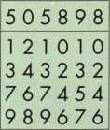

f e d c b a

12 10 10 121012 121014 **121016 121030 121032** 121034 121036

System A with progressives shallow to deep results in uni­formity shallow change keys under initial master keys. Sadly, many key system are done this way.

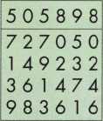

f e d a c b

727050 727250 727450 727650 72 705 2 727252 727452 727652

System B has progressives scrambled and sequence of pro­gression altered. Uniformly shallow change keys avoided at first and deep cut at bow is post-poned. |

About the Author: Jerome V.

Andrews is Manager of Dealer Sales and  
Training for KABA High Security Locks in  
Southington, CT where he provides system design  
services for both KABA and Beaks and technical  
support for KABA engineering.

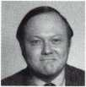

**“Some programs do total position progression only. Perhaps their designers didn’t understand the other method or it was too costly to do tooth.”**

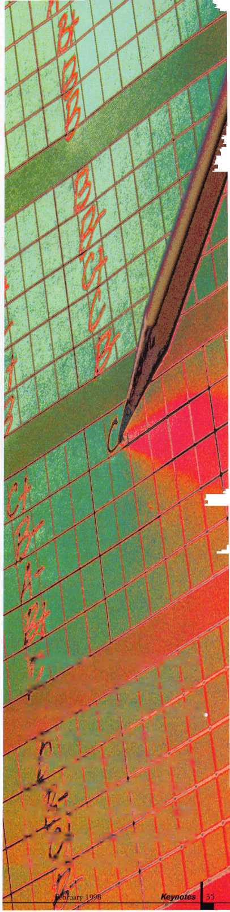

Computext is one of four major computer­ized code programs. It is produced/published by Locksmith Publishing Corp. It is based on the printed Reed system, also published by Locksmith Publishing Corp. The printed codes are divided into Padlock and General codes, but the computerized codes include both. The current version of Computext is DOS based and will run on virtually any DOS based computer or Windows environment when switched to DOS mode. The hard drive storage require­ments are listed as approximately 15 meg, but may vary somewhat on different machines.

When installing the software, you must be in DOS mode. I have a computer that uses Windows 95. When I started the installation,

I apparently went into auto pilot and tried to install it as if it was a Windows program. I wondered why the computer didn’t recognize the commands listed in the program’s instruction book for installation. Suddenly I realized that I was not in DOS mode and promptly rectified the situation. If you have Windows 3.1, you can do a shut down and it will end up going into DOS.

If you have Windows 95, you have two options. In the shut down process, you have the ability to restart the computer in MS-DOS mode. While in DOS, you can do the installation, setup, run the program or

whatever. When done with DOS, you can return to Windows by typing “win” or “exit,” and pressing enter. The other option is to point to “Programs” while in the Start menu, and select (among all the programs listed) “MS- DOS Prompt.” It will create a window with DOS inside. The advantage to this is that you can multi-task. Normally DOS programs are not capable of multi-tasking. If you have DOS operating in a window, though, you can go back and forth between Windows programs and the DOS program in its own window.

The installation was fairly straightforward and took about 15 minutes. After the program is installed, you can go into “setup” to select certain preferences when running the program. If you have a color monitor, you can choose between three screen colors: blue, red and black. One of the other options allows you to select “ITL Machine Support.”

When the program is running and it is displaying code information, it usually provides information as to the proper key blank to use with the particular code number (and cutting information). It will normally cross reference the key blank number in 12 different key blank brand/designations. Although you can select any brand while in the program, you can choose a default brand (that will show automat­ically when you select a code number) in the

by Sal Dulcamaro, cml

setup program. There are many more preference selections in the setup program, but you can find all the specifics in the program instructions.

When you run the program, an opening screen has the name “Computext” in large letters on the screen for a fraction of a second. Next, the bottom of the screen indicates the options. At the bottom right it says “press ENTER for VEH-MFR search.” I will explain that process a bit later. We will deal with the instructions at the bottom left at this time. It says “Input CODE then press ENTER -OR- “We will ignore the ” -OR- “because that refers to the other instructions, but otherwise all it indicates is to type in the code number for which you are looking.

Photo 1 shows the typed in code number to be “1A11.” As soon as you press enter, you get the next screen (not shown) that lets you choose the lock type. What this does is limit or widen your search by lock classification. The categories are: UTILITY LOCK, VEHICLE LOCK, PADLOCK CODE, ILL/CHG DBL-SIDED and PRE ’60s AUTO.

This feature is designed to speed up the process by not searching through code series that obviously do not apply. I was looking for

361 Keynotes

February 1998

a recent GM auto code “1A11.” Therefore I didn’t need to search through utility lock, padlock, etc ... codes. My selection would be the second choice “VEHICLE LOCK.” Although there are five categories listed, the program gives me two more options:

6) SEARCH ALL TYPES and 7) END PROGRAM. If I had chosen option #6, the program would scan all categories for the code number. The seventh option is fairly obvious. Photo 2 shows the result of my search.

In Photo 2 there is a long list of auto related codes that include the code number that I input. The key blank number and manufac­turer information help me to decide which code series is right for what I’m seeking. In this case, I chose the code series at the top and pressed enter.

Photo 3 shows very detailed information for the code number that I selected. At the top are the different key blank brand/designations. ILCO is obvious. IL/X appears to be Taylor key numbers. The abbreviation seems to indicate the Taylor X series key numbers that Ilco adopted as part of its new modified key numbering system. ILEZ is Ilco EZ numbers. DOMN stands for Dominion. CURT is Curtis. JET, STAR and ESP are exactly as they are spelled. BRKY appears to be Borkey. SILC stands for Silca. ORIO seems to be Orion, and ORIG means original brand key number.

I presume that would be an OEM number for whoever makes the locks for which the codes apply.

The next line on the screen below the key blank information says: “PRESS ARROW KEYS FOR ADDED INFORMATION.” What that refers to is the left and right arrows as a set, and the up and down arrows as a separate set. The left and right arrows will toggle the asterisk currently to the left of “ILCO” at the very top left of the screen.

The asterisk next to “ILCO” indicates that the key blank number currently listed is an Ilco key number. On the fourth line of the computer screen (at the far left and just below the code number), it reads “ILCO KEY BLANK: PI 106.” If the left or right arrow keys are pressed, the asterisk moves next to one of the other brands at the top of the screen, and the key blank number listed switches to the same brand.

I will explain what the up and down arrows do shortly, but in the meantime I will explain some of the other details of this screen. To the right of the code number (third line from the top of the screen) is the volume and page of the printed Reed codes that the same code series can be found. Immediately below that is the manufacturer (MFR) information. In this case, it indicates post-94 GM and the “I” in

parentheses indicates an ignition key.

All the key cutting information is in the center part of the screen. The key cuts are displayed left to right. If you look just below where it says “CUTS,” you will see in parentheses “BOW TO TIP.” This indicates that the key cuts are listed bow to tip. All codes in Computext are listed bow to tip. Be careful when comparing the codes in this program to the printed codes in the printed General and Padlock code books. In the Reed code books, most codes are listed bow to tip, but some are listed tip to bow. Codes that were listed tip to bow in the printed codes have been converted in the computerized codes. Similar conversions have been done with a few code series where the cut depths were reverse of industry standard. Normally the shallowest cut is the smallest number and the deepest cut is the largest number. A few code series in the printed codes are opposite to standard. In each case where that may have occurred, the numbers have been transposed in the computerized codes. Note this format change, so you don’t think that codes in those series contradict each other in the printed and computerized versions.

To the far right of the listed key cuts is the designation “TIP STOP.” This indicates that the key doesn’t have a shoulder and the cut spacing is measured from the tip of the key. Despite that fact, in Computext the cut number sequence is still referenced from the bow rather than the tip. The key cut spacing is shown just below the listed key cuts. The dimensions in this picture are measured from the tip. Next below are the cut depths. This is a double sided key and the depths are measured presuming only one of the two sides has been cut. A key cut on both sides will not measure the same.

In the bottom left corner is a computer generated illustration of how the cut key should look. The keyway is illustrated just to its right. You can use the picture as a final check to compare the key that you cut. If it looks dramatically different, you may need to re-cut the key.

In the bottom right hand corner is code machine information. At the current setting, it indicates which code card to use for the HPC1200 code machine or the 1200 punch machine. “INC” indicates increment, which is the step or variation between depths. I presume “CTC” means cut to cut, or the spacing dimension. The information listed in this corner can be switched. Earlier I stated that I’d explain what the up and down arrows do. Well, those arrows act to change the code machine information. If you press the down arrow once, you will list the accessory specifications for the Exacta Punch code machine. Press the down arrow again, and you’d get Curtis cam and

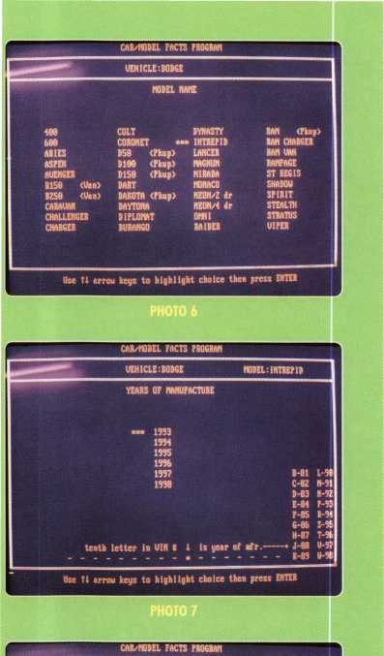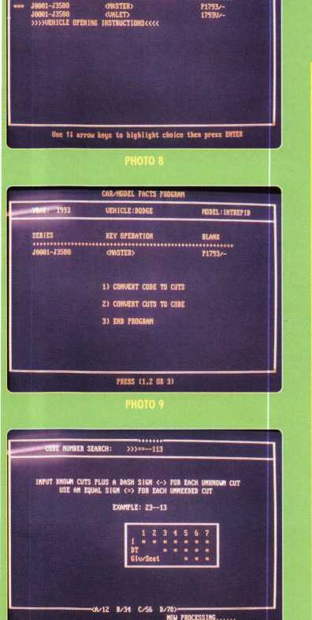

M

carriage info, and Pak-a-Punch accessory info. Press again and you get code machine cutter information for HPC1200, Framon, Ilco and Jensen. One more time and you get ITL and Codemax info. Throughout this process of toggling back and forth with the up and down arrows, the only information that changes on the screen is the code machine information in the bottom right hand corner. That is except for the next selection.

When you press the down arrow the next time you will see the Framon code machine information in the bottom right hand corner.

In this case, however, the spacing dimensions have changed. This spacing variation will only occur in the Framon category when the key is tip stopped. It has to do with the construction of the Framon code machine. The spacing dimensions in the Framon setting look as if they are for a shoulder stopped key. If you aren’t familiar with the Framon machine you probably won’t understand why this happens, but let me assure you that it works properly that way.

Vertically down at the right hand side of the screen are a number of commands that are accessed by pressing the first letter of the word. “INFO” allows you to add information of your own or to edit information that was previously added. “CHANGE” allows you to change data in the program related to the particular code.

Be very careful using this feature, because you could input false code information by mistake. “EDIT” doesn’t work in this particular screen. “SEARCH” will allow you to look up another code in the same code series. On the very bottom right hand part of the screen (below the code machine info) are two other commands: 1) End and 2) Restart. “End” will close the program and “Restart” will return you to the first option screen which appears when you first launch the program.

**Special Features**

Computext has some very special features, especially if you are an automotive locksmith. Seeing that we are back at the first option screen, let me now explain the instructions at the bottom right hand of the screen. If we press the enter key without inputting a code number, we get the screen with the Framon code machine information. I’m going to jump right into selection #2, and show you some very interesting things. I pressed “2” and the next screen appeared.

Photo 5 shows a good sized list of automotive brands from Acura to Yugo.

This feature will explain itself as I guide you through it. I’ve highlighted “DODGE” and when I press enter, I get the screen in photo 6. This screen lists all the different Dodge car

***Keynotes***

February 1998

models over the years. I highlight “INTREPID” and press enter. Photo 7 shows me the different model years that the Intrepid was made and the bottom right hand part of the screen indicates how you can determine the year from the VIN. Choosing “1993” and pressing enter brings me to photo 8. When I choose the highlighted code series at the top, I get the choices found on the screen in photo 9.

If I choose #1,1 can pick a code number and get the cutting information, just as I did earlier. If I choose #2,1 have a few options. If I want to provide my customer with a code number (when he/she already has an operating key), I can input the cuts and the program will search for the appropriate code number. I did choose #2, but I had something else in mind.

The next screen that draws up (not pictured) shows the tumbler arrangements for the car I had chosen. By removing the glove box lock I can determine the last three cuts. In this case, they are: —113. A dash (-) indicates an unknown cut, and an equal sign (=) indicates an unneeded cut. The resulting list is shown in photo 11. This is a list of cut combinations that share the known cuts. Although only 48 are showing on the screen, 68 were discovered.

At the bottom of the screen, my choices are: 1) END, 2) RESTART and 3) PROGRESSION. When I pressed #3 (not pictured), I got the message that a progression of that size was impractical. Four digits is a lot to progress.

If I had a bit more information, I could make a customized progression chart for this particular lock.

**Computext- The Next Generation**

It seems to be overly ambitious to try and progress four cuts when you only know three of the total seven cuts needed. It may not seem such an incredible task, when I reveal an additional option that was on the screen in photo 11. At the far right hand side of the screen reading vertically down (just below “EDIT”), you may notice the word “TRYOUT.” I suppose it might be cheating a bit since this feature is not on the current version of Computext, but it will show up soon in the next version. When I typed the letter “T” for “TRYOUT,” I ended up with the screen shown in photo 12.

The list in photo 12 is a very specialized progression chart. First of all, it is customized to a particular set of locks. Secondly and maybe more importantly, it is a tryout progression. Like tryout keys, it makes use of half depths.

In this case four full depth increments are reduced to two tryout depth increments, which dramatically reduces the number of cut combination variations needed to create a functional key.

Not impressed? Let me break down the figures for you. A non-specific progression chart where seven cuts are required and we only have three, requires us to find four unknown values. With four increments possible per position, you get 4x4x4x4 or 256 possible unique combinations. Just the custom progression feature alone (without the new Tryout function) reduced that 256 by 188, to get only 68 combinations. The tryout function reduced that number to 16 and by arranging the combinations in a way to re-cut the same keys over and over, it can generate all the combinations with only six key blanks.

The cut depth dimensions are shown on the bottom of the screen. The “A” dimension is a half depth between #1 and #2. “B” is likewise half way between #3 and #4.

**Stuff that’s Already There**

Beside the features mentioned earlier (excluding the “TRYOUT” function), there is another rather interesting feature included with the current version of Computext. If you look back at photo 8, you’ll see at the bottom of three selection options “VEHICLE OPENING INSTRUCTIONS.” If you had made that selection, you’d have arrived at a screen similar to that in photo 13. Actually the center box of the screen would have been blank, but the five selection options at the bottom of this screen would have been there. This option is the result of pressing FI. You’ll notice that it gives fairly specific car opening instructions for the 1993 Dodge Intrepid. At the bottom of the center box is the rotation direction for picking the passenger door lock, and the explanation that there are no codes on any of the car locks. The illustration indicates that the opening tool goes approximately nine inches down into the door.

Pressing F2 gets the screen variation in photo 14. Although photographed too light from the computer screen, I can attest that the image is quite clear to the eye. If you would have pressed F3 (not shown) you would have seen the proportions and dimensions for making your own car opening tool. Although not pertinent to the car opening, both photos 13 and 14 show at the top left hand corner of the screen that this car model has a driver air bag.

Similar information for a 1997 Lexus LS400, in photo 15, reveals the car to have both driver and side air bags. That could be valuable information when confronting this car in a lockout situation. The existence of codes on the passenger door lock is also revealed.

I don’t know that this feature would be an adequate replacement for a car opening kit, but as a computer program it could be quite valuable when quoting prices over the phone for a lockout or fitting keys.

**Buying Computerized Codes**

As I had mentioned earlier, there are four major code programs. Up until now, I had been familiar with the other three but had no real familiarity with Computext. The other three are: HPC’s CodeSource (Windows),

Blackhawk’s COD- Codes on Disk (Windows and DOS versions) and Treskat’s Codemaster (DOS only). Computext, as I’d mentioned earlier, is DOS based. From an operational standpoint, it is my opinion that they are all good programs. Each has individual weak points and strengths. I don’t think there is a one-size-fits-all program that all locksmiths will agree upon. What one locksmith considers a major flaw might not even be a consideration for another locksmith.

For example, some code programs will work with the ITL computerized code machines. A locksmith who didn’t own an ITL probably wouldn’t even consider that feature (or lack of it) any part of his or her decision when shopping for a code program. For some locksmiths the amount of hard drive memory could be a consideration. For a locksmith who didn’t intend to buy a new computer any time soon who was running out of space on his hard drive, a memory hungry program would be totally out of the picture. Someone else with a multi-gigabyte hard drive probably wouldn’t care.

Getting feedback from people who own the specific programs, and trying it hands-on (if they’ll let you) is good way to find what fits you best. Consider customer service as part of your criteria. Although I’ve never heard anything extensively critical of three of the companies, postings on Clearstar indicate many owners of the Treskat program telling stories of being insulted on the phone and treated rudely (including foul language) by the owner of Treskat when calling for technical assistance. Buyer beware.

the Author: Sal Dulcamaro,

CML, has been in the locksmith business for over

|  |  |  |  |  |  |
| --- | --- | --- | --- | --- | --- |
|  | JZZ9Z 1ZZ3113 | 17 | 32271 2243113 | 33 | 39684 3132113 |
| z | J15S6 1242113 | 18 | 31685 2312113 | 34 | 31855 3213113 |
| 3 | 38224 1243113 | 19 | 39941 2313113 | 35 | 32484 3223113 |
| 4 | J1485 1322113 | 29 | 31694 2323113 | 36 | 38158 3242113 |
| 5 | J8Z73 1323113 | 21 | 39615 2342113 | 37 | 31332 3243113 |
| 6 | J2794 1342113 | 22 | 39695 2343113 | 38 | 33353 3421113 |
| 7 | 32142 1343113 | 23 | 39619 2421113 | 39 | 33389 34ZZ113 |
| 8 | 32659 2123113 | 24 | 39616 2422113 | 48 | 39793 3423113 |
| 9 | 39994 2132113 | 25 | 36528 2423113 | 41 | 31234 3431113 |
| 19 | 31294 2133113 | 26 | 32976 2431113 | 42 | 32924 3442113 |
| 11 | 39999 2212113 | 27 | 38196 2432113 | 43 | 33347 3443113 |
| 1Z | 32548 2213113 | 28 | 32828 2433113 | 44 | 33194 4212113 |
| 13 | 31961 2223113 | 29 | 32286 2442113 | 45 | 38189 4213113 |
| 14 | 31288 2231113 | 38 | 32246 2443113 | 46 | 32818 4221113 |
| 15 | J283S 2233113 | 31 | 32925 3122113 | 47 | 32867 4222113 |
| 16 | 32573 2242113 | 32 | 39298 3123113 | 48 | 31933 4223113  _TnTU! = Afi 1 ■ |
|  |  | “(ft/12 | B/34 C/56 D/78>““" 1)END 2)*ESTA8T | 3)PMJ6JtESSI0N {CHOICE? | |

**Progress cats on one key blank per coluw until correct co4e Is foaml**

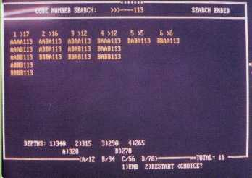

1

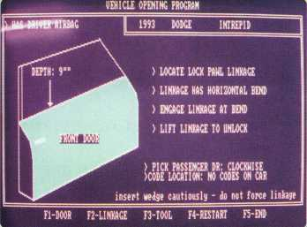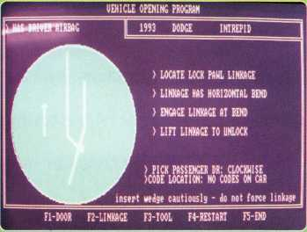

VEHICLE OPENING PROGRAM

22 years. He is the president of All Pro Security, Inc. in Michigan and has been an ALOA member for 15 years. A past president of the Locksmith Security Association of Michigan. Sal currently serves as editor of the association newsletter. He was named “Keynotes Author of the YeaY for 1996-97

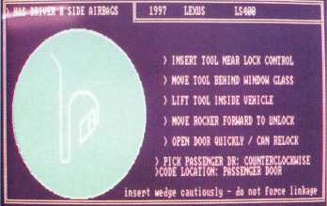

F1-D00R F2-LINKAGE F3-T00L FfRESIARI

February 1998

Keynotes

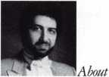

burglary tools can cover a wide variety of commonly used tools.

A partial list would include: glass cutters, cellulose strips, knives, screwdrivers, crowbars, tire irons, pipe wrenches, brace and bits, adhesive tapes or sticky paper,

Fishing poles, keyhole saws, bricks, ladders, sledge hammers, chisels, hacksaws, auto jacks, hydraulic jacks, bolt cutters, acetylene torches, vice grips, locksmith tongs or nippers, and many other tools. All tools listed above are in and of themselves legal.



Keynotes

February 1998

Tools found at the crime scene or in possession of a suspect may be highly significant items of physical evidence. The tools themselves will frequently transfer other evidence onto the crime scene. Such evidence is sometimes as valuable as the tool mark itself. A suspected tool must not be forced or fitted into a mark because of the foreign substance that may be adhering to its cutting edges. Such an attempt at comparison will only serve to destroy evidence. Paint flakes, splinters, and the like that may be attached are removed and lose their value.

Tool marks by themselves mean little, but when they are matched with the instrument that made them, significant evidence can be contributed to the prosecution of a case. Officers must make an earnest attempt to take tool mark measurements, which means that a small ruler should be located on a sketch and/or photographed as a means of recording their extent, locations and pattern.

The photograph may also be used for comparison purposes in the event the suspected tool is located. In the case of a burglary, a photograph of a whole window showing the location of the jimmy marks and another of a close up of the marks must be made.

Although photography is used to preserve the evidence of tool marks, attempts should be made to keep them in their original state whenever possible. Movable objects such as safes, cash boxes, cabinets, and the like offer little difficulty as the marks may be collected by recovering the whole object. If a lock is destroyed by the burglar and will be discarded by the victim, all efforts should be made to obtain it for evidence. If a tool mark on metal is not immediately recovered, it should be covered with a thin film of oil to prevent oxidation.

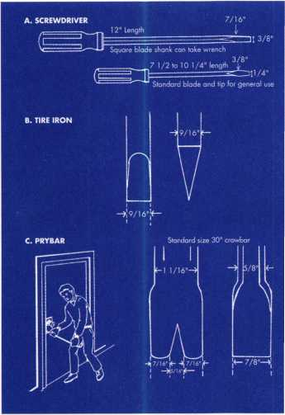

‘Tool marks by themselves mean little, but when they are matched with the instruments that made them, significant evidence can be contributed to the prosecution of the case.”

1. **PRYING TOOLS**

By recognizing the impressions made by these three prying devices, you’ll be more familiar with the type of tool used most frequently in burglaries. In nearly one third of the burglary reports, a prying tool was used to gain entrance.

Where these are used to gain entry, try to obtain a picture of the pry marks. If the victim is going to have to change the molding on the door frame, ask him to save the molding with pry marks for evidence. If a suspect is caught with the right tools, then those can then be compared to the evidence.

1. **TWISTING TOOLS**

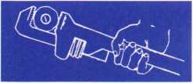

Ten percent of burglary cases involve twisting tools—pipe wrenches, channel locks and vice-grips. Where twisting tools are used on the door knob, the lock should be obtained as evidence for comparision purpose should a burglary suspect be caught with such a tool. With an 18-inch long twisting tool (the maximum size considered easily concealable), a maximum torque of 3,300 in-lbs. was determined to be applied to a door knob or protruding deadbolt cylinder housing.

Pipe Wrench

With this type of twisting tool, the marks left on the door would be mostly striations and would leave only a slight impression,

while the channel locks leave more of an impression than striations.

Channel Locks ■■■■■miii ■■■mil niir|fr

On the most common lock attacks, the width of the channel locks were found to be either 5/16" wide on the ones made in Japan. This twisting tool also leaves both impressions and striations on the knob.

Vice Grips mi min' i —!►

The width most frequently used is 1/2" to 5/8". The marks left are deep impressions and some striations.

**III. CUTTING TOOLS**

Bolt-Nippers or Blacksmith Tongs

Bolt-nippers are positioned on a  
protruding lock cylinder (see diagram).

A sharp fast downward force is then applied causing the cylinder guard and lock cylinder to break away, exposing the internal mechanism that can then be operated by finger or screwdriver.

B. Bolt Cutters

**IV. OTHER TOOLS**

The following tools are used in five percent or less of the burglary cases to gain entry, but are included for your general knowledge and ability to recognize these less frequent typed of entry.

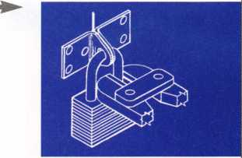

February 1998

Keynotes

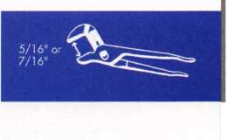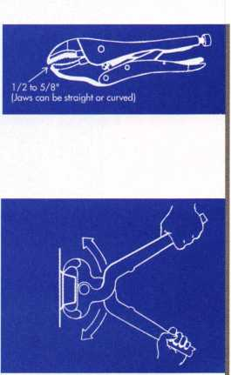

Screwdriver and Wrench

The screwdriver is inserted in the key slot and the wrench is used to turn the lock, thus causing the pin tumblers to break. The door knob can then be operated by hand.

Battering Ram

Either breaking a door knob off with a heavy pipe—or placing a hollow pipe over the end of the door knob and applying a downward force to break it off— will expose the internal mechanism of the lock. The internal mechanism can then be operated by hand or screwdriver. In this type of attack, no tool marks will be left at the crime scene.

Puller

The “slide hammer” or “dent puller” is commonly sold for use in automobile body repair shops. It also services as a tool to pull the plug or lock cylinder out of the lock body or housing, exposing the internal mechanism for operation by finger or screwdriver. With this tool, a hardened self-tapping screws engaged fully in the lock cylinder’s keyway.

Bumper or Hydraulic Jacks

With the standard bumper jacks or a hydraulic jack, the force of the jack can be applied between the two jambs of the door in order to spread them and overcome, by deflection, the length of the latch throw. In this type of attack, look for marks on the side of the door jambs.

Spring Loaded Punch

This type of attack is very uncommon but it’s included for informative purposes. Tempered glass has a skin that is formed around the glass. Once this skin in pierced, the glass disintegrates into small cubes or crystals about the size of the thickness of the glass. Tempered glass can be found on the patio doors and car windows, except for the windshield. Any sharp pointed instrument will pierce the skin and cause the glass to disintegrate.

Padlock

This tool is designed to pull the shackle out of the padlock body.

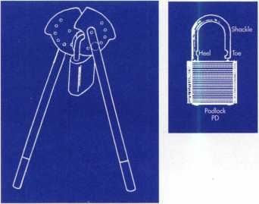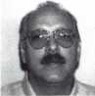

»About the author: Steven B. Spiwak

is a fourth generation locksmith who specializes  
in a variety of variety of areas including crime  
prevention and institutional security. His broad  
experience in the security field spans 20 years of  
writing, teaching and consulting. Spiwaks lengthy  
client list includes Ford Motor Company, Exxon,  
The Chicago Tribune, Sears, Westin Hotels, the  
U.S. Treasury Department and the Federal  
Bureau of Investigation. Most recently he formed  
Lockport, Inc.—a security consulting company  
for industrial, commercial, institutional and  
governmental clients. Readers with article  
suggestions or requests for him can contact  
ALOA at email [publ@anet-dfw.com](mailto:publ@anet-dfw.com) or fax  
to (214) 827-1810.

lave you felt like you’ve been forgotten by the insurance industry?

I don’t blame you. Insurance companies have come along in the past  
without offering anything for your business. They wanted to write  
locksmiths but didn’t have a program for locksmiths. All they could  
give you was off the shelf products.

Janis Program Administrators has been known in the alarm and  
monitoring industry and identifies what we call vertically integrated  
markets, such as the locksmith industry, and modifies and customizes  
the insurance to meet specific needs.

One locksmith may specialize in auto locks whereas another one  
specializes in high-rise or condo systems but most locksmith, safe or  
vault companies are pretty similar. There are different variations but  
it’s still one market. In other words, we identified an industry that  
despite some minor differences within had similar insurance needs  
and no customized coverage.

We spent over two years learning about the locksmith  
market by talking to locksmiths and by identifying what they do and

how they operate on a daily  
basis. We found out what kind  
of coverages they may want

and pinpointed areas where we can offer customized insurance.

Here’s an example. Until now, you’ve only been able to get auto insurance covering comprehensive and collision. Comprehensive covers anything else that happens to the vehicle other than collision. If you haven’t collided with something then it’s a comprehensive claim and subject to your deductible. If you run off the road and hit a tree, a building or another car—that’s collision. A normal deductible for your comprehensive is $250 while your deductible for collision is most likely $500.

How does depreciation specifically affect your business? Some organizations in identifying the market have seen that there are a lot of lock, safe and vault companies out there who, out of necessity, from the nature of their business, work exclusively out of their vehicles. Some, even if they have their own store, they use the vehicle as an integral part of their business going so far as installing custom equipment. In the lock and safe and vault industry, there are even professionals who specialize in installing a whole interior of drawer, bins and counters in a locksmith’s vehicles. Some of you may have installed these yourselves. In any case, it’s not cheap.

If you’ve just spent $10,000 putting in drawers, bins, counters and equipment, and you’re involved in an accident, you’re not going to see close to $10,000 come your way from the insurance company. You’ll be lucky if you see 50 percent because they will tie that value into the depreciation of the vehicle. Some companies may even try to hurt you more than that by giving you even less or, worse, nothing at all.

What gives them the right? Here’s their reasoning. They would ask you, “If you trade vehicles, are you going to take out those drawers, bins, counters, and equipment and put in the new vehicle?” The locksmith says sure. The claims adjuster then says, “Oh, it’s not permanently installed. No coverage at all.”

Broadening the Automobile Policy

By Rick Janis

Fortunately, some insurance reads: “We will pay the additional repair or replacement cost necessary to customize the damaged auto with equipment of like kind and quality that was included with the auto prior to a loss. We will pay the cost of installation onto a replacement auto if the covered auto is nor repairable. The customization will include all permanently installed equipment usual and incidental to the insured’s business. The maximum companies will pay in any one accident is $25,000.

Your vehicle still gets paid ACV. But we know the drawers, bins, counters and equipment in your vehicle are valuable to you. That’s how you run your business. Keep in mind that I’m not talking about the inventory in the truck. Historically the insurance industry has always treated the vehicle and its permanently installed equipment separate from loose contents. Some organizations won’t break from that tradition. You can get that through a property coverage form that covers property in transit in a vehicle.

If you ask other insurance companies who don’t have a special program for the locksmith industry, they’ll either tell you that they can’t do that, they don’t know how to do that or they’ll put it on some kind of floater for you. It will probably wind up costing an arm and a leg. Some of you may have probably said that it would be great to have but you couldn’t get it. Most of you probably thought that if someone offered it to you, you wouldn’t pay that price. You figured you would take your chances. Now you don’t have to. The terms can be changed to be in complete favor of the locksmiths.

About the Author Rick Janis headsJanis Program Administrators and also has a separate program for alarm and monitoring companies. To contact him, call (860) 232-7739 or fax him at (800) 240-0631.

February 1998

Keynotes

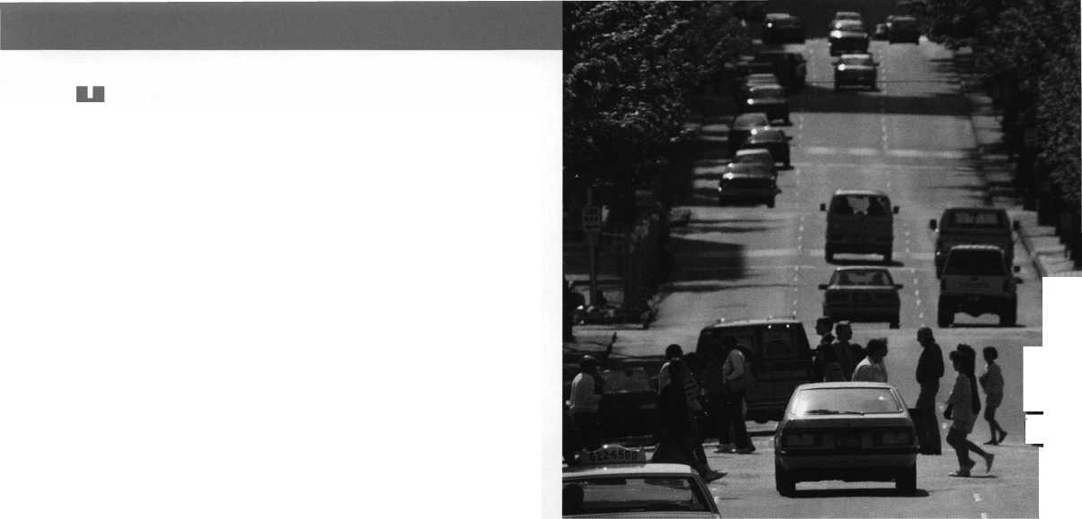

Benefitino From

By Don Dennis, CPL

I have always been surprised at how many  
locksmiths do not concern themselves with safe  
work. They take on the challenges of opening  
expensive cars, or whipping out their trusty drill  
and laying a hole saw into a fancy handmade  
(one-of-a-kind) wooden door, or executing a  
free-hand attempt at the installation of special  
locks on aluminum doors and frames. Yet stare  
down a safe? No way! If the cost of the item is  
not the problem then it must be due to the  
mystique that a safe is not to be entered. It must  
be a mental thing.

Over the next several months, I hope to begin  
to break down the ‘safe block’ that confronts so  
many of my colleagues. Opening and servicing  
safes only requires more time than the other  
tasks that I have mentioned. The monetary  
return for this time spent is as great if not far

greater than most other areas that we work  
in. The only thing that anyone needs to do

basic work in the safe world is a little  
education, and proper tools. You already  
have common sense, patience, and a piece

of paper to write out your billing invoice.

Let us begin!

ATTITUDE AND EDUCATION

I hear all of the excuses from, “I don’t have safes in my yellow page ad!” to “I’m too old!” to “I don’t have the time!” Of these, time is the only real concern. So what if you do miss an auto lock-out or a call to fix a house lock? You’ll make a lot more on the safe job than both of the others put together. Maybe you are into this safe opening job, and you are beginning to get a little upset and stressed. Time for a break!

When you are starting out, be sure to refer high security, time sensitive safe openings to certified and/or experienced SafeTechs. Most other safe openings can be taken at your own pace. You’ll be surprised how quickly you gain confidence and expertise in the basics.

As in lockmsithing there are a number of ways you can go about learning the basic skills you will need to add safe work to your list of skills. Perhaps you can make arrangements to apprentice with a SafeTech or locksmith experienced in basic safe work. If nobody wants you as competition, consider taking classes through the Safe and Vault Technicians Association — (214) 827-SAFE. This organization has a full slate of classes at their annual convention each spring. Many manufacturers offer training on their equipment. Check “Upcoming Events” in Keynotes to see when and where training sessions are scheduled, Mas Hamilton, for example offers periodic classes. You can also contact

44

Keynotes

February 1998

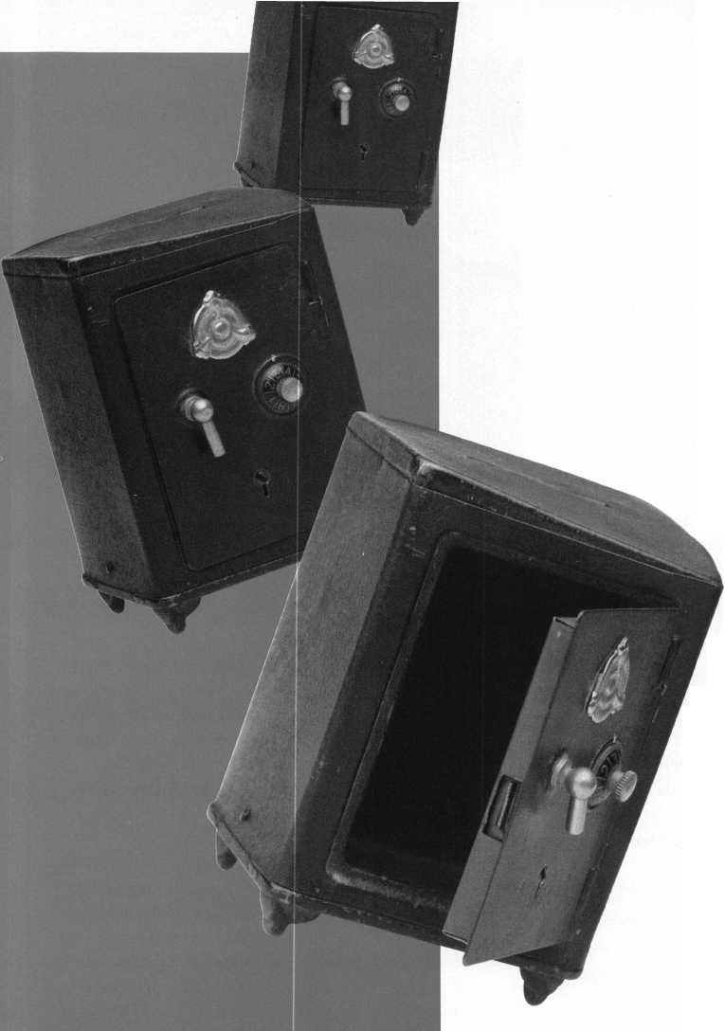

manufacturers directly and ask about training. Other companies such as Lockmas- ters and MBA offer training on a variety of levels. And last, but not least, ALOA offers basic safe training at the annual convention and trade show each July. The point here is that the information and training is available, and it will pay off in increased business for your shop.

SETTING UP YOUR SHOP SYSTEM

So, let’s take the next step to bring basic safe work into your business. The first thing you need to establish is a means of keeping safe customer data. I currently have a computer program that helps me keep track of all of the information. Just like your lock and hardware customers, you will want to remember many things from who the customer is, where they live, their business location, their spouse’s name, children, birthdays, phone numbers, and other personal information. When the part on their biographical information comes to the secured portion, it will be best to keep a separate file. I do this by giving the biographical file a number. This number goes to a file named “the number minus 200.” For example, John Doe has a number of 575 on his biographical file. 575 minus 200 equals 375. In my file cabinet, number 375 does not have John Doe anywhere in the file. It is simply file number 375 and contains all of the safe information, master key information on the business, auto key codes, and home key cuts that pertain to Mr. Doe. (If keys are involved then my key cabinet would have the necessary keys on tag #375.) I should probably add that the biographical information goes with me everywhere. When the customer calls, their information for a casual conversation is with me while the secured file is at the shop.

The one thing that I have not mentioned until now has been a date. The date is critical. I place the date in the biographical file as well as in the secured file. Each time that a safe is serviced or combination changed, this date is also changed. When the date is two years old, I will call the customer and schedule a time for a safe servicing. This means that every two years, like it or not, I have the chance to make some more money. The rule is that you really need to service a safe every year. This is what you tell the customer. If they call, then you have a yearly visit to make. If they don’t call (in my

experience, only five percent will call) then you have the reminder to place yourself back in front of the customer at least every two years. They will often thank you for keeping them in mind and watching out for their interests. They may even trust you all the more for it and rely on your services that much more. I should mention here that I have not always had a computer. But I have always had a day-management calendar of some sort and in that I wrote a list of the dates followed by the customer’s name. This was my reference as to when to pay the next visit. There are other factors that will change this date. If you have to check the safe for a problem during the year, you need to go ahead and give a service and then make a new date for your next visit.

I know that all of this sounds a bit complicated and to some an intimidating liability to keep such records. But if you do master key jobs, then records are a must. This is not any different. I also will use a coding system. An example of a system is in using the letters of a word to represent a number. The word “authorized” where the “a”=l, the “u”=2, the “t”=3 and so forth. Thus a cut key may have cuts numbering “414930” (six pin). In your security record the key would be represented by the letters “hahetd.” A safe combination of 34-76-52 would look like “th-ir-ou.” Your records are now secure since to anyone else it will look as if you were in need of schooling!

PROMOTING SAFE SERVICE

The **Yellow Pages** has been a difficult education for me. Some of them (**Yellow Pages** salespeople) guide you into feeling helpless and somewhat neurotic — unable to function without them. They are wrong!!!

Let me say this again. They are wrong!!!

Your best advertising is word-of-mouth from happy customers to personal contact and community involvement. Yes, I will agree that the **Yellow Pages** are useful for the person with an emergency who has never hired a locksmith or the newcomer in town doing a pricing survey. So put a small in-column ad and put the rest of your money in your own pocket. I have run the $l,000-a- month ads and, after being established for 20 years, I have been unlisted. It all comes down to the people you know and the part you play in the community.

So maybe we the locksmiths need to become more friendly and outgoing. I am running on like this to bring up the point that safe work advertising is not only for the

**Yellow Pages.** Get out and talk to the merchants and business people. Not only in solicitations but also in your community projects. You will find that the SafeTech is valued by the community to the point that you will not only have their safe work, but you will also have business locks to change and their homes to install locks on. Their employees will see the esteem that their boss has for you and they too will use your services. The ball keeps rolling since the employees have friends too.

The next thing that you need to do is to include safe servicing and combination changing on your business cards. With all of the personal contacts that you will be making to build up your accounts, you need to make the one thing that the future customer will keep to reflect the services that you perform. On the back of the card, make a place for you to write out the safe combination. The customer will carry this card forever (if not, your phone will ring) or until you hand them a new one with their new combination.

Contact NEBS or some other outfit to make up some small stickers that you can stick to the safe escutcheon or dial. If the sticker is of a light metal film style, it will last forever and the competition will have a devil of a time getting them off to put on theirs. This way when the employee has a problem with the safe they will know who to call when the boss is on vacation. NEBS is in the paper product business and can be reached for a free catalogue at (800) 225- 6380. Don’t be bashful about putting your sticker on a safe. Don’t hide it on the inside either. A locked safe doesn’t talk and your customer will run to the **Yellow Pages** with an emergency.

Again, should you come across the call asking you to open a safe that is well beyond your capability, ask a certified and/or experienced SafeTech to help. Ask to be their assistant. Just think of what you will learn and still be able to keep your customer.

About the Author: Don Dennis, CPL, owns and operates Dennis Safe & Lock in Johnson City, Tenn.

i

February 1998

***Keynotes*** | 45

**Associate**

Members

|  |  |
| --- | --- |
| Manufacturers | American Lock Co.  3400 West Exchange Road  Crete, IL 60417-2099 (708) 534-2000; FAX (708) 534-0531 |
|  | s s |
| A & B Safe Corp.  171 S. Delsea Dr.  Glassboro, NJ 08028 (800) 253-1267; FAX [609) 863-1208 | American Security Products  11925 Pacific Ave.  Fontana, CA 92337-6963 (800) 423-1881; FAX (909)685-9685 |
| (0 | • • |
| Adesco Safe Manufacturing Co.  16720 S. Garfield Ave.  Paramount, CA 90723 [800) 821-6803; FAX (310) 408-6427 | Arrow Lock Company  10300 Foster Avenue  Brooklyn, NY 11236 (718) 257-4700; FAX (718) 649-9097 |
| e | 0 9 9 9 |
| ASSA Inc.  10300 Foster Ave.  Brooklyn, NY 11236 (800) 235-7482; FAX (718) 257-2772 | Auto Security Products (A. S. P.)  P.O. Box 10  Redmond, WA 98073-0010 (425) 556-1900; FAX (425) 558-1205 |
| • | • • |
| Abus Lock Company  3555 Holly Lane North  Plymouth, MN 55447-0507 (800) 352-2287; FAX (612) 509-9939 | Baton Locks & Hardware Co.  14275 Commerce Dr.  Garden Grove, CA 92643 (714) 265-3636; FAX (714) 265-3630 |
| e | e • |
| Adams Rite Manufacturing Co.  P.0. Box 1301  LaPuente, CA 91749-1301 (562) 699-0511; FAX (562) 699-5094 | Chicago Lock Company  10100 88th Ave.  Pleasant Prairie, Wl 53158-0069 (800) 445-3204; FAX (414) 947-7178 |
| • # | • |
| Adrian Steel Company  906 James St.  Adrian, Ml 49221  (800) 677-2726; FAX (517) 265-5834 | Corbin Russwin Architectural Hardware  P.O. Box 25288  Charlotte, NC 28229 (800) 543-3658; FAX (800) 447-6714 |
| • | • • • • |
| Alarm Lock Systems, Inc.  345 Bayview Ave.  Amityville, NY 11701 (800) ALA-LOCK; (516) 789-3383 | Curtis Industries  6140 Parkland Blvd. Ste. 300  Mayfield Heights, OH 44124-4103 (800) 555-5397 |
| • | • <S |
| Aiphone Intercom Systems  1700-130th Avenue, NE  Bellevue, WA 98005 (206) 455-0510; FAX (206) 455-0071 | DETEX  302 Detex Dr.  New Braunfels, TX 78130 (800) 729-3839; FAX (210) 620-6711 |
| see | • • • • |
| All-Lock Company  900 Ravenwood Dr.  Selma, AL 36701  (334) 874-9001; FAX (334) 874-6011 | Don-Jo Manufacturing, Inc.  P.O. Box 929  Sterling, MA 01564 (508)422-3377; FAX (508) 422-3467 |
| • • | • t |
|  |  |



Associate members of the Associated Locksmiths of America (ALOA) manu­facture or distribute materials or equips ment, or provide services, for die securi­ty industry. Many have donated money, services and equipment to ALOA in addition to their annual dues. Their sup­port of ALOA projects enhances overall membership benefits and we encourage our members to patronize these firms. If you know of a potential candidate for associate membership, please contact the ALOA Sales staff at (214) 827-1701. Associate member dues are $500 per year and entide the payor to use the ALOA logo, and selected discounts on ALOA products and services.

Legend

Alarms: Personal, vehicle, electronic, fire, burglar, and exit

**9** Automotive: Lockout equipment, key chains/rings

9 Builders Hardware: Door closers, furniture/decorative hardware, viewers, emergency exit devices

9 Business/Technical & Educational: Books, reference guides, publications, computer software

9 CCTV/Photo Imaging: Cameras, monitors, photo ID equipment, cables

9 Electric/Electronic Security: Card access control and readers, surveil­lance, electric/magnetic locks mid strikes, keypads

9 Lock Devices: Auto locks, cylinders, emergency exit/entrance control, locks (various types), strikes

**9** Tools & Supplies: Key blanks, cutters, picks, rings/hooks, custom van/truck supplies



461 ***Keynotes***

February 1998

|  |  |  |
| --- | --- | --- |
| Door Controls International  2362 Bishop Circle East  Dexter, Ml 48130  [800)742-3634; FAX [800) 742-0410 | Hurd Corporation  503 Bohannon Rd.  Greeneville, TN 37744-1450 (423) 787-8800; (423) 787-8817 | Locksmith Publishing Corp.  850 Busse Hwy.  Park Ridge, IL 60068 (847) 692-5940; FAX (847)692-4604 |
| 99 9 9 | • • • | • |
| Emtek Products, Inc.  15250 E. Stafford St  City of Industry, CA 91744 [800)356-2741; FAX (800) 577-5771 | llco Unican  400 Jeffreys Road  Rocky Mount, NC 27804 (919) 446-3321; FAX (919) 446-4702 | Lori Lock  P.O. Box 1040  Southington, CT 06489 (860)621-3605; FAX (203) 621-5972 |
| 9 9 | ••••••• | 9 9 |
| ESP Lock Products, Inc.  375 Harvard Street  Leominster, MA 01453 (508)537-6121; FAX (508) 537-1699 | Industries, C.L. Inc.  9730 Gouin Blvd. West  Pierrefonds (PQ) H8Y 1R5 (514)683-6282; FAX(514) 683-9015 | Lucky Line Products  7890 Dunbrook Rd.  San Diego, CA 92126 (619)549-6699; FAX (619) 549-0949 |
| • | • • | 9 |
| Federal Lock Company  14247 E. Don Julian Rd.  City of Industry, CA 91746 (800)682-9851; FAX (708) 378-4767 | International Electronics, Inc. (I.E.I.)  427 Turnpike St.  Canton, MA 02021 (800) 343-9502; FAX(617) 821-4443 | M.A.G. Engineering & Mfg. Inc.  15261 Transistor Lane  Huntington Beach, CA 92649 (714)891-5100; FAX (714) 892-6845 |
| • | • | 9 9 • |
| Folger Adam Security, Inc.  16300 W. 103rd Street  Lemont, IL 60439  (630) 739-3900; FAX (630) 739-6138 | Jet Hardware Mfg. Co.  800 Hinsdale Street  Brooklyn, NY 11207 (718) 257-9600; FAX(718) 257-0973 | MARKS USA  5300 New Horizons Blvd.  Amityville, NY 11701 (516) 225-5400; FAX (516) 225-6136 |
| • # | • | 9 |
| Fort Lock Corp.  3000 N. River Rd.  River Grove, IL 60171 (708) 456-1100; FAX (708) 456-9476 | KABA High Security Locks  P.O. Box 490  Southington, CT 06489 (860) 621 -3601; FAX(860) 621 -9727 | Master Lock Company  2600 North 32nd Street  Milwaukee, Wl 53211 (414) 444-2800; FAX (414) 449-3114 |
| •••••• | • | 9 9 |
| Gardall Safe Corporation  P.O. Box 30  Syracuse, NY 13206 (315) 432-9115; FAX (315) 434-9442 | Kenstan Lock Company  101 Commercial St  Plainveiw, NY 11803-2412 (516) 271-2700; FAX(516) 271-2759 | Medeco Security Locks  P.O. Box 3075  Salem, VA 24153  (540) 380-5000; FAX (540) 380-5010 |
| • | • • | • 9 9 |
| Grobet File Co. of America  750 Wasahington Ave.  Carlstadt, NJ 07072 (800) 962-7242; FAX (800) 243-2432 | KEY-BAK; Div. of W. Coast Chain Mfg. Co.  1460 S. Balboa Ave.  Ontario, CA 91762 (909) 923-7800; FAX0O9) 923-0024 | Meilink Safe Company  111 Security Parkway  New Albany, IN 47150 (800) 634-5465; FAX (800) 896-6606 |
| • | • • • • | 9 |
| H.E.S., Inc.  2040 W. Quail Ave.  Phoenix, AZ 85027 (602) 582-4626; FAX (602) 582-4641 | Knaack Manufacturing Co.  420 E. Terra Cotta Ave.  Crystal Lake, IL 60014 (800) 456-7865; FAX(815) 459-9097 | MUL-T-LOCK USA, Inc.  300-1 Route 17 South Suite A  Lodi, NJ 07644  (800) 562-3511; FAX (201) 778-4007 |
| • • • | • | 99 9 |
| Highland Glen Products, Inc.  218 Parkdale Ave.; P.O. Box 924  Buffalo, NY 14213 (716) 883-1110; (800) 248-KEYS | LCN Closers (Division of Ingersol)  121 W. Railroad Ave.  Princeton, IL 61356 (815)875-3311; FAX (815)875-3222 | National Cabinet Lock  200 Old Mill Road, P. 0. Box 200  Mauldin, SC 29662 (864) 297-6655; FAX (864) 297-9987 |
| • • | • | • |
| Hill Security Products  711 East Walton Avenue  Spokane, WA 99207 (509) 487-1142; (800) 722-1142 | LAB Security  700 Emmett St.  Bristol, CT 06010  (800) 243-8242; FAX (203) 583-7838 | The National Locksmith Magazine  1533 Burgundy Parkway  Streamwood, IL 60107 (630) 837-2044; FAX (630) 837-1210 |
| • | 9 | • |
| HPC, Inc.  3999 N. 25th Avenue  Schiller Park, IL 60176 (847)671-6280; FAX(847) 671-6343 | La Gard, Inc.  3330 Kashiwa Street  Torrance, CA 90505 (310)325-5670; FAX (310)325-5615 | Newman Tonks  805 N Buckman St.  Shepardsville, KY 40165 (800) 826-5792; FAX (800) 777-8229 |
| • • • | • | • 9 |

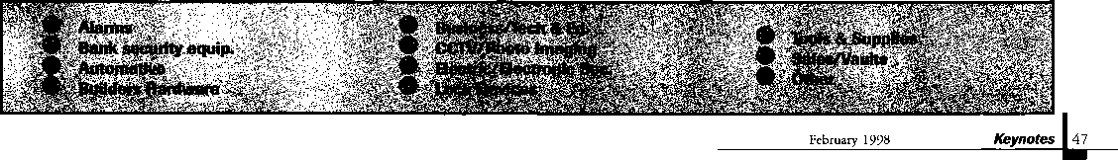

|  |  |  |
| --- | --- | --- |
| NKL Industries Ltd.  1111-13 Cavalier Blvd.  Chesapeake, VA 23323 (800) 528-9900; (757) 485-0271  ^ (0 | Sully Tools Inc.  3515 Nodding Pine Ct.  Fairfax, VA 22033  (703) 689-3416; FAX (703) 787-0869  a a a | Andrews Wholesale Lock Supply  544 S. 9th St.  Lebanon, PA 17042-6608 (717) 272-7422 |
| Prime-Line Products Company  5405 Industrial Pkwy.  San Bemadino, CA 92407 (800) 255-3505; FAX (909) 880-8968  a a | Trine Products Corporation  1430 Ferris Place  Bronx, NY 10461  (718)829-4796; FAX (718) 792-9127  a a a | Boyle & Chase Inc.  P. O. Box 74  Accord, MA 02018-0074 (800) 325-2530; FAX (617) 335-5342  ^ (0 |
| ROFU International Corp.  2004-B 48th Ave.; Court E  Tacoma, WA 98424 (800) 255-7638; FAX (253) 922-1728  • | U-Change Lock Industries  1640 W. Hwy. 152  Mustang, OK 73064 (405)376-1600; FAX (405) 376-6870  a a a | Clark Security Products, Inc.  4775 Viewridge Ave.  San Diego, CA 92123-1641 (800) 854-2088 |
| Rutherford Controls Inc.  2697 Internal Pkwy, Bid 5 #100  Virginia Beach, VA 23452 (757) 427-1230; FAX (804) 427-9549  • | Vindicator Corp.  3001 Bee Caves Rd.  Austin, TX 78746-5561 (512)314-1200; FAX (512) 314-1270  a a a a | Cook’s Building Specialties  2441 Menaul Blvd. NE; P.O. Box 37320 Albuquerque, NM 87176-7320 (505)883-5701; FAX (505) 883-5704  a a a a a a |
| Sargent & Greenleaf, Inc.  P.O. Box 930  Nicholasville, KY 40340-0930 (606) 885-9411; FAX (606) 887-2057  • • • • | Weiser Lock Company  6700 Weiser Lock Blvd.  Tucson, AZ 85746  (520)741-6338; FAX (520) 741-6363  a a | DiMark International  3117 Liberator St., Unit A  Santa Maria, CA 93455 (800) 235-2435; FAX (805) 928-8034  a a |
| Schlage Lock Co.  1915 Jamboree Suite 165  Colorado Springs, CO 80920 (800) 847-1864; FAX (800) 452-0663  • • | Wilson Safe Company  3031 Island Avenue/P.O. Box 5310  Philadelphia, PA 19153 (215)492-7100; (800)345-8053 | Dire’s Lock & Key Co.  2201 Broadway  Denver, CO 80205 (303) 294-0176  eeeeeeeeaee |
| Schwab Corporation  3000 Main St.  Lafayette, IN 47903-5088 (765) 447-9470; FAX (317) 447-8278  a | Yale Security Inc.  P.O. Box 25288  Charlotte, NC 28229-8010 (800) 438-1951; (800) 338-0965  ^ (£} | Doyle Lock Supply  2211 W. River Road N.  Minneapolis, MN 55411 (800)333-6953; FAX (612) 521-0166 |
| Securitron Magnalock Corp.  550 Vista Blvd.  Sparks, NV 89434  (800) 624-5625; FAX (702) 355-5636  a a | Distributors | Dugmore & Duncan Inc.  30 Pond Park Rd.  Hingham, MA 02043 (800)225-1595; FAX (617) 740-4043  @ (0 ^ |
| Security Door Controls  3580 Willow Lane  Westlake Village, CA 91361 (805) 494-0622; FAX (800) 959-4732  a | Accredited Lock Supply Co.  P.O. Box 1442  Secaucus, NJ 07096-1442 (800)652-2835; FAX (201) 865-5031  ^ @ <0 ^ | Ewert Wholesale Hardware  4709 W 120th St  Alsip II 60658 (800) 451-0200  aa a aa |
| Sentry Group  900 Linden Ave.  Rochester, NY 14625-2784 (716) 381-4900; FAX (716) 381-8559  a | Ace Lock & Security Supply Co.  565 Rahway Ave.  Union, NJ 07083-6631 (908) 688-7666; (800) ACE-FAX4  aaaaaaaa | Fairway Supply, Inc.  2631 Lombardy Lane  Dallas, TX 75220  (214)350-0021; FAX (214) 352-4299  U) @ (0 <£) ^ |
| Silca Key U.S.A. Inc.  400 Jeffreys Rd.  Rocky Mount, NC 27804 (919) 446-3321; FAX (919) 446-4702  a a | Akron Hardware Consultants, Inc.  2579 South Arlington Road  Akron, OH 44319  (800) 321-9602; FAX (800) 328-6070  a a a | Foley-Belsaw Company  6301 Equitable Road  Kansas City, MO 64120 (800)821-3452; FAX (816) 483-5010  ^ (|^ (j^ |
| STRATTEC Security Corp.  3333 W. Good Hope Rd.  Milwaukee, Wl 53209 (414) 247-3333; FAX (414) 247-3329  a a a | American Security Distribution  4411 E. La Palma  Anaheim, CA 92807 (714)996-0791; FAX (714) 579-3508  a aa aaa a | Fried Brothers, Inc.  467 N. 7th St.  Philadelphia, PA 19123 (800) 523-2924; FAX (800) 541-3489 |
|  |  |  |

® Business/Tech&MK**\**

r|0^Qevte

i

';- %^$\

t& Supplies

. Safes/Vaults **':}§&i**

Other

48

***Keynotes***

February 1998

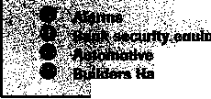

|  |  |  |
| --- | --- | --- |
| HS&S Wholesale Distributors  12915 West 8 Mile Road  Detroit, Ml 48235 (800) 521-2202  @ (0 ^ | M. Zion Company  17 Murray Street  New York, NY 10007 (212) 349-8677  ••••••• | Top Notch Distributors, Inc.  3151 Goni Rd.  Carson City, NV 89706-7922 (800) 722-4210; FAX (800) 248-3620  • • • |
| Hans Johnsen Company  8901 Chancellor Row  Dallas, TX 75247  [214)879-1550; FAX [214) 879-1530  @ <|£) (0 | McDonald-DASH Locksmith Supply  5767 E. Shelby Dr.  Memphis, TN 38141 (800)238-7541; FAX (901) 366-0005  (J) ^ | Turn 10  P. 0. Box 746  Marietta, OH m45750 (800) 848-9790; (800) 391-4553  • • |
| Hardware Agencies, Ltd.  1220 Dundas Street East  Toronto, ON M4M 1 S3 [416)462-1921 | McManus Locksmith Supply, Inc.  P.O. Box 9231,1309 Central Ave.  Charlotte, NC 28299 (702) 333-9112  • • • | U.S. Lock Corporation  77 Rodeo Drive  Brentwood, NY 11717 (800) 925-5000; FAX (800) 338-5625  ^ @ ^ |
| Hardware Suppliers of America  P.O. Box 2208  Winterville, NC 28590 (800) 334-5625  e e | McMaster-Carr Supply Company  600 County Line Rd,  Elmhurst, IL 60126-2081 (630) 833-0300; FAX (630) 834-9427  •••••• | Webster Safe & Lock Company, Inc.  3020 Millbranch  Memphis, TN 38116 (901) 332-2911; FAX (901) 332-2878  ^ ^ @ ^ |
| IDN, Inc.  1000 S. Main, Suite 280  Grapevine, TX 76051 (817) 421-5470; FAX (817) 421-5468  •••••••••• | Monaco Lock Co.  339-345 Newark Ave.  Jersey City, NJ 07302 (800) 526-6094; FAX (800) 845-LOCK  • • • | Service |
| Intermountain Lock & Supply Co  2300 W. 2nd Ave., Unit B  Denver, CO 80223  (800) 323-8046; FAX (303) 698-2094 | Omaha Wholesale Hardware  1201 Pacific Street, PO Box 3628  Omaha, NE 68108 (800) 238-4566  (J) | Alarm Monitoring Service, Inc.  5021 Fairfield St.  Metairie, LA 70006 (504) 454-2163; (504) 456-8737  • |
| Jo-Van Distributors Inc.  929 Warden Ave.  Scarborough, Ontario MIL 4C6 (416) 752-7249; FAX (416) 752-3845 | E. L. Reinhardt Co., Inc.  3250 Fanum Road  Vadnais Heights, MN 55110 (800)328-1311; FAX (612) 481-0166  •••••• | Allstate Insurance Company  2775 Sanders Road, Suite A5  Northbrook, IL 60062 (847) 402-8196; FAX(847) 326-7509  • |
| JLM Wholesale, Inc.  3095 Mullins Ct  Oxford, Ml 48371-1643 (800) 522-2940; FAX (800) 782-1160  ^ (0 (Q | Security Lock Distributors  40 A Street  Needham Heights, MA 02194 (800) 847-5625; FAX (800) 878-6400  • • • | GEICO  One Geico Blvd.  Fredericksburg, VA 22412 (540) 286-4399; FAX (540) 286-7106  • |
| Key Sales & Supply Co., Inc.  9950 Freeland Ave.  Detroit, Ml 48227 (313) 931-7720; (313) 931-7758  ••••••••• | Sentry Security Fasteners  8109 N. University  Peoria, IL 61615  (309) 693-2800; FAX (309) 693-2872  • * | The Hartford Financial Services Co.  55 Farmington Ave.; P.O. Box 2908  Hartford, CT 06104 (860) 520-2915; FAX (860) 520-2264  • |
| Lockmasters, Inc.  5085 Danville Road  Nicholasville KY, 40356 (606) 885-6041  • • • • | Southern Lock and Supply Co.  Box 1980,10910 Endeavor Way  Pinellas Park, FL 34664 (800) 237-2875; FAX: (800) 447-2299 | Pine Technical College  1000 4th Street  Pine City, MN 55063 (800)521-7463; FAX (612) 629-7603  • |
| Locks Company  2050 N.E. 151 St.  N. Miami, FL 33162 (800)288-0801; FAX (305) 949-3619  ••••••• | Stone & Berg Wholesale  99 Stafford Street  Worcester, MA 01603 (800) 225-7405; FAX (800) 535-5625  •••••••••• | Unlocks, Inc.  3505 Tarpon Woods Blvd. G409  Palm Harbor, FL 34685 (800) UNLOCKS; FAX (813) 787-7960 |
| The Locksmith Store Inc.  1229 E Algonquin Rd. Suite E  Arlington Heights, IL 60005 (847) 364-5111; FAX (847) 364-5125  • III | Strauss Safe & Lock Company  1801 Second Avenue  Des Moines, IA 50314 (515)288-9571; FAX: (515)288-9752  •••••• |  |
|  |  |
|  | | |

February 1998

Keynotes

49

Keynotes

Classified



[Deptl

■Employment Locksmith Wanted

l/F/3: Boston based safe company needs organized, management type person to supervise service and delivery crews. Technical background helpful. Salary plus bonuses based on experience.

(800) 367-3453 (617) 497-7542fax

Locksmith Wanted

l/F/3: Locksmith wanted for shop and mobile unit. Minimum three years experience. Good dri­ving record and good communi­cation skills. Call anytime.

Plaza Locksmith Ventura, CA 93003 (805) 653-6946 (805) 644-6622 Ask for Mike or Darlene

Locksmith

l/F/3: Established lock shop in operation 50 years, friendly staff, looking for a qualified locksmith for outside road work. Knowl­edge and experience in various areas of the industry. Safe open­ing knowledge essential. Mini­mum five years’ experience. Pro­fessional attitude, organized, good communication skills, clean driving record. Benefits include health insurance, paid vacation, holidays. Vehicle, tools, two-way radio provided. We’d like to have you join our team. **Resume and references to:**

Dawn Barnes 135 Main St. D12 Wes thorough, MA 01581 (508) 366-8864 fax

Experienced Locksmith Wanted

l/F/3: Join an established lock­smith company in beautiful Marin County, Calif Just 35 minutes north of San Francisco. Pleasant year-round conditions. Good base pay plus commission, profit sharing, paid absence. Paid health and pension also available. Must be proficient in all phases of locksmithing, neat appearance and good driving record. Back­ground check will be required

for state license.

Resume, references and salary requirements:

Novato Lock 7395 Redwood Blvd.

Novato, CA 94945 (415) 892-9111

Store Manager/Locksmith Wanted

l/F/3: Work in beautiful, grow­ing Denver, Colo. Position now available with 27 year company operating three stores and nine service vehicles. Presently look­ing for a hard working, enthusi­astic individual with good lock­smith skills to operate all facets of store operations including inventory control, sales, purchas­ing, and technical service. No mobile or on-call. Paid vacations, holidays, medical/dental, educa­tional classes, and uniforms fur­nished. Salary offering varies with experience level, 33k base for qualified applicants.

Resumes to:

Englewood Lock and Safe, Inc.

4310 S. Broadway Englewood, CO 80110 (800) 257-2568 (303) 789-3748fax

Locksmith Wanted

1 l/F/3: Sacramento Valley Lock- works, Inc. has an immediate, full-time position for an experi­enced, well rounded individual to become a member of our team. All levels of experience will be considered. Our company specializes in Commercial sales and service, Electronic Access Control and Safes. We offer a competitive wage compensation package, including Medical/Dental, paid Holidays and vacation. We will consider financially helping in any mov­ing expenses and locating resi­dency if needed. Applicants must have a clean driving record, clean appearance, be self moti­vated, and possess the capability of working together as a team player. SVL was established in 1988 and is considered one of the top Commercial Security Contractor’s in the Valley.

Shane Huff or Carolyn Hamric (916) 733-0324 fax (for resume) (916) 733-0320 (for interview)

Locksmith Wanted

1 l/F/3: Relocate to Southern California. Experience needed. Residential, commercial, safes, and auto. 40IK, medical insurance, commissions.

Resume, references, and salary information:

The Lock Shop, Inc.

73-560 Highway 111 Palm Desert, CA 92260 (760) 346-5214 (760) 779-1811 fax

Locksmiths Wanted

2/F/3: Largest Locksmith in Las Vegas needs experienced locksmiths (two years minimum) for road technicians and counter help. Base salary plus generous commission program. This is a career opportunity with paid holidays and vacation, medical benefits, 401K plan, and a great advancement potential.

Resume' to:

Liberty Lock & Key 5470 W. Sahara Las Vegas, NV 89102 (702) 876-5470

Locksmith Wanted

2/F/3: Minimum two years experience in service work.

Safe, alarm and access control experience a plus. Must have clean driving record, good communications skills, be hard working and neat in appearance. Salary and benefits commensurate with experience and training.

Resume to:

Lockbusters, Inc.

PO Box 72045 Houston, TX 77272-0475 (281) 265-3335 (281) 265-9434 fax

Locksmith Wanted

2/P/3: Stanford University seeks a Lock Shop Supervisor with an extensive understanding of locks, safes and security systems, and working knowledge of journey-level locksmithing.

Your primary responsibility is to supply efficient, timely and value-added services to the University facilities. In addition, you will supervise the work of seven locksmith technicians.

To qualify, you must have a supervisory background, strong business management skills and experience using preventative, routine and reactive maintenance practices. Excellent time management, organizational and communication skills are a must, as is the ability to think clearly and analytically and identify/ solve problems. A valid California driver’s license or ability to obtain one prior to start date is required. For a full description of this and other positions, see us on the Web at: www-leland.stanford.edu/group /employment. AA/EOE **Resume and cover letter to:**

Stanford University Human Resources Services,

Req. **#** J972511 655 Sierra St.

Stanford, CA. 94395-6110

LOCKSMITH

Mystic Lake Casino Hotel, a leader in Minnesota's gaming industry, is seeking an Independent, discreet locksmith with at Jeast three years’ experience in a lockshop environ­ment and training in low voltage electricity to join our team of nearly 4,000 employees. You’ll need exten­sive knowledge of Medeco and BEST lock hardware, master systems and architectural hardware. Must be pro­ficient in opening cars. We offer a competitive salary and benefits package. All tools are supplied. For confidential consideration, please send your resume to:

Mystic Lake Casino Hotel  
Team Employment  
2400 Mystic Lake Bhref  
Prior Lake, MN 55372

***Keynotes***

February 1998

a number for ' information on each item.

Reader Service

KCynOtGSVe b ru a ry 1998

Use this card to obtain more information about the products and services advertised or described in this issue

**Card valid until June 1,1998.**

Name _

Company

Street Address _ City

Phone_

_Title

_State

_Country _FAX _

_ZIP_

|  |  |  |  |  |  |  |  |  |  |  |  |  |  |  |  |  |  |  |
| --- | --- | --- | --- | --- | --- | --- | --- | --- | --- | --- | --- | --- | --- | --- | --- | --- | --- | --- |
| 6 | 11 | 16 | 21 | 26 | 31 | 36 | 41 | 46 | 51 | 56 | 61 | 66 | 71 | 76 | 81 | 86 | 91 | 96 |
| 7 | 12 | 17 | 22 | 27 | 32 | 37 | 42 | 47 | 52 | 57 | 62 | 67 | 72 | 77 | 82 | 87 | 92 | 97 |
| 8 | 13 | 18 | 23 | 28 | 33 | 38 | 43 | 48 | 53 | 58 | 63 | 68 | 73 | 78 | 83 | 88 | 93 | 98 |
| 9 | 14 | 19 | 24 | 29 | 34 | 39 | 44 | 49 | 54 | 59 | 64 | 69 | 74 | 79 | 84 | 89 | 94 | 99 |
| 10 | 15 | 20 | 25 | 30 | 35 | 40 | 45 | 50 | 55 | 60 | 65 | 70 | 75 | 80 | 85 | 90 | 95 | 100 |

Card valid until June 1,1998.

| number for  
' information on  
each item.

Reader Service

‘February1998

Use this card to obtain more information about the products and services advertised or described in this issue

**Card valid until June 1,1998.**

Name .

Company

Street Address _ City

Phone_

_Title

_State

_Country

_FAX

_ZIP_

|  |  |  |  |  |  |  |  |  |  |  |  |  |  |  |  |  |  |  |  |
| --- | --- | --- | --- | --- | --- | --- | --- | --- | --- | --- | --- | --- | --- | --- | --- | --- | --- | --- | --- |
| 1 | 6 | 11 | 16 | 21 | 26 | 31 | 36 | 41 | 46 | 51 | 56 | 61 | 66 | 71 | 76 | 81 | 86 | 91 | 96 |
| 2 | 7 | 12 | 17 | 22 | 27 | 32 | 37 | 42 | 47 | 52 | 57 | 62 | 67 | 72 | 77 | 82 | 87 | 92 | 97 |
| 3 | 8 | 13 | 18 | 23 | 28 | 33 | 38 | 43 | 48 | 53 | 58 | 63 | 68 | 73 | 78 | 83 | 88 | 93 | 98 |
| 4 | 9 | 14 | 19 | 24 | 29 | 34 | 39 | 44 | 49 | 54 | 59 | 64 | 69 | 74 | 79 | 84 | 89 | 94 | 99 |
| 5 | 10 | 15 | 20 | 25 | 30 | 35 | 40 | 45 | 50 | 55 | 60 | 65 | 70 | 75 | 80 | 85 | 90 | 95 | 100 |

A Lfl. A **Mentor**

Card valid until June 1f 1998.

|  |  |  |
| --- | --- | --- |
|  |  |  |
| Name | PRP | ALOA# |
|  |  |  |
| City | State | Zip |

Years Expe rience

A r_e a s of Locksmi thing **that** you **are proficient in:**

ODomestic Auto OCommerciaL OMaster Keying

OForeign Auto OResidential OAccess Control

OAuto Opening OSafe Servicing OSafe Opening

OCCTV OComputers OBusiness

Other

Avai LabLe for ca L L s :

Phone numbpr?;

Weekdays

Saturday

Sunday

AM tO AM tO AM tO

PM

PM

PM

Days

Nights

Pager

BUSINESS REPLY MAIL

FIRST-CLASS MAIL PERMIT NO 16501 DALLAS TX  
POSTAGE WILL BE PAID BY ADDRESSEE

NO POSTAGE  
NECESSARY  
IF MAILED  
IN THE

UNITED STATES

PO BOX 11602 RIVERTON NJ 08076-7202

lllml..l,ll„.l...l.ll..l...l..l.lll MI..I.I

BUSINESS REPLY MAIL

FIRST-CUSS MAIL PERMIT NO 16S01 DALLAS TX  
POSTAGE WILL BE PAID BY ADDRESSEE

NO POSTAGE  
NECESSARY  
IF MAILED  
IN THE

UNITED STATES

PO BOX 11602 RIVERTON NJ 08076-7202

III...I..I.II...I...I.II..I...I..I.III

ml.IM.I

Place

Stamp

Here

Robert DeWeese, CPL Bear Lock & Security, Inc. 205 Cleveland Ave. Baltimore, MD 21222-4237

Classified Advertising Policy

Classified advertising space is provided free of charge to ALOA members, and for a fee of $.60 per word, $15

minimum for non-members. Classified ads may be used to advertise used merchandise and overstocked items  
for sale, “wanted to buy” items, business opportunities, employment opportunities/positions wanted and the like.

Members or non-members wishing to advertise services or new merchandise for sale October purchase a  
“Commercial Classified Ad,” for a fee of $1.30 per word, with a minimum of $40. Each ad will run for two issues.  
For blind boxes there is a $5 charge to members and non-members. All ads must be submitted in writing to the  
ALOA office by the fifteenth of the month, two months prior to issue date. Send to **Keynotes** Classifieds, 3003  
Live Oak St., Dallas TX 75204-6186. ALOA reserves the right to refuse any classified advertisement that it

deems inappropriate according to the stated purpose of the classified advertising section.

Keynotes

Classified

Locksmiths Wanted

2/F/3: Colorado’s largest locksmith company seeks locksmiths with experience in impressioning, master keying and automotive. Top wages and benefits available for the right persons.

Resume to:

Colorado Security Products, Inc.

5005 South Kipling; Unit A-8 Littleton, CO 80127 (303) 761-4899, Monday through Friday, 8 am - 5 pm, MST

**■Businesses for Sale** Manufacturing Company for Sale

l/F/3: Lock technology corp. New Rochelle, NY, Lock Manufacturing company est. 1974. Owner is retiring.

For details, call Frank

(914) 632-4373

Business For Sale

1 /P/2: Branson, Mo.—America’s live country music capitol. Service the start! Established five years and growing. Full service mobile locksmith business.

$65,000 net year.

(417) 335-2329

Businesses for Sale

l/F/3: Commercial, industrial, residential and automotive. Storefront and mobile service. 25 years in Colorado foothills com­munity of47,000. Busy and pro­ductive business with continued growth. Buyer needs experience in all phases of locksmith appli­cations and hardware installation to meet customer demand. Keynotes Classifieds 3003 Live Oak St.

Dallas, TX 75203

Sunny Southern California

l/F/3: Established in 1962, same owner since 1977. Located in suburban, growing commu­nity near California’s largest water reservoir project. Well- established commercial accounts. Sale includes van, inventory, equipment and com­mercial property. Training avail­

able. Owner willing to stay during transition.

(909) 658-2777

Business For Sale

1 l/F/3: Well-established, large clientele, unlimited potential in fast-growing east Texas community.

(409) 639-1029.

Leave name and telephone number.

■Wanted to Buy/Sell

Safes for Sale

l/F/3: 100 safes, various sizes. Low prices. For a catalog:

Empire Safe Co (800) 543-5412 (212)941-9073 fax Attn: Wholesale Department

Tools and Products for Sale

l/F/3: All types. Safe deposit locks, parts, sections of 50 boxes and bank equipment parts, etc. Best source for Security/ Kumhari Locks.

For information, price list, or ordering:

(800) 642-8763 (972) 289-8476fax

Antiques for Sale

l/F/3: Private collection of old key lock antique safes seven in all: Samuel Jones Improved Sala­mander, Boston E.R. Morse Safe Maker, Boston, E.F. Miller and Sons Safe Maker, Providence, R.I., M.B. Bigelo & Anson Hardy (1884) Valentine Butler, New York, Alum Patent 35" tall, Valentine Butler Alum patent, New York 55" tall. A most distinct collection.

Milton Wolfserder American Safe & Lock Co.

117 N. Main St.

Providence, RI 02903 (701)331-3013

For Sale

2//F/3: Curtis Automatic/ Manual Key Machine MOD. 3100-040. Practically new - $450.00 +.

Call:

Thompson Lock and Security (912) 375-3331 (912) 375-8550 beeper

Key Blanks Wanted

l/F/3: Wanted, Old Auto key blanks, Hurd, and Briggs and Stratton—will pay $1.00 each.

Douglas Vogel 1100 Shady Oaks Ann Arbor, MI 48103

For Sale

l/F/3: Norton Powermate 6610POR door operators. Regular dealer $ 1500/each.

Will sacrifice for $ 1000/each. Purchase all seven for $850/each. (785) 825-6257 Ask for Lonnie

For Sale

l/F/3: Scotsman key machine (Ace type), model 747XU, cuts three sizes. Used but in good condition. Asking $250. Also, Taylor 137S (small) and Taylor 137A (large) key blanks. 20 cents each (approximately 200 pieces).

AAA Distributors

286 Franklin Street

Buffalo, NY 14202

(800) 462-8180 (northeast only)

(716) 856-2261

■Commercial Classifieds

Tryout Keys, Depth Keys

l/P/3: Aero Lock does not use key duplicator machines to produce its tryout keys or depth keys. Only original computer controlled code cut. Buy the best.

Aero Lock

3675 New Getwell Rd. #9 Memphis, TN 38118 (800) 627-9433 (901) 362-1197 fax e-mail: [aerolock@ix.netcom.com](mailto:aerolock@ix.netcom.com), http:!I[www.aerolock](http://www.aerolock). com

Situations Wanted

1 l/F/3: ALOA member since 1973 relocating to Kyiv (formerly Kiev), Ukraine for next two to three years. Willing to represent your interests or line of products in Eastern European region.

V.M. Roubachewsky, c/o Dept, of State-Kyiv,

Washington D.C. 20521-5850

(301)884-5915

e-mail: natalier@mail.ameritel. net.



**•A.**

International Convention and Security Expo June 14-20,1998 Nashville Convention Center 800-532-2562 • 214-827-1701 convtion@anet- dfw. com

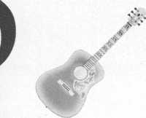

February 1998

Keynotes

51

**Get the best master keying textbook**



**around, written by one of the n well- known locksmith instruct in the profession.** Just $44.00 **(including shipping and handlii Fundamentals of Master Keyint covers system structure and rei keeping; basic mechanical and arithmetic concepts; and how t write a system.**

*An Introduction to Split Pin Master Keying*

To order, write or FAX

Associated Locksmiths of America Inc.: 3003 Live

Oak Street Dallas TX 75204 FAX (214) 827-1810

Credit card orders: Phone (214) 827-1701

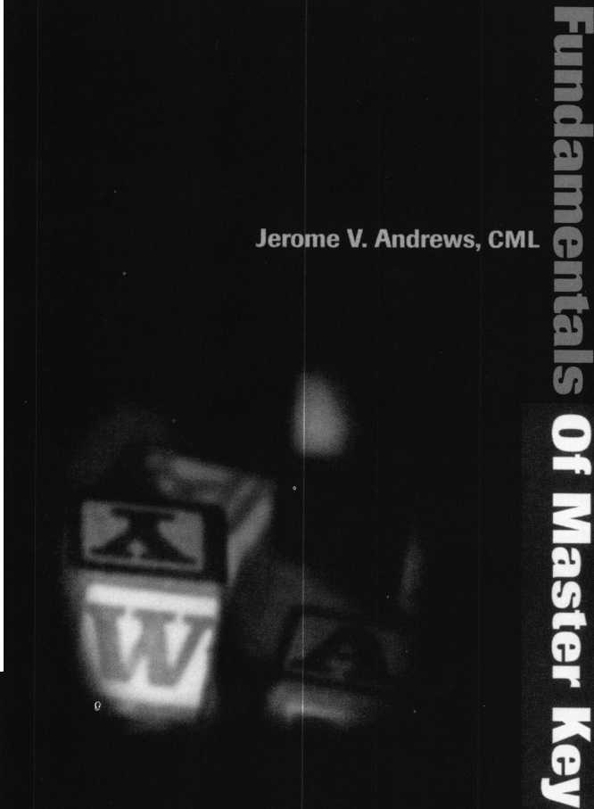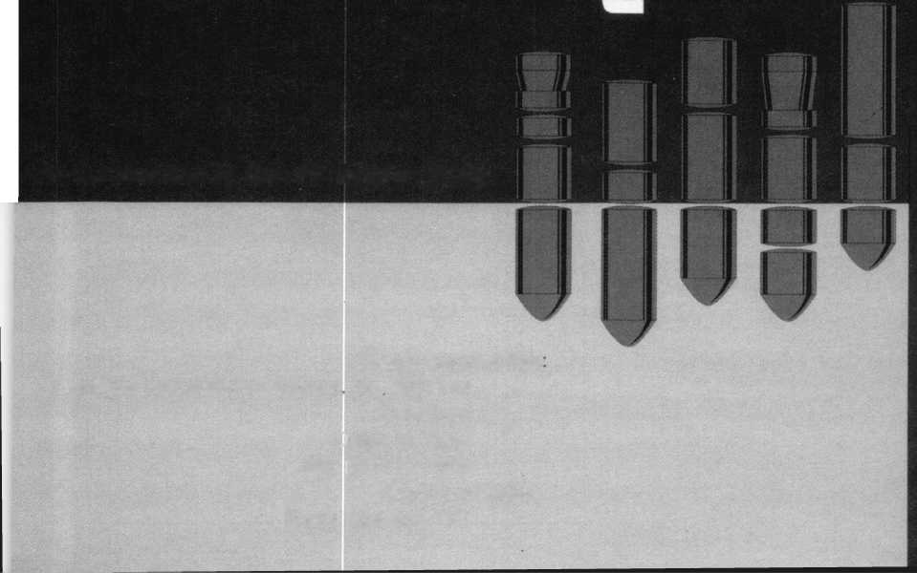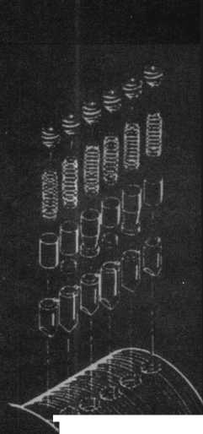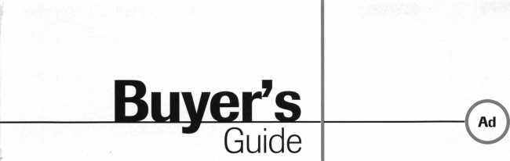

Alternative Tools

Here are new tools that address problems  
from an alternative point of view. When the  
“usual” methods can’t get it done, try an alter-  
native tool. “The Tool” tension wrench is  
designed especially to allow more room for  
picks in SCI and KW1 keyways. “Lever Up”  
lifts vertical auto lock linkage without dis-  
connect danger and without the tool entering  
the vehicle. “Paddle Pusher” operates pad-  
dles and crash bars like you were standing  
inside. $12.95 (+$4.95 S/H). Allow four to  
six weeks for delivery. Send order on back of

business card with check or m/o to: Alternative Tools, Inc.; 162

Robin Dr.; Loveland, CO 80537.

Reader Service #23

Custom Key Tags

Every dolloar counts, so let us help you  
keep your customers coming back. Key  
Tags are an inexpensive way to advertise  
and keep your customers coming back to  
you. Add a tag to a set of new keys or key  
chain and the next time your customer  
needs a new key cut, they’re sure to  
remember you. We customize key tags to  
hold your store’s name or logo on one side  
and telephone number on the other. Each  
key tag is made from buffed pewter and  
measures 3/8"x7/8" in size, and comes

with its own ring. Our minimum order is 250 @ $1.20 each =  
$300.00 including set-up charge. Simply send us your store name  
and telephone number and we’ll do the rest: Milman Manufacturing,  
at either Commercial Street, Box 113, Roxboro, Quebec H8Y 3E8,  
Canada; or Champlain Mall Rd. , P.O. Box l64l;Champlain, NY  
12919; USA. Phone (514) 425-5794 or fax (514) 425-5793.

Reader Service #24

Door Controls International

Door Controls International announces our new  
champion lever trim. UL certified ANSI/BHMA  
156.3—1994, grade 1. The 08L lever trim is to  
work in conjunction with our fire rated security  
alarmed rim exit device, Pannex. The vandal  
resistant lever is available for standard or narrow  
stile doors, and can also be supplied with electric  
release. Phone (313)426-0400.

Reader Service #25

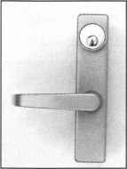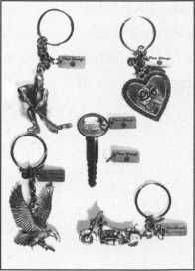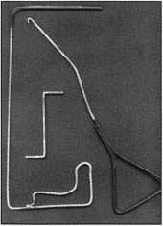

PRO-LOK

Pro-Lok has developed new machined aluminum padlock service tools for professional locksmiths. The green anodized LT605 Diskbuster is a fixture that automatically lines up your drill bit to penetrate the shearline on disk-type padlocks, allowing safe, simple openings. The gold anodized LT612 Padlock Drill Jig lets you drill most rekeyable padlocks open while saving the lock body and cylin­

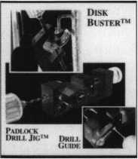

der. The black anodized LT612DG Drill Guide is an optional attachment that cen­ters the oval retaining nut on the bottom of many rekeyable padlocks, allowing you to drill

it out, service the cylinder and reuse the padlock. For more information, contact PRO-LOK. Phone (714) 633-0681

Reader Service #26

PRO-LOK

The 1998 update from PRO-LOK will feature over 100 pages of car opening infor­mation. From the Audi A4 to the Volvo 960, you will find full color pictures and an easy to follow step-by-step guide to unlocking the ’98 cars. With each page as a self-contained lesson, both the beginner and the expert will be able to open those new ’98 cars. For more information, contact your distributor or PRO-LOK at (714) 633-0681.



One Stop Shopping



**Rugged, Dependable  
Security Products.**

Providing solutions to your

access control dilemmas

**♦ SELSi?**

For information ijgN call our ^ I Electronic I Access Department today!

Toll Free: 800-282-2837 Fax: 800-447-2299



Warehouses in: Largo, FL; Miami, FL;  
Oakland Park, FL; Charlotte, NC; and Atlanta, GA.

**Serving the Security Industry Since 1946.**

Reader Service #5

February 1998

Keynotes

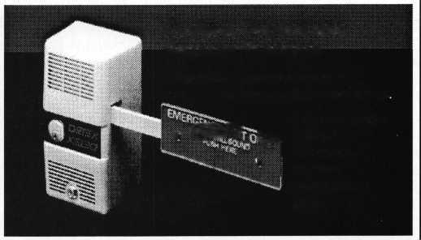

|  |  |  |  |  |
| --- | --- | --- | --- | --- |
| 1 |  |  |  | Report |
| J |  | | |  |
|  | | | | | David Lowell, CML, CMS  PRP/Education Manager |

PRP Sittings Available At ISC.

|  |  |
| --- | --- |
| /PRP Dates |  |
| March 8,1998 |  |
| Yosilanti, Mich. |  |
| IDN Hardware Sales |  |
| John Kress |  |
| (313) 591-1150 |  |
| March 14, 1998 |  |
| Illinois Dept, of Pro Regulation |  |
| Mary Jo Southward |  |
| (217) 785-0523 |  |
| March 24, 1998 |  |
| Las Vegas, Nev. |  |
| ALOA Education Conference at ISC | |
| David M. Lowell, CML, CMS |  |
| (800) 532-2562 |  |
| March 28,1998 |  |
| Hammond, La. |  |
| Lou-Miss Locksmith Association |  |
| Thomas L. Hunt, CPL, CPS |  |
| (205) 833-3333 |  |
| March 28, 1998 |  |
| Somerset, NJ. |  |
| Master Locksmiths Association |  |
| of New Jersey |  |
| Charles Green, CRL |  |
| (973) 267-8884 |  |
| March 28,1998 |  |
| Kenosha, Wis. |  |
| Greater Chicago Locksmith Association | |
| John J. Geeenan |  |
| (773) 486-2030 |  |
| April 25, 1998 |  |
| Anaheim, Calif. |  |
| American Security Distribution |  |
| Debby Lussier |  |
| (909) 371-2607 |  |
| April 26, 1998 |  |
| Eau Claire, Wis. |  |
| Indianhead Chapter |  |
| John Dorsey, CPL |  |
| (715) 832-4207 |  |
| May 23, 1998 |  |
| King of Prussia (Valley Forge), Penn. | |
| SAFETECH |  |
| David M. Lowell |  |
| (214) 827-7233 |  |
| May 31,1998 |  |
| Chicago, III. |  |
| ALOA Education Conference at ISC | |
| David M. Lowell, CML, CMS |  |
| (800) 532-2562 |  |
| June 18, 1998 |  |
| Nashville, Tenn. |  |
| ALOA '98 Security Expo |  |
| David M. Lowell, CML, CMS |  |
| (800) 532-2562 |  |
| 30-day application period required y | |

54 I Keynotes February 1998

Be sure to notice the significant development in the dates listed over on the left. ALOA PRP sittings have been scheduled (along with ALOA ACE classes) at ISC (Interna­tional Security Conference) events this year. We hope that this gives an extra incentive to those of you who are going to have to travel to sit for the PRP—this way you can take in a conference and some great classes while you're there. For many, this makes the difference in being able to justify a special trip. Personally, I think sitting for the PRP is important enough all by itself, but it’s great to be able to offer additional benefits to our best professionals.

Speaking of sitting for the PRP while taking great classes and a leading trade show, don’t forget ALOA ’98 in Nashville this coming June. We'll have the best of everything there.

New Certifications

CPLs

Cash, Houston/Charlotte, N.C.

CRLs

Arusiewicz, John J./Burlington, Conn. Casper, Richard F./Duluth, Ga.

Fink, Harold/Pasadena, Md.

Gardner, George R./North Ferrisburg, Vt. George, David/Northfield, Ct.

Harnden, James/Winthrop Harbor, 111. Hardy, Harold L./Stockbridge, Ga.

Kink, Lee W./Cary, N.C.

Lear, William D./Gunterville, Ala.

Tavares, Mark S./Harstons Hills, Mass. Vessels, John D./Ledyard, Ct.

Williams, Paul H./Elm City, N.C.

Zizza, Mark R./Colebrook, N.H.

PRP History Requests

If you need information about your PRP his­tory, please contact the ALOA office at 3003 Live Oak Street; Dallas, Texas, 75204.

When you do contact (in writing) the PRP staff, please reference your current ALOA membership number and/or any old ALOA membership numbers under which you might have taken the PRP evaluation.

PRP Resource Guide

One excellent resource in preparing for the PRP is the PRP Resource Guide available from the ALOA office for $18 (which includes shipping). The Guide covers PRP registra­tion procedures, categories, a study guide, sample questions, references to applicable materials in other publications, and a professional glossary of terms.

Mandatory Categories

One the first questions asked by some PRP candidates is, “What is the basic information —what are the basic skills—required of a certified locksmith?” For those of you who are new to the process, the PRP begins with 10 mandatory categories. Those are:

* Codes and Code Equipment
* Cylinder Servicing
* Key Blank Identification
* Key Duplication
* Key Impressioning
* Professional Lock Opening Techniques
* Lockset Functions
* Lockset Servicing
* Basic Master Keying
* Cabinet, Furniture and Mailbox Locks.

I About the Manager: David

Unveil, CML, CMS, is ALOA’s immediate past  
president and an ALOA Trustee. David has  
served on the ALOA board for 10 years. He owns  
and operates Phoenix Lock & Key in Arizona,  
and has been an ALOA member since 1981.

Proficiency Registration Program

Available to locksmiths worldwide, ALOA’s

proficiency registration program (PRP) evalu­ates the educational and technical competence o dedicated individuals in 36 categories such as hardware installation, high security and safe/safe vault locks, master keying, alarms and access control devices. There are four levels of PRP certification:

Registered Locksmith (RL)

Certified Registered Locksmith (CRL) Certified Professional Locksmith (CPL) and Certified Master Locksmith (CML)



It pays

to have new faces  
in the crowd.



During 1998  
each ALOA member  
who sponsors  
a new applicant  
will receive $40 cash  
(upon clearance,  
and payment

of application fee and dues).

|  |  |
| --- | --- |
| 'Ti«rt | Tips |
| Oracle |  |
|  | |Tony Ramunno, CML,CPS  Trade Tips Editor |

Button Pin Spring Action

I found this tip while practicing a Baldwin Images Lock. Simply inset your pick through the keyway underneath the button pins.

Once a spring action is felt (with little resistance) turn the knob and the latch should release.

William Stone

10 steps to an 8-cut key

FIGURE 1

Ford 8-Cut Ign. 703241, 703242

O

1

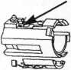

Drill here (on steering

column housing) rj>

U A

FIGURE 2

Ford 8-Cut Ign. 703241, 703242

, Small, square window

1. Remove shroud on steering column.
2. Drill 5/32" hole in the steering column housing. Use the retainer pin hole as a starting point. The hole should be 3/8 " toward the ears, and 1/8" left of center.
3. Locate the sidebar through the small square window on the IGN lock housing.
4. Insert one pick into the hole and push on the sidebar.
5. At the same time, insert another pick into the keyway and rake the tumblers.
6. After the sidebar falls in, turn and remove the IGN lock cylinder.
7. Remove the tumblers and place on a work surface in order.
8. Decode the tumblers with a magnifying glass. The depth numbers are on the tumblers.
9. Reassemble lock.
10. Cut the key.

This can give you seven of the eight cuts.

The last cut can be achieved through

progression, if necessary.

Steve Elwood

#20862

Last month's Trade Tip winner was Darrel Shandy with “Peening Pins. ”

/How To Become A  
Trade Tipper

Each month, the Associated Locksmiths  
of America (ALOA) holds a “Trade Tips”  
contest in Keynotes for ALOA members.  
In addition to helping other locksmiths  
by sharing your knowledge, there are  
three levels of prizes to be awarded:  
Monthly Prize  
Sargent & Greenleaf 6120  
electronic safe lock

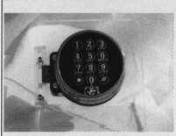

Grand Prize: An expense-paid trip to the ALOA ’98 Security Expo

Each year, the ALOA Publications Committee selects one outstanding tip, the author of which receives a seven-day ALOA convention package that includes travel and accomodations.

Authors of any Trade Tip published will still receive $20.

Want to Participate?

Mail your best idea (including photos,

illustrations or parts, if necessary) to

Keynotes

Trade Tips Editor

3003 Live Oak St.

Dallas, TX, 75204-6186.

All entries are sent to the Trade Tips editor with the author’s identity deleted. The tips must be submitted exclusively to Keynotes and become the exclusive property of ALOA. Tips are judged on the basis of accuracy, professionalism, ethical standards, originality and usefulness.

February 1998

Keynotes

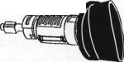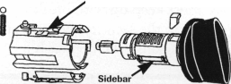

Chapter

News

Dana Barnum, CML Committee Chairman

They say that letter writing is becoming a lost art, but you guys didn’t have to pick this month to prove it. Anyway, how about e-mail? Mine is [danabarnum@aol.com](mailto:danabarnum@aol.com) So no “hot topic” letters lately, but good news here and there—way over there in some cases.

The Rising Sun Also Rises

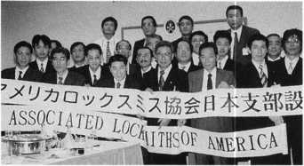

ALOA recently recognized the associa­tion’s first Japan chapter. Attending the inaugural meeting in Tokyo was guest speaker from the Korean chapter, Joe J. Lee, and moderator Keizo Takahashi. Members in attendance learned about the importance of establishing a chapter in their native country and elected officers. The latter are as follows: Chairman, Keiryu Tsukishiro and vice-chair­

men, Toshio Sakamoto (of Central Japan) and Yoshimoto Harada (of Western Japan).

ALOA wishes to extend a special thanks to Joe Lee for continuing to be our good will ambassador to Korea and Japan. His hard work on behalf of the association is invaluable.

We are very excited to have this new chapter of ALOA.

Spiwak In Minnesota

Industry guru Steve Spiwak not only started writing for KEYNOTES again beginning this issue, he’s been all over speaking out on his belief in the need for fundamental changes in locksmith associa­tion structure and the ways we do business. When he sat down with this chapter in the frozen north, some agreed with what he had to say and others didn’t like what they heard. But at least nobody fell asleep.

The crux of Spiwak’s grassroots message is that the survival of locksmithing as an indus­try depends on our collective acceptance of that “business as usual” will no longer work for us. We must keep up with breaking developments in the security industry and fundamentally change our approach to

***W aluA chapter members can write to Dana Barnum at: CHAPTER NEWS; 3003 Live Oak Street; Dallas TX 75204; fax (214) 827-1810; aloa@anet-dfw. com***

commerce. Spiwak believes that it is crucial for all security associations—ALOA, DHI, NBFAA, SIA, etc.—to join forces for our common good.

Legislative Wake Up

The North Dakota Chapter recently formed a legislative committee to advance the ALOA Model Law and licensing for their state. More and more local groups are recog­nizing that legislation is here to stay and we’d better deal with it our way.

WKmKiiL-jAbout the Chairman: Dana Barnum, CML, #05444, operates South Penn Lock & Safe Co. in Media, Penn. He also serves on the ALOA Education Committees, as well as having been on the board of directors of the Greater Philadelphia Locksmiths Association (GPLA). Dana has also sponsored many new ALOA members. Dana can also be reached at FAX (610) 565-9902 or e-mail him at danabamum@aol. com

"Hawkeye™ Products are the professional's choice when **only** the best will do!"

Adjustable-Focus allows you to see objects near or far with clarity.

Special... Purchase any Hawkeye Borescope Kit and receive the  
Hi-Lite 150 light generator for only $225.00 ... Save $50!!!

(regularly priced at $275)

Hawkeye offers three  
size kits:

HEB-7

7" fiberoptic probe  
w/ 90 mirror tube and  
power handle $490.00

HEB-12

12" fiberoptic probe w/ 90  
mirror tube and power  
handle $600^0 $580!!!

HEB-17

17" fiberoptic probe w/ 90 mirror tube and power handle $**700.00** $670!!!

DISTRIBUTOR & MANUFACTURER

127 SE 29th Street ♦ Topeka KS 66605 888 798 8464 ♦ FAX 800 798 TIME (8463)

Reader Service #7

■

Keynotes

February 1998

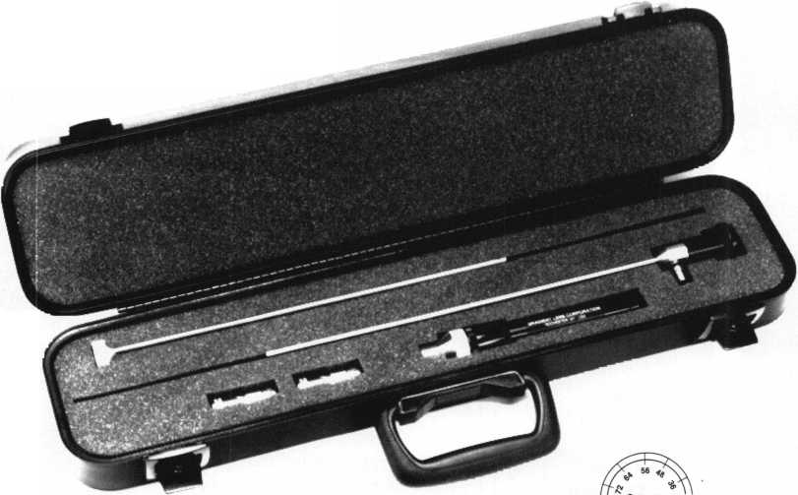

Chapter

Roster



Dept

**Y "^ie best way to learn about ALOA’s programs  
and to network with locksmiths in your area is by  
participating in local ALOA chapter activities. This is  
your opportunity to exchange management and tech-  
nical information, build your professional image, and  
share trade tips with your fellow locksmiths.**

**If you want to start a chapter in your area, please call  
ALOA, (214) 827-1701.**

**Alabama** Alabama Locksmiths Association

411 6th St.

Decatur, AL 35601 (800) 292-5008 *Larry Warnick, CML

Arizona

Grand Canyon Chapter

1905 E. Weber, Suite 108 Tempe, AZ 85281 (602) 921-0123 *John Ilk, CRL

California

Los Angeles/

Orange Counties Chapter

P.O. Box 697

Alhambra, CA 91820-0697 (310) 869-2555 *John H. Cosby, CPL

San Diego Chapter

1049 Island Ave.

San Diego, CA 92101-7228

(619) 234-4829

Burt Fieser—Chairman

Colorado

Colorado Front Range

2055 26th St.

Boulder, CO 80302 (303)443-9740 John I. Shandy, CML— Chairman

*John M. Thomas, CRL— Vice Chairman (303) 666-8980

Connecticut

Nutmeg Chapter

Phil’s Lock Shop 360 E. Main

Meriden, CT 06450-6022 (203) 237-4602 Phillip Hobbs, CPL— Chairman

Florida

South Florida Chapter

1710 NE Miami Gardens Dr.

Miami, FL 33179 (305) 944-0469 *Jerri Moeller, CRL Secretary

Paul Renderer, CML— Chairman

Georgia

Georgia Chapter

P.O. Box 48088 Atlanta, GA 30362-1088 (404)455-6244 Michael D. Robinson, CRL *M.W. Whitman, Jr.

Hawaii

Hawaii Chapter

4420 Lawehana St.

Unit 4

Honolulu, HI 96818 (808) 623-5914 *Andreas Muenker, CML— Chairman

Indiana

Central Indiana

1237 Wabash Ave.

Terre Haute, IN 47807 (812) 234-6249

*Herbert Dusenberry, CML

Northern Indiana

122 N Orchard St. Kendallville, IN 46755 (219) 347-1754 *Earl Shanfelt

Southern Indiana

P.O. Box 185 Bloomington, IN 47402-0185 (812)334-3737

* Daniel W. Hill, CML

Kentucky

Kyana Chapter

510 E. Parrish Ave. Owensboro, KY 42303- 3125

(502) 684-5093

*Timothy Morrison, CML—

Secretary

Maryland

Chesapeake Chapter

205 Cleveland Ave. Baltimore, MD 21222 (410) 633-0111

* Bob De Weese, CPL— Chairman

Massachusetts

Massachusetts Chapter

200 Weir Street Taunton, MA 02780 (508) 823-4649 *Stephen Ehrlich, CML— Treasurer

Minnesota

Minnesota Chapter

3M Center

Bldg. 223-BE-04

St. Paul, MN 55144-1000

(612)733-6674

*Douglas Rude, CRL

Montana

Montana Chapter

Mountain Locksmithing 210 N 7th

Bozeman, MT 59715 (406) 586-5187 *Jim Morrissey, CRL— Chairman

Carol Morrissey, CRL— Secretary

Nebraska

Nebraska Chapter

343 W. 2nd St.

Hastings, NE 68901 (402)463-6661 *Brad Boden

Nevada

Sierra Nevada Chapter

C/O Pamela Vankirk P.O. Box 115 Reno, NV 89504 (702) 328-9285 *Danniel F. Howard,

CML—Chairman

New Jersey

Garden State Chapter

106 Ridgedale Ave. Morristown, NJ 07960 (201) 538-2737 *Steve Frei, Chairman

New Mexico

New Mexico Chapter

917 2nd St. NW Albuquerque, NM 87102 (505)242-1380 *Evelyn Wersonick, CML Marc McGrannahan, Chairman

Sunbelt Chapter

South Central Region New Mexico State University

Box 30001 Dept. 3545 Las Cruces, NM 88003-0001 (505) 846-6292 *Don Brazil—Chairman

North Dakota

North Dakota Chapter

Rte. 1 Box 67 Devil’s Lake, ND 58301-3907 (701) 662-5625 *James H. Strong, CRL

Ohio

Ohio North Coast Chapter

#2 Horseshoe Drive

Monroeville, OH 44847

(419)465-4153

*Ronald Betschman, CML—

Chairman

Ohio Valley Chapter

144 Julep

Cincinnati, OH 45218 (513) 825-7528 *James T. Brickler,

Chairman

Pennsylvania

Keystone State Chapter

3 W 4th St.

Bridgeport, PA 19405 (610) 272-9292 *Barry Leas, CRL

South Dakota

South Dakota Chapter

402 S. Minnesota Ave.

Sioux Falls, SD 57102 (605) 331-6026 *Ronald Heidzig— Chairman

Tennessee

Smokey Mountain Chapter

2557 Middle Creek Rd. Pigeon Forge, TN 37863 (615)453-8344 *Jessie Swan, RL

West Tennessee

1261 Wellsville Rd. Memphis, TN 38117 (901)685-1130 *John Singleton

Texas

Sunbelt Chapter

see New Mexico listing

Washington, DC

Washington, DC Area

2987 Thomas Rd.

Bryan Road, MD 20616 (301) 283-0145 * William Smith, Jr., CML— Chairman

Wisconsin

Fox Valley Chapter

1425 N. Richmond St.

Appleton, WI 54911

(414) 731-5400

e-mail [sageinc@athenet.net](mailto:sageinc@athenet.net)

*JohnF. Engel, CRL

Chairman

Matt Swoboda—

Vice Chairman Indianhead Chapter 201 N. Barstow St.

Eau Claire, WI 54703-3525 (715)832-4207 *John Dorsey, CPL Chairman

Wyoming

Wyoming Chapter

5920 E. Pershing Cheyenne, WY 82001 (307) 638-8752 *Betty Crenshaw, CML

International

Chapters

Korea Chapter

Suh Man Soo, President

*Joe J. Lee

5430 Howland St.

Phila., PA 19124 Phone and fax: (215)744-5254

* Denotes contact person for this chapter.

All questions regarding chapter activities, meetings and events should he directed to this individual.

February 1998

Keynotes

|  |  |
| --- | --- |
| ALOA | ( |
| Extra | 1 |



Dept

In Memory

Charles Rhyne

Charles Rhyne recently passed away at the age of 62. He had been an ALOA member since 1982 as well as a member of SAVTA and was employed by Ardmore Cycle Shop in Ardmore, Okla.

Clarence Reiss

Clarence “Gus” Reiss left us late last year at the age of 91 • He was an ALOA member since 1967. A resident of Lakeview, Ore., Reiss worked from his home on 934 S 4th St.

VW Beetle Alert

The new Volkswagen Beetle is using a sidewinder-type key, HU66 in Silca numbers. This is the same as the Audi A4 & A6, Porsche Boxter& VW Passat. If you have a Framon Sidewinder, you WILL need a special set of vises to cut these keys, and we recommend a special cutter & guide as well. Check out Framon Manufacturing’s website ([framon@northland.lib.mi.us](mailto:framon@northland.lib.mi.us)) under Sidewinder accessories for more information.

Subaru Forester Codes

Framon has also had a few calls on the new Subaru Forrester code series. The new code series is 30001-37850, and is similar to the Nissan Pathfinder key. From what our sources understands, the Pathfinder key will not work due to size problems; the correct key is an X251 Ilco.

Honda/lsuzu Key Note

Honda also has a new key out, an X250. Isuzu is also using this key for a few models.

Ford Notes

On display in the Ford booth at the recent Detroit Auto Show was one truck that was using the Tibbe key. Our source wasn’t certain whether this is going to be a North American model or not, but suggested you keep your eye out. The Tibbe keys can be cut

58 I KeynotesFebruary 1998

on the Framon#2 with a special attachment, part number F2SH070. The kit runs $250, and includes a special cutter (.088" Carbide slotter), vise and instructions.

For 1998, Ford is mixing things up a bit with the transponder keys. What is commonly known as the PATS 1 system— where only 1 key is needed to program—is still in use on the following models: 1998 Ford Expedition & Contour, 1998 Mercury Mystique and the new Navigator (not sure if this is a Lincoln or a Mercury). The PATS 2 system-where you need TWO original keys to program-is being used on all other models.

Framon Manufacturing reports servicing a PATS 2 car recently, thinking it was a PATS 1. They programmed the car using the PATS 1 instructions, and the system shut down just like it is supposed to. The original key did still work. The customer went back to the dealership, got the second original that they forgot about, and the problem was cleared up. Be CAREFUL!

Editor's Note: Special Thanks to Phil Agius, vice president, Sales & Marketing, Framon Manufacturing Company, Inc., for providing the updated auto information.

Don’t Forget

The last day to submit applications for the ALOA scholarship is March 1. Don’t wait until the last minute. See application in this issue.

Back Page Hints Word List

Alarm

All

Automatic Key Machine  
Awl

Backset

Bevel

Blank

Bolt

Cam

Core

Cut

Cue

Cylinder

Depth

Doublesided

Door

Duplicated

Fit

Impression

Keyway

Lift

Look-Alike

Locksmith

Master

Mill

Pattern

Pick

Repin

Ring

Shackle

Shearline

Spacing

Spindle

Tumbler

User

Way

Wall

***Keynotes Advertisers***

RS# Advertiser

1. All-Lock Company,  
   99 ISC



100 Jet Hardware Mfg., Inc.

2 KSP

8 Locksmith Publishing Corp.

1 MLANJ

_ 17 _ 59 **_ BC** _ 17 **IBC** _ **11** 26

1. Monday Security Group

98 Security Technology and Design 21

1. Southern Lock and Supply Co. 53

7 Timemaster 56

1. Unlocks Inc. 26

**ULOA Conference Program eriiltionil Securitv Confere**

**M^^eying Methods & Formats Comprehensive Int^fej^pgeable Core Safe Lock froubleshoo{ii1? • Access Control • Servicin^TtHiminum^t^efront Doors • Commercial Grade Locksfet| • Auditcon System 2100 Certification • Electronic Safe Locks •**

**Introduction to Closed Circuit Televisio| ^The Complete Door and Door Closdrs «** / **/ -Exit Devices •**

**nvestigat>ve locksmith**

*Reader Sente* #

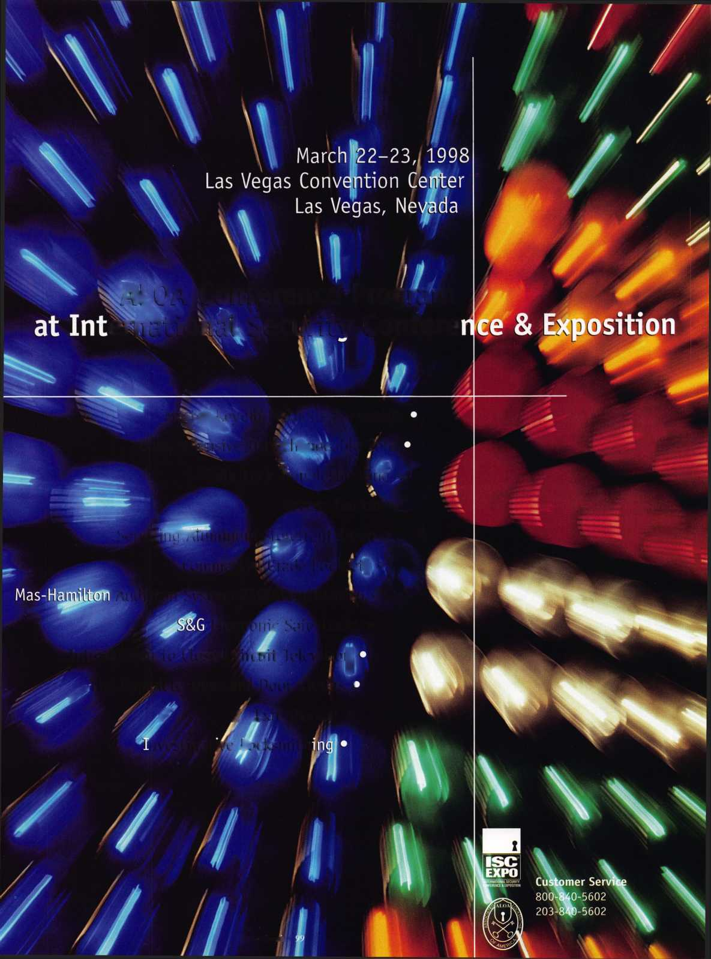

Back

Page



[Dept]

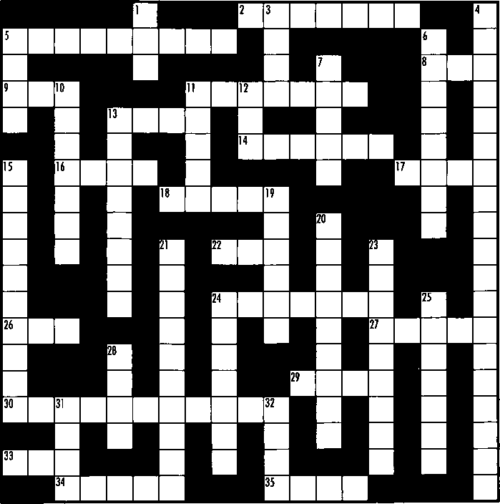

Across Clues:

1. The complimentary element to depth.

5. Key blanks that match the originals in  
everything but price.

1. Material removed by the cutter  
   leaves this.
2. What the correct key should do.
3. The distance from the edge of the door  
   to the center of the cross bore hole.
4. The center of the lock cylinder housing  
   otherwise known as the plug.
5. The key used to operate all the change keys  
   within a given system.
6. The metal portion of the lock that is  
   inserted into the strike plate.
7. Common term for a component.
8. An uncut key.
9. The broached portion of a lock cylinder  
   is called the key.

24. The part of a padlock that is attached to  
the body and is used to bind a hasp or chain.

1. The more formal name for an ice pick.
2. An electrical noisemaking security device.

29- A type of cut made by a cutter of the  
same name.

1. A key that is cut on both edges.
2. A key term used to reference key machine  
   accuracy.
3. The act of changing a cylinder combination.
4. A term for a fastener which commonly comes  
   in **“E“C”** and snap types.

**Down** Clues:

1. When every lock is keyed in alike in the system, they are the same.

1. A tool used to manipulate a lock.
2. A device used to duplicate keys at the touch of a button.
3. When making a key by impression you mustas well as apply torque.
4. When a key machine has been properly adjusted, the duplicate keys will be.
5. The partner of spacing.
6. A moving blocking device within a cylinder that can be conical or flat.

By Steven Spiwak

1. The device on the back of a mortise cylinder.
2. This item comes in rim, key-in-the-knob and mortise varieties.
3. Cutting a key results in a newlykey.
4. The unique configuration into which the key has been inserted.
5. A professional technician who makes his living within the field of security.
6. A technique used to make keys using only a file and a key blank.
7. The point at which all the elements in a cylinder are aligned.
8. The central rod directly connected to the inside and outside doorknobs.
9. The configuration of cuts on a key.
10. The greatof China.
11. What a computer programmer wants his programs to be

friendly.

1. The place where you most often install a lock.
2. The angle on the edge of a door.

See “ALOA Extra” for clues. Answers will be in March **Keynotes.**

***Keynotes***

February 1998

**Professionalism Through  
Education”**

**cOGN/£**

C^LL^

**•** Technical Reference Manuals

**•** Instructional Yideos

**•** Computer Software

**to provide you, the security**

**specialist, with technical**

**information that is both**

**accurate and relevant to your**

**ever-changing role in the**

**marketplace. In addition to**

**serving you each month**

**pages**

**Locksm'tP Leo**

**published « 1**

**vocational and refe**

**material to help you prosper**

Free Information - Reader Service Card #8



Jet **Soars to a new level of Quality**

**A Symbol of Precision**

**JET HARDWARE MANUFACTURING CORP 800 Hinsdale Street, Brooklyn NY 11207**

Free Information - Reader Service Card #100

